**SPLUNK**

**Splunk Beginner to Architect**

**Section 1: Splunk Introduction:**

1. **Introduction to Splunk:**

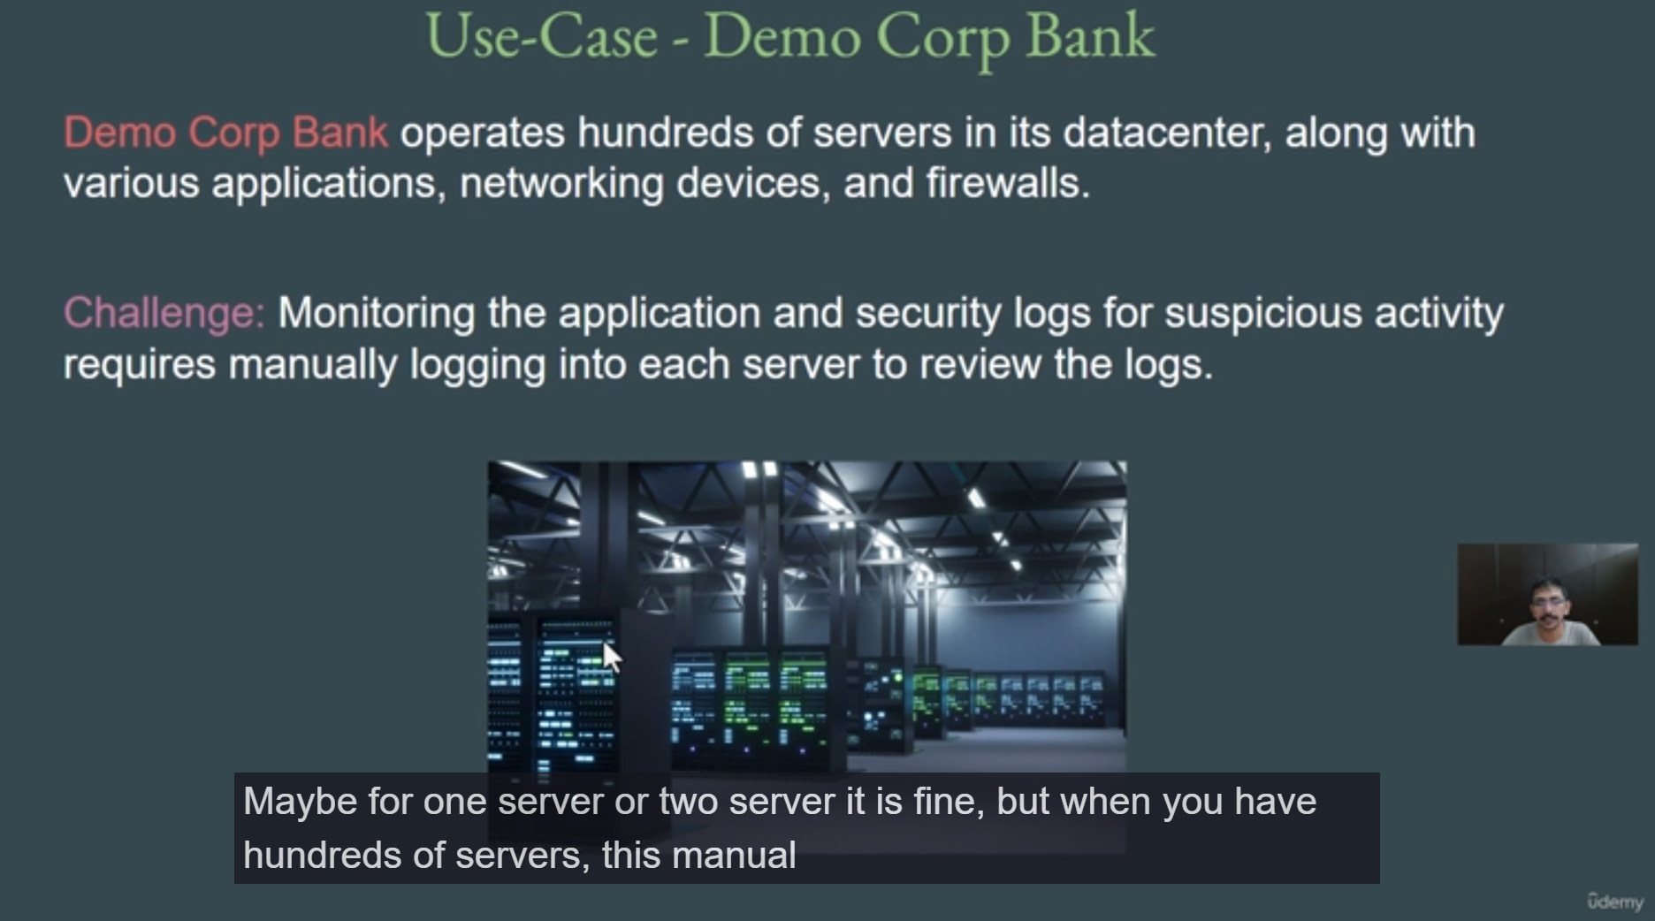

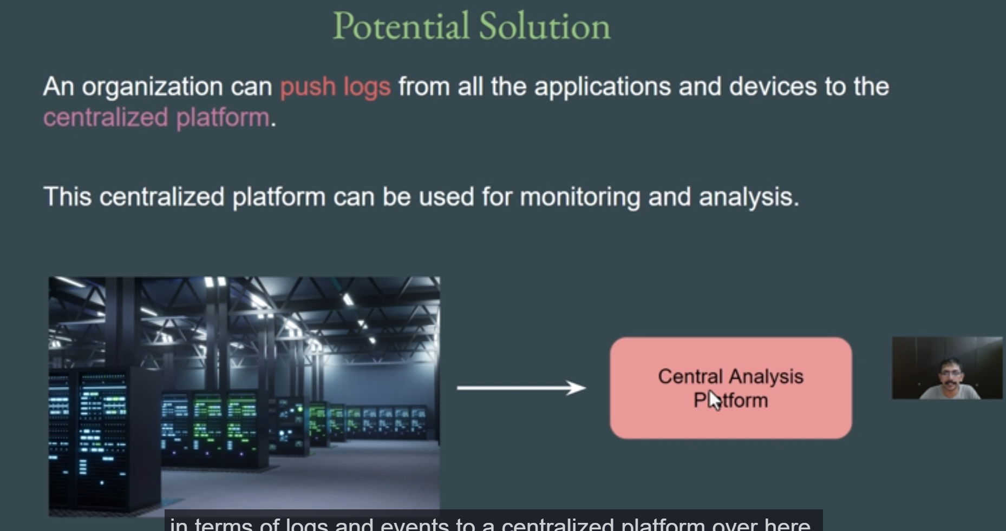

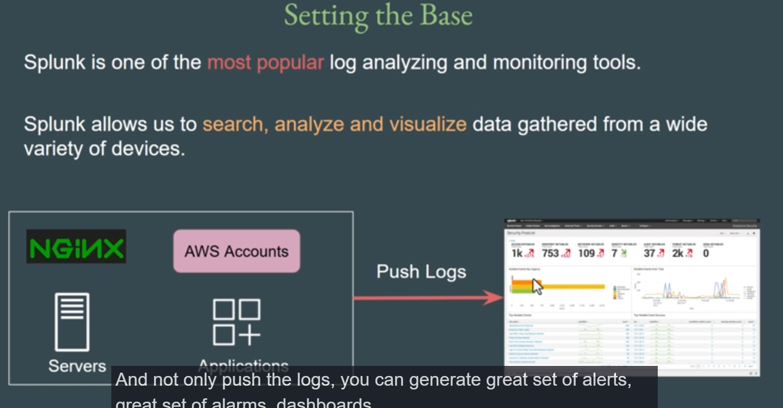

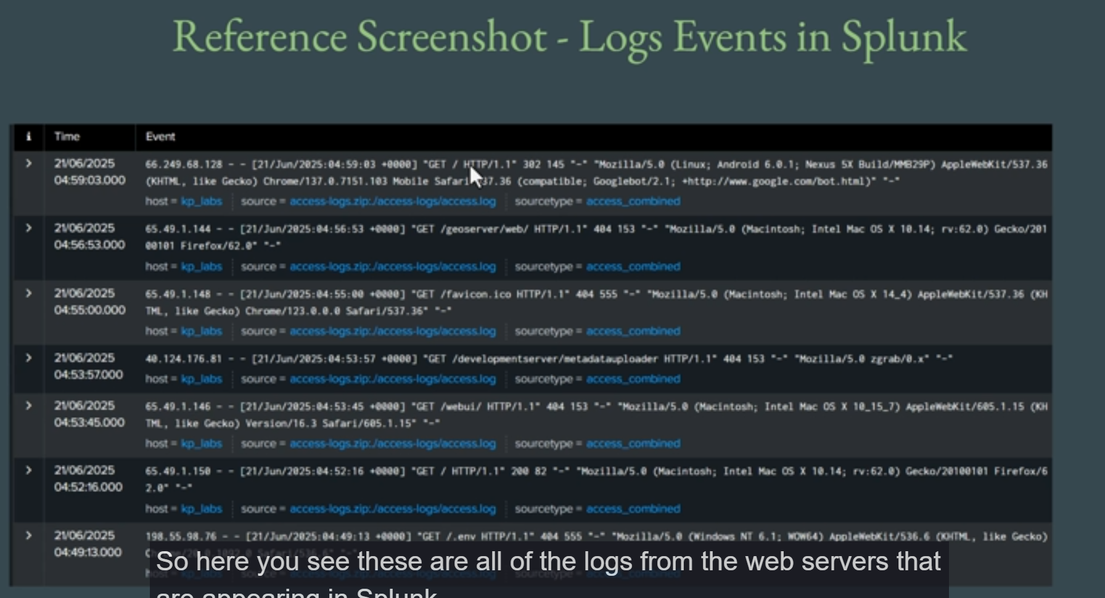

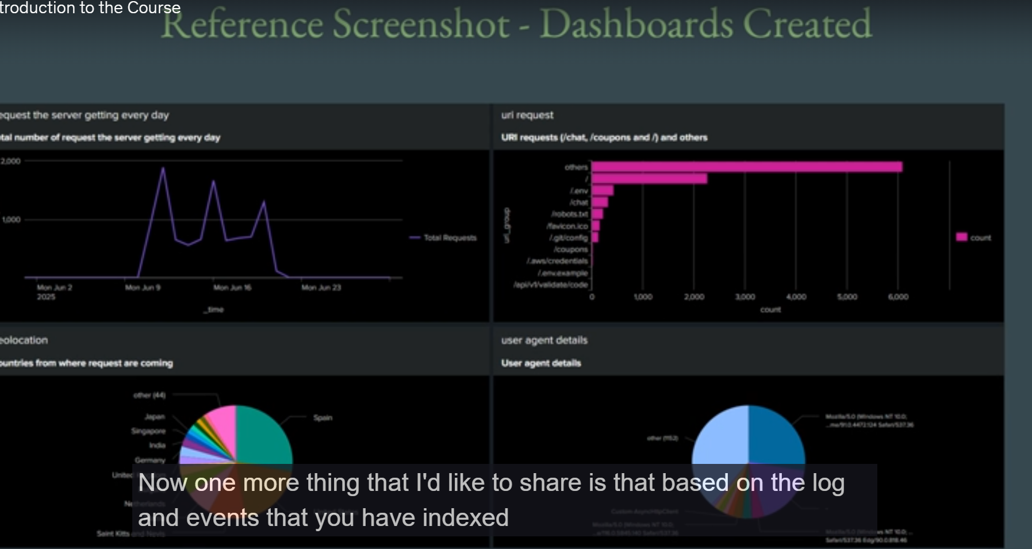

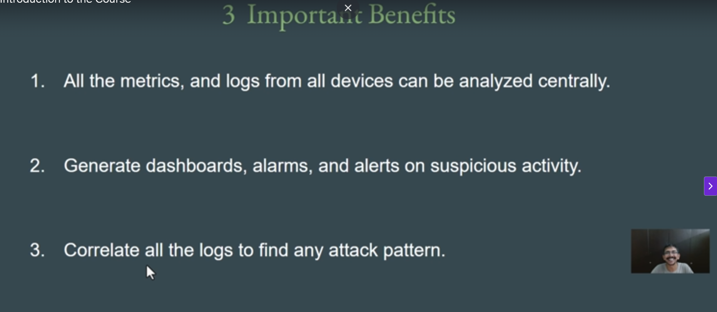

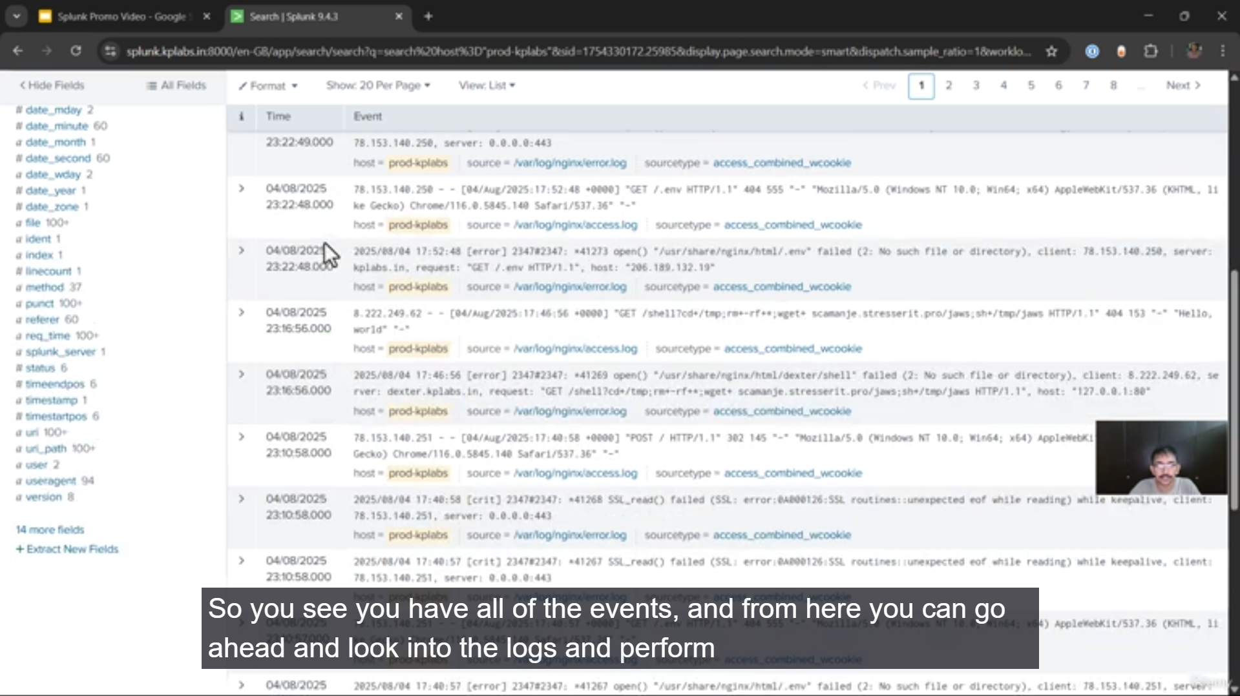

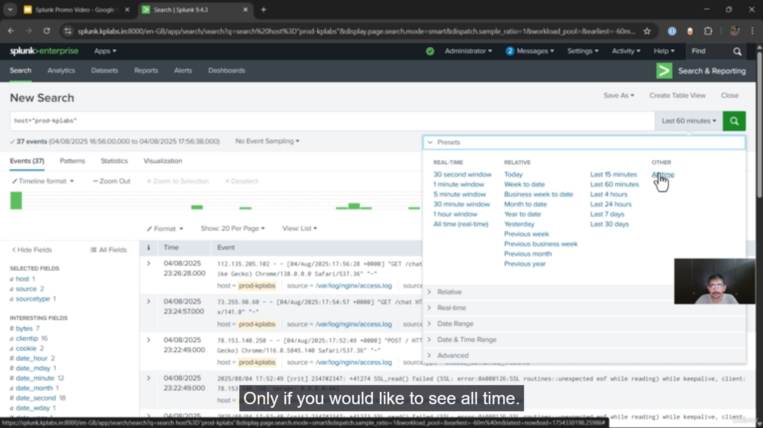

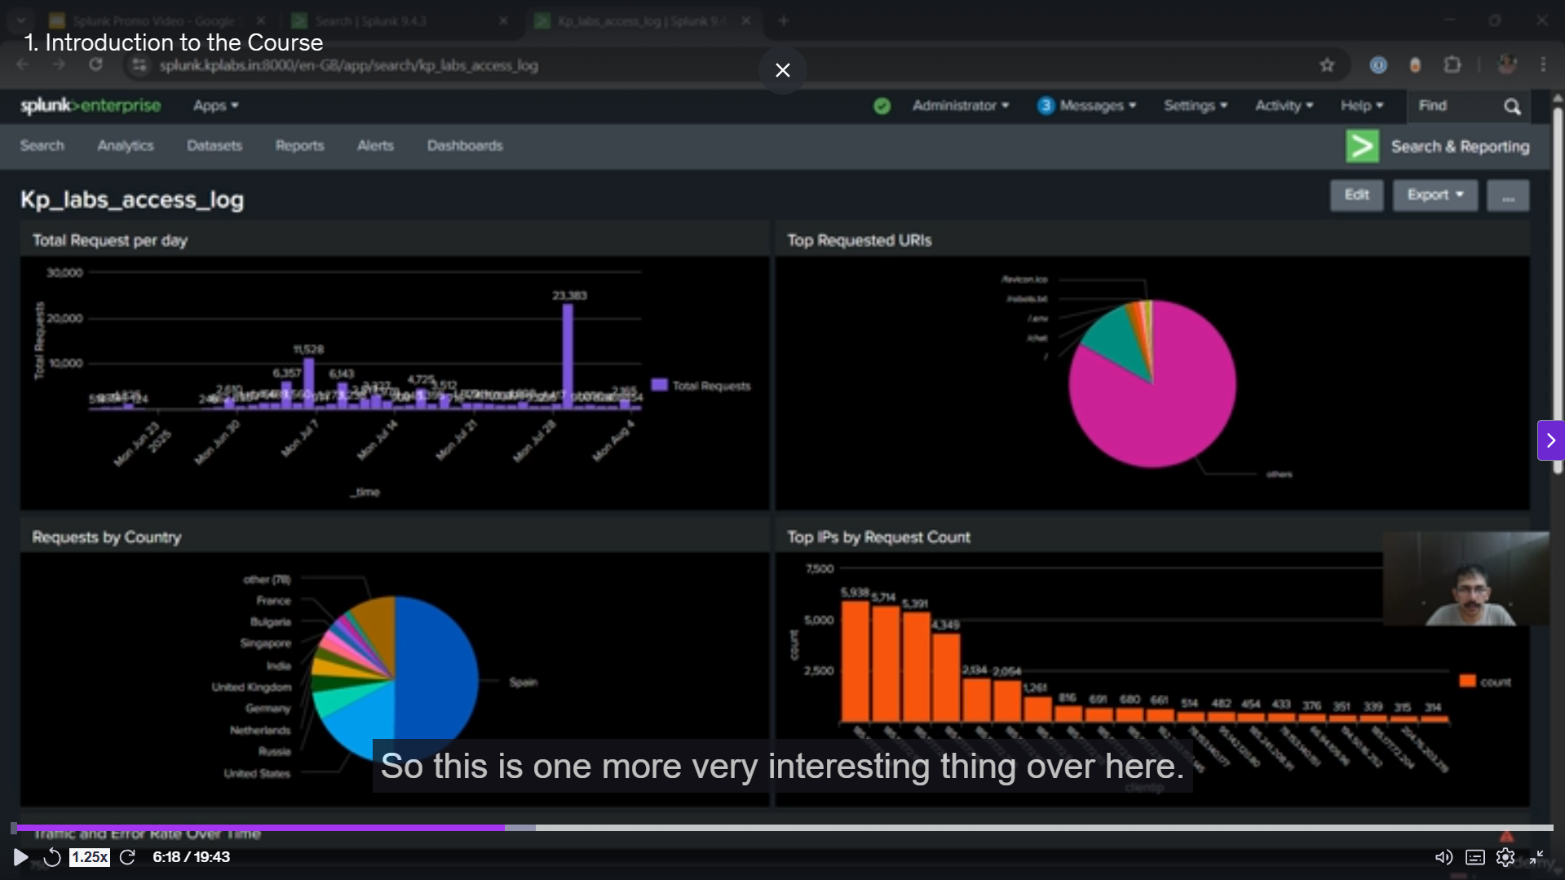

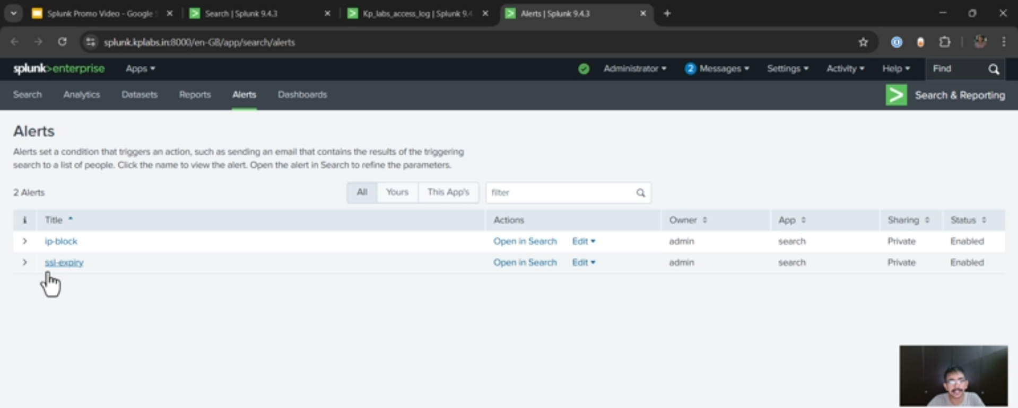

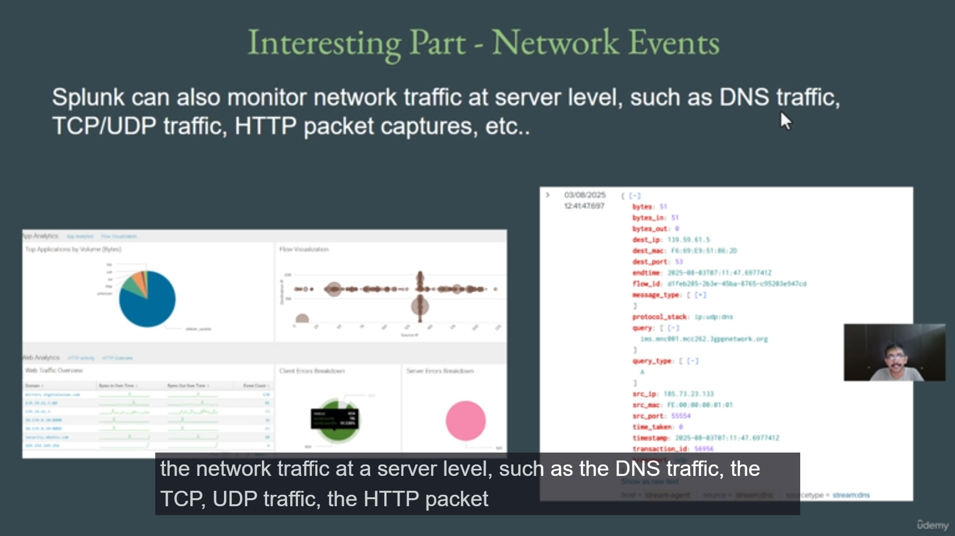

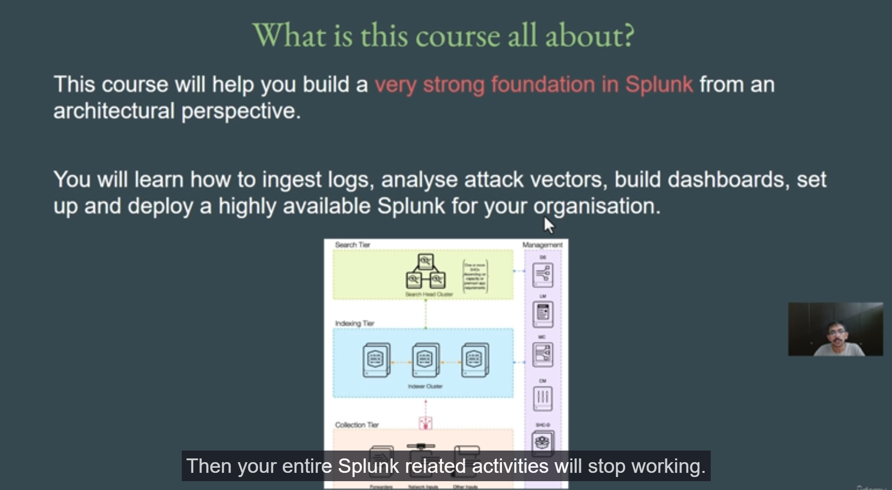

**Splunk Course Introduction Summary**

**1. The Challenge of Traditional Monitoring**

* **Common Organizational Setup:** Modern organizations, like the "Demo Corp bank" use case, operate with hundreds of servers (on-premise or cloud like AWS, Azure, GCP), various applications, networking devices, and firewalls.
* **The Problem:** Monitoring application and security logs for suspicious activity in this complex environment is challenging. The **manual approach** of logging into *each* server to review logs is not feasible or scalable for hundreds of devices.
* **The Solution:** A **centralized analysis platform** is needed to which all logs and events from every device are pushed. This simplifies life for all teams, as they only need to log into one platform for analysis.

**2. What is Splunk?**

* **Core Function:** Splunk is one of the most popular **log analysis and monitoring tools** in the industry.
* **Key Capabilities:** It allows users to **search, analyze, and visualize** data (logs and events) from various devices across the organization.
* **Centralized Architecture:** Logs from servers, AWS accounts, applications, etc., are all sent to a central Splunk platform, where users can then generate **alerts, alarms, and dashboards.**

**3. Benefits of a Centralized Analysis Platform (Splunk)**

* **Centralized Analysis:** All metrics and logs from all devices are analyzed in one place.
* **Visualization and Alerting:** Users can generate **dashboards, alarms, and alerts** for suspicious activity, sales metrics, or other use cases.
* **Correlation & Security:** The platform can **correlate all logs** to easily find attack patterns and abnormal activity (e.g., detecting a sudden spike in website requests).

**4. Splunk Demo Highlights**

* **Log Searching:** Users can easily look up logs for a specific server (e.g., 'prod') within Splunk, eliminating the need to SSH into the server manually.
* **Time Range Flexibility:** Logs can be filtered by specific time ranges (e.g., last 60 minutes, all time) to quickly pinpoint an issue.
* **Dashboards for Management:** Splunk excels at creating insightful dashboards that answer management questions (e.g., total website visitors, sales figures) without having to manually read log events.
* **Advanced Alerting & Automation (Security Example):**
  + Splunk can be set up to generate alerts on critical events (e.g., suspicious activity).
  + The platform can **integrate with tools like Slack** for instant notification.
  + Crucially, Splunk can be integrated with firewalls to enable **immediate, automated defense**, such as blocking an attacker's IP address upon detection of a hostile request (e.g., trying to open admin.php).

**5. Splunk's Strength and Ecosystem**

* **Industry Leader:** Splunk is recognized as a **leader** in the security information and event management (SIEM) Magic Quadrant, affirming its top-tier status in the industry.
* **Network Traffic Monitoring:** Beyond logs, Splunk can monitor **network traffic** at a server level, including DNS queries, TCP/UDP traffic, HTTP packet captures, and protocols like FTP, LDAP, and iMap, which is vital for detecting network-based attacks.
* **Add-ons and Apps Ecosystem:** Splunk's power is greatly enhanced by thousands of **readymade Add-ons and Apps** (similar to the Android/iOS app ecosystem) for integrations with third-party tools like **AWS, Kubernetes**, and many others, making setup and integration much easier.

**6. Course Curriculum Overview**

The course is designed to build a strong foundation on Splunk from an **architectural perspective**. Key topics include:

* **Log Ingestion:** Learning how to push logs from servers, AWS accounts, and network devices into Splunk.
* **Analysis and Security:** Analyzing log events to find attack patterns.
* **Dashboard Creation:** Building effective and amazing dashboards.
* **High Availability Architecture:** The most important part, covering how to build a **highly available (HA) clustered Splunk architecture** for large organizations to prevent a single point of failure. This involves understanding and configuring sub-components like **Search Heads, Indexers, and Forwarders** in a cluster setup.

===================================================================================

**Section 2: Splunk Installation:**

1. **Introduction to Splunk:**

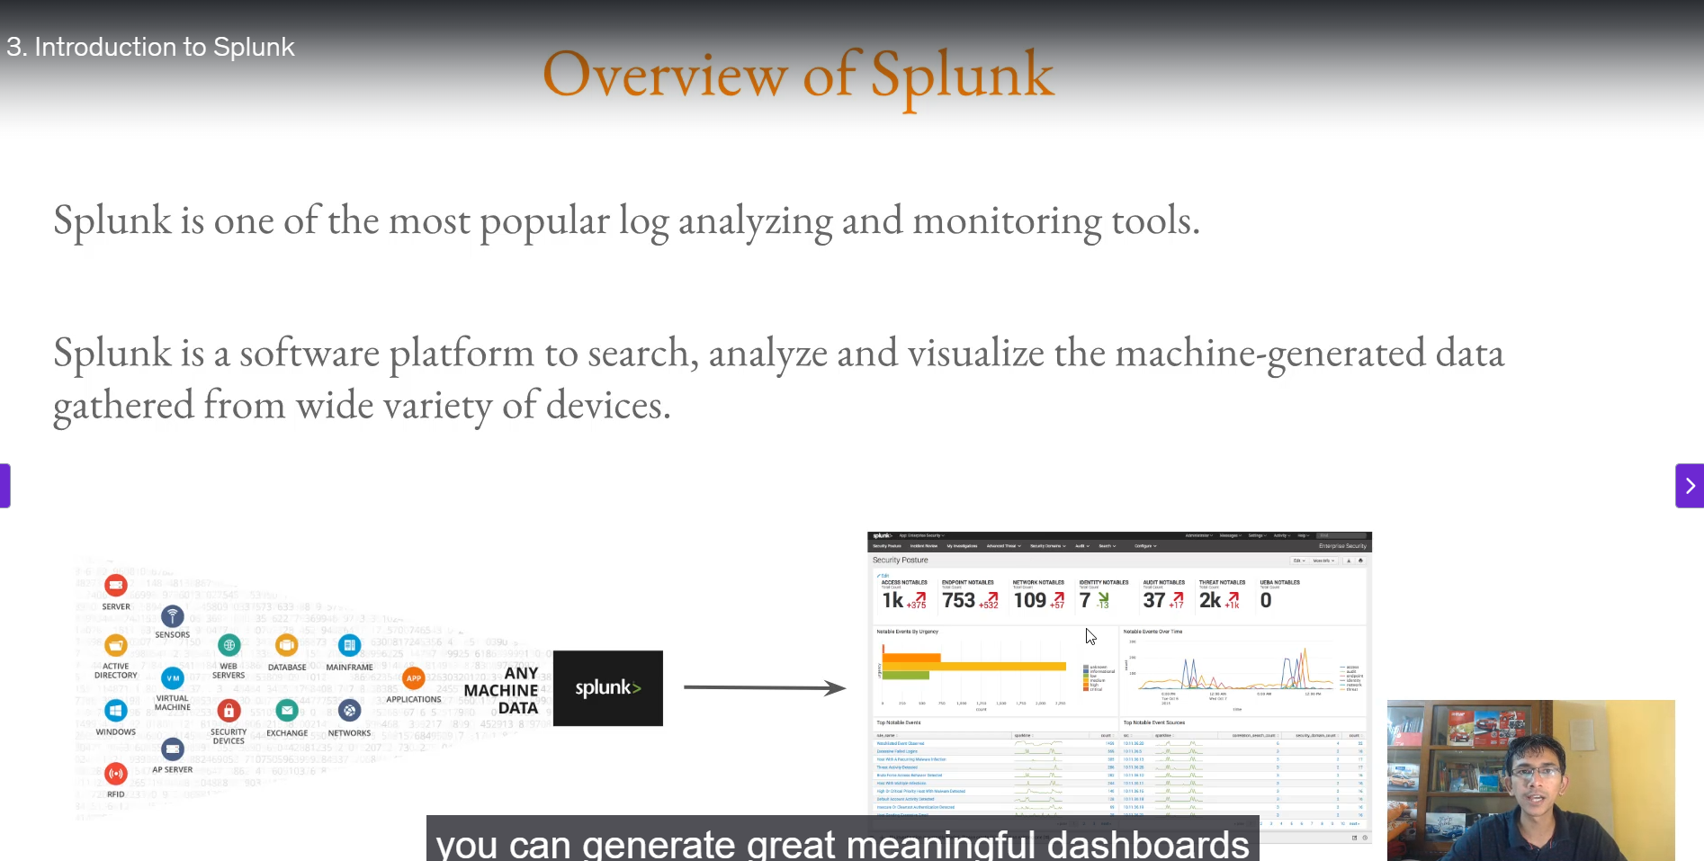

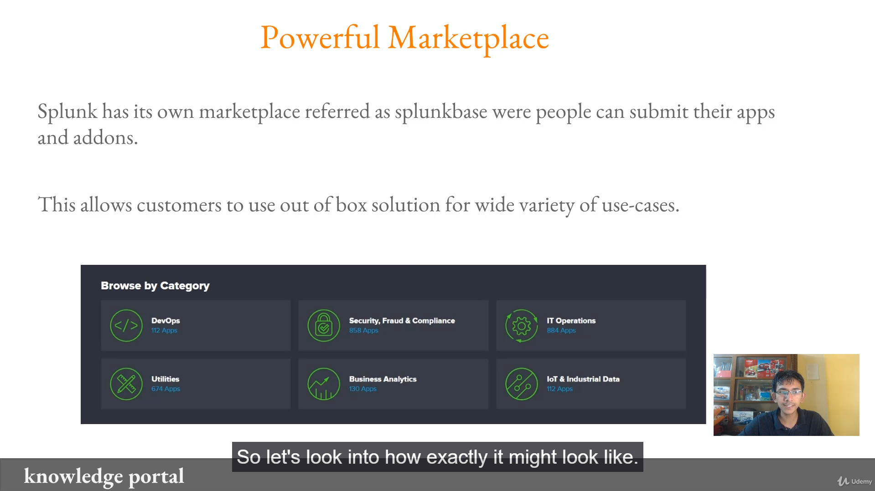

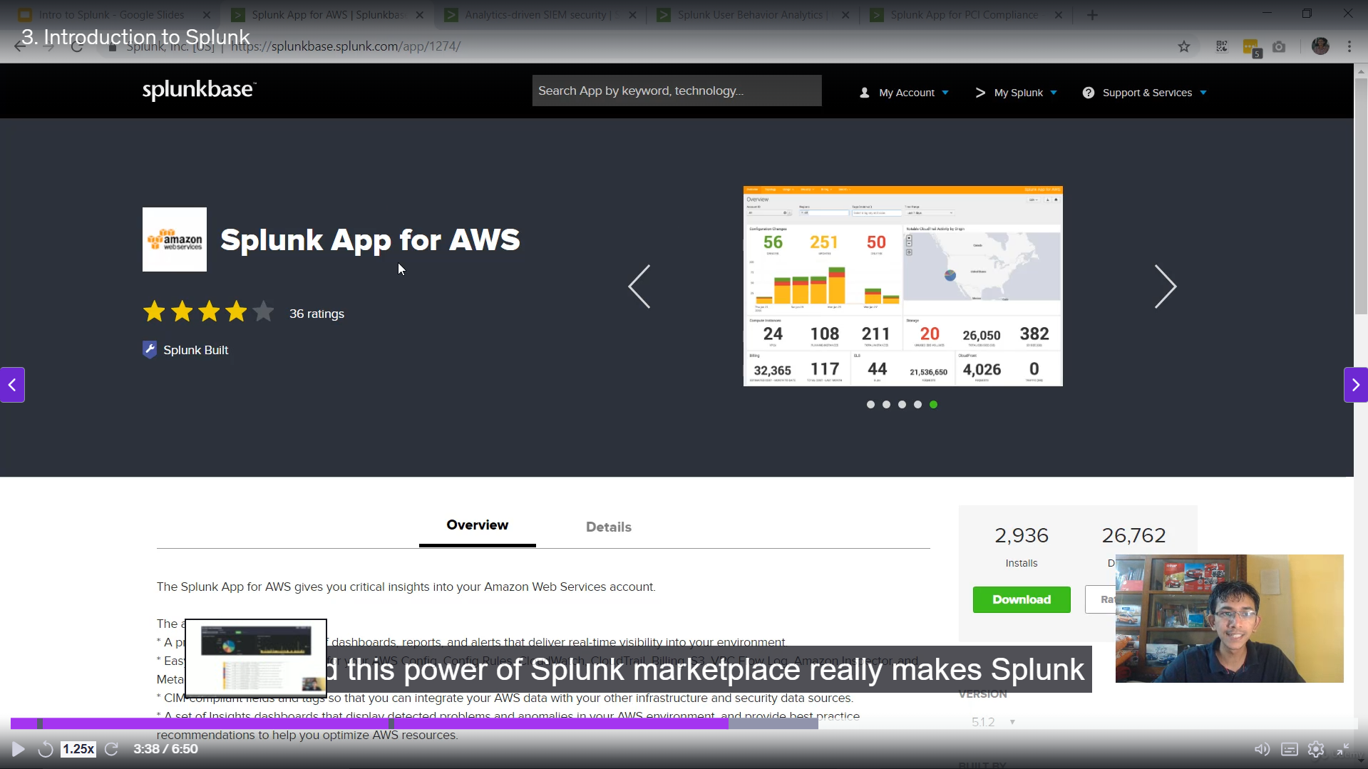

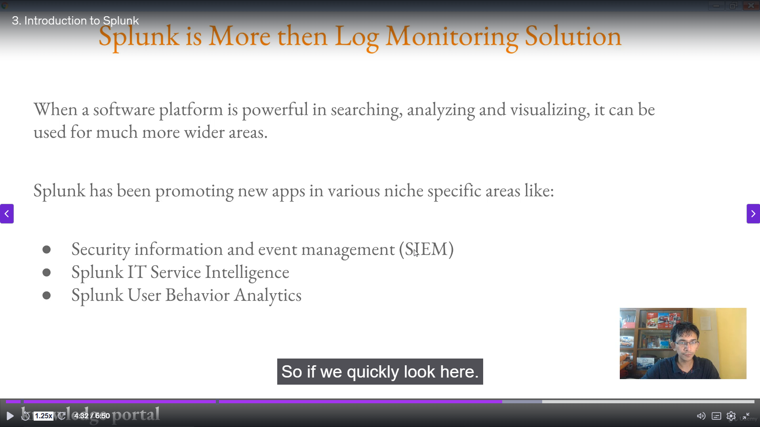

This is a summary of the introductory video on Splunk, highlighting its core functions, key features, and strategic positioning in the industry.

**Introduction to Splunk Summary**

**1. Splunk as a Platform**

* **Definition:** Splunk is one of the most popular **log analyzing and monitoring tools** in the industry.
* **Core Functionality:** It is a software platform that allows users to **search, analyze, and visualize machine-generated data**.
* **Data Sources:** This data can be gathered from a wide variety of devices, including:
  + Servers
  + Active Directory
  + Applications
  + Virtual Machines
  + Databases, etc.
* **Output:** By running queries, users can quickly generate meaningful **dashboards** (often in minutes) and **prioritize events** based on severity (e.g., using red for critical, yellow for warnings, and blue for informational).

**2. The Power of the Splunk Ecosystem**

* **Splunkbase (Marketplace):** A major feature that makes Splunk powerful is its marketplace, known as **Splunkbase**, where people and organizations submit their own applications and add-ons.
* **Out-of-the-Box Solutions:** This marketplace allows customers to use ready-made, out-of-the-box solutions for various use cases, similar to the app ecosystem of Android or iOS.
* **Extensive Categories:** Apps are available for numerous categories, including:
  + IT Operations
  + Security, Fraud, and Compliance
  + DevOps
  + Utilities
* **Example: AWS Integration:** Ready-made apps, such as the "Splunk App for AWS," contain pre-built dashboards and functionalities. Users only need to download and install them to gain immediate, comprehensive monitoring capabilities.

**3. Splunk's Evolution Beyond Basic Log Analysis**

* **Ease of Use:** Splunk has gained popularity due to its **ease of learning** and its powerful **Splunk Query Language (SPL)**.
* **Niche-Specific Applications:** Splunk has developed and promoted specialized applications for niche areas:
  + **SIEM (Security Information and Event Management):** Splunk Enterprise Security (an app installed on Splunk Enterprise) provides powerful dashboards and capabilities for security anomaly detection.
  + **IT Operations:** Splunk IT Service Intelligence.
  + **User Behavior:** Splunk User Behavior and Analytics.
* **Compliance:** Splunk offers apps for regulatory frameworks, such as the **Splunk App for PCI Compliance**, which helps management and auditors assess compliance status and identify improvement areas.

**4. Industry Recognition**

* **SIEM Magic Quadrant:** Although Splunk was initially a "big data, log monitoring" tool, the introduction of the **Splunk Enterprise Security** app has positioned it as one of the **top solutions** in the SIEM Magic Quadrant.
* **Reason for Success:** This success is attributed to its powerful log analysis, monitoring, and SPL capabilities.

===================================================================================

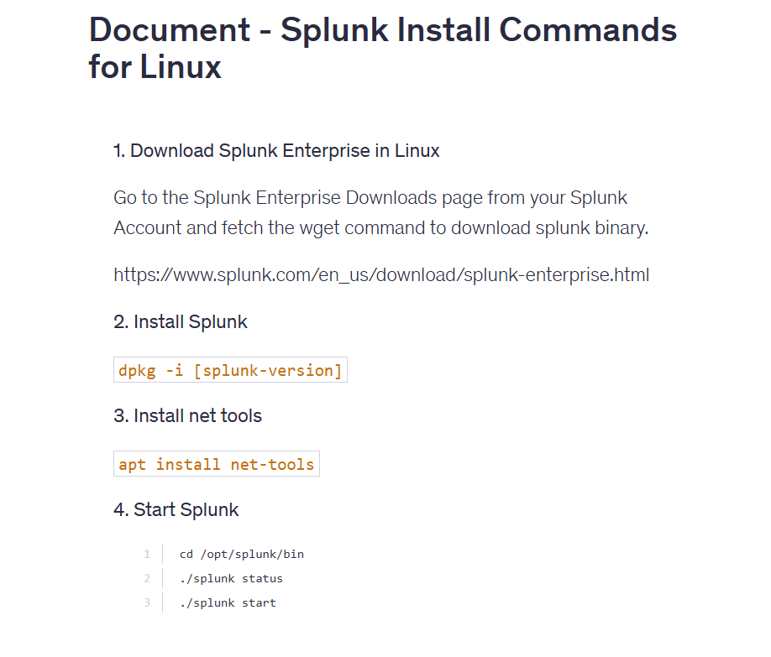

******************************************************************************************************************************************************************************************************************************************************************************************

**Section 3: Getting started with Splunk:**

1. **Onboarding data into Splunk:**

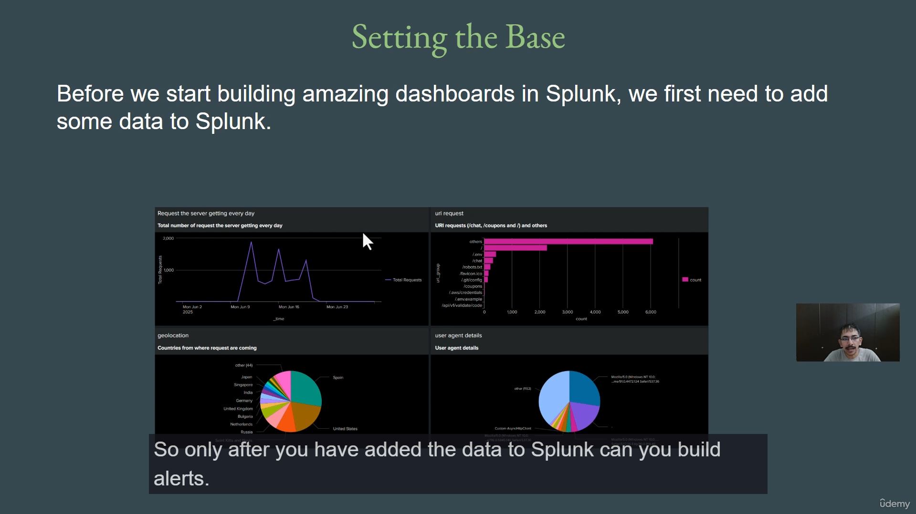

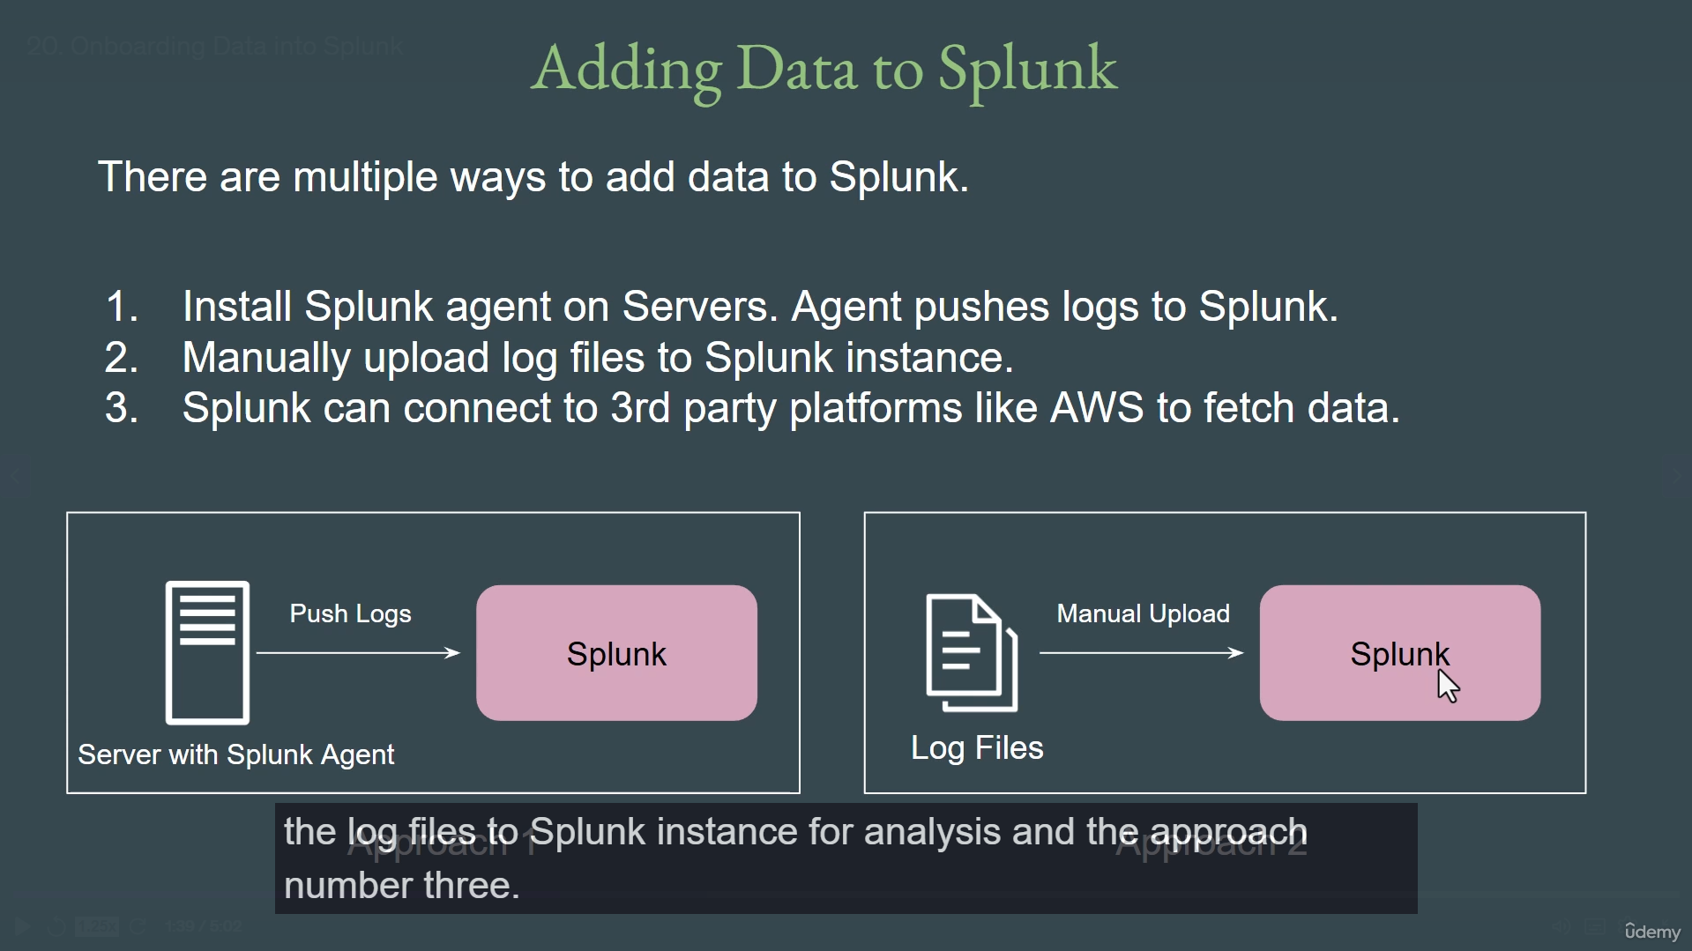

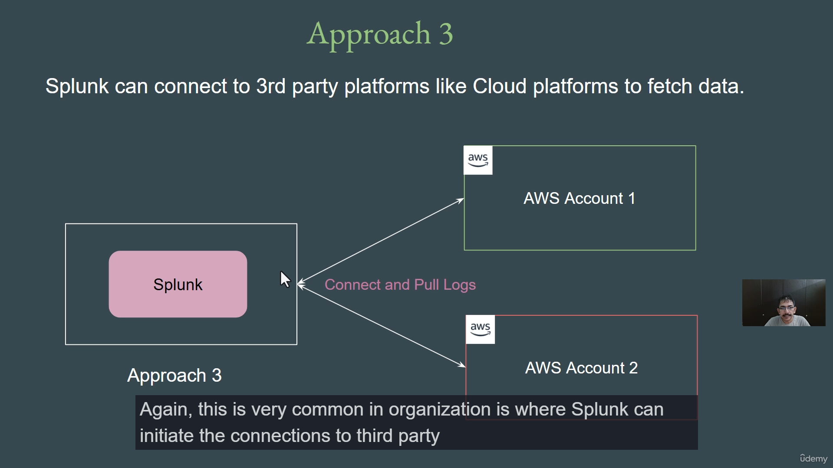

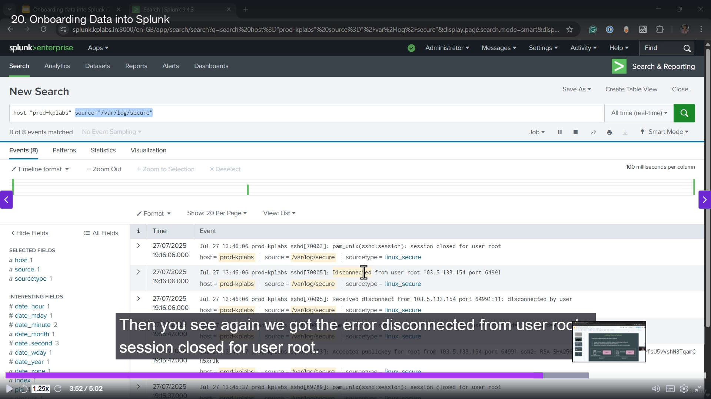

**Onboarding Data to Splunk Summary (Data Ingestion Methods)**

**1. Prerequisite: Data Ingestion**

* **Necessity:** Before you can build dashboards, create alerts, or correlate data in Splunk, the foundational prerequisite is to **add data to the Splunk instance**.

**2. Three Main Approaches for Data Ingestion**

There are multiple ways to ingest data into Splunk, with three main approaches common in production environments:

**Approach 1: Using the Splunk Agent (Forwarder)**

* **Mechanism:** This is the most common method in large organizations. A **Splunk Agent (called a Forwarder)** is installed directly on the servers (Linux, Windows, etc.).
* **Process:** The agent actively runs on the server and pushes all generated logs to the central Splunk instance.
* **Performance:** Data transfer is nearly **instantaneous** (real-time/near real-time), as demonstrated by a live SSH login/logout example where the logs appeared in Splunk immediately.

**Approach 2: Manual Upload of Log Files**

* **Mechanism:** Users can manually upload log files directly to the Splunk instance.
* **Process:** This is typically done through the Splunk Graphical User Interface (GUI) by selecting the "Upload" option and choosing the file from a local computer.
* **Use Case:** This method is generally used for analysis of specific, static log files rather than for continuous, real-time monitoring.

**Approach 3: Connecting to Third-Party Platforms**

* **Mechanism:** Splunk initiates a connection to pull data from external, third-party platforms, most commonly cloud providers like AWS.
* **Process:** Since agents cannot be installed directly on a cloud account, you provide Splunk with the necessary platform credentials (e.g., AWS account credentials). Splunk then regularly connects to the platform to fetch the latest data and events.
* **Goal:** This enables necessary visualization, analysis, and alert creation based on the data pulled from the external platform.

**3. Course Progression**

* The remainder of the course will explore **each of these ingestion methods in great detail practically**, including important considerations for using each approach in a production environment.

===================================================================================

1. **Importance of Source Types:**

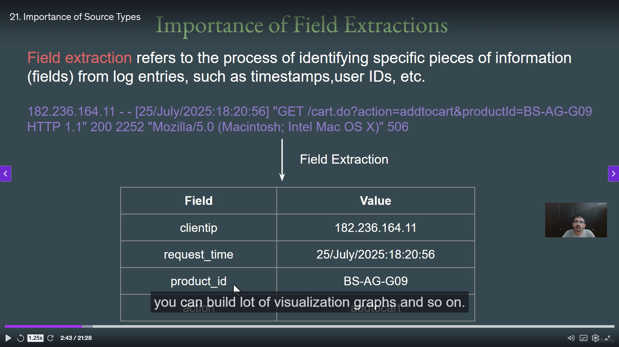

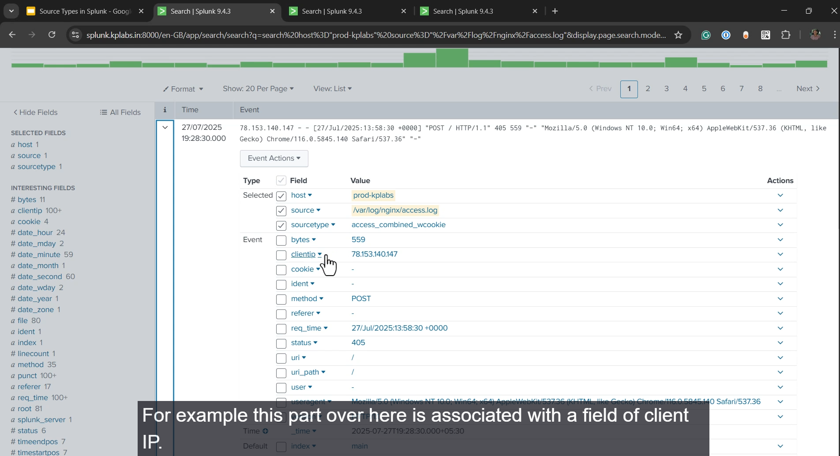

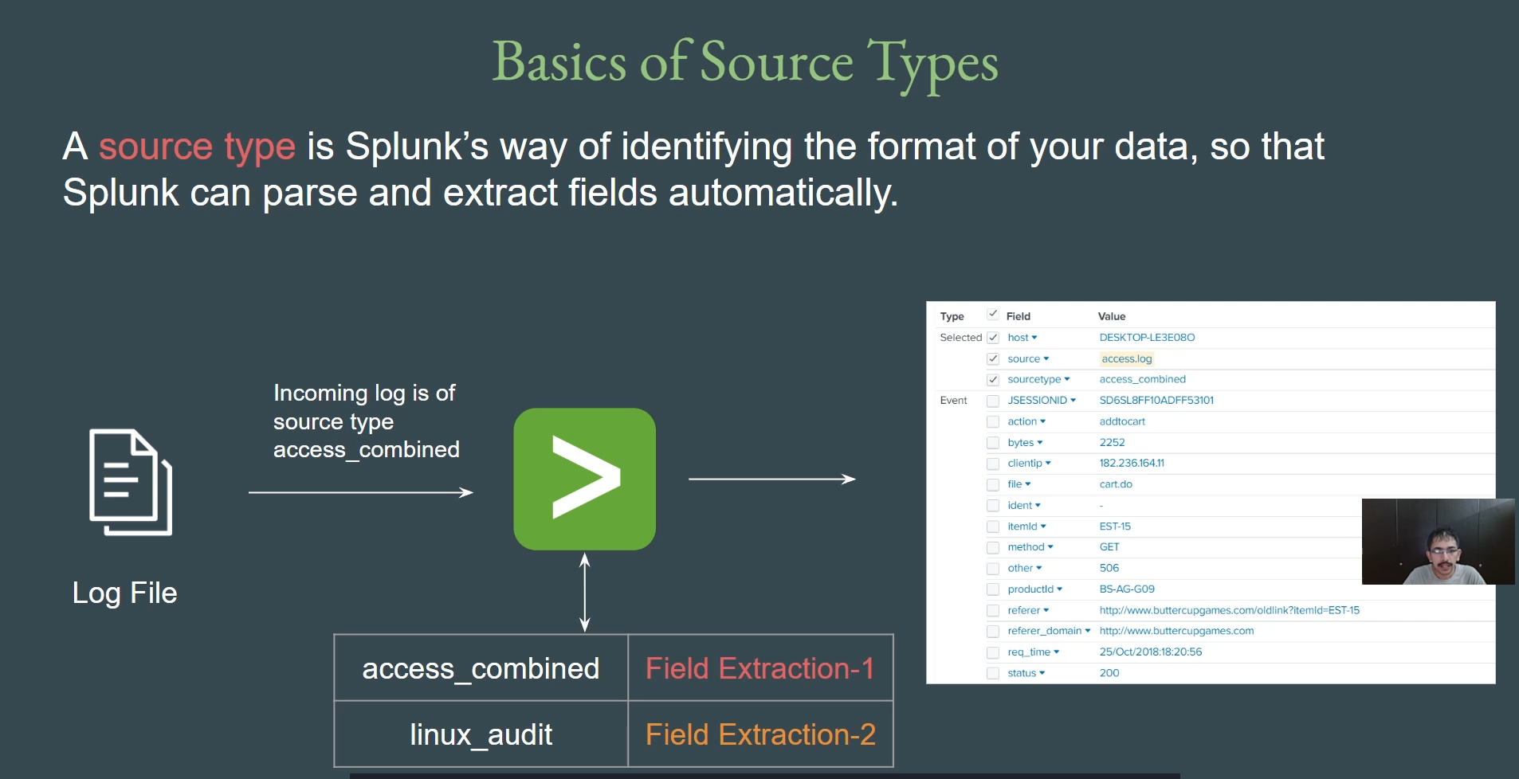

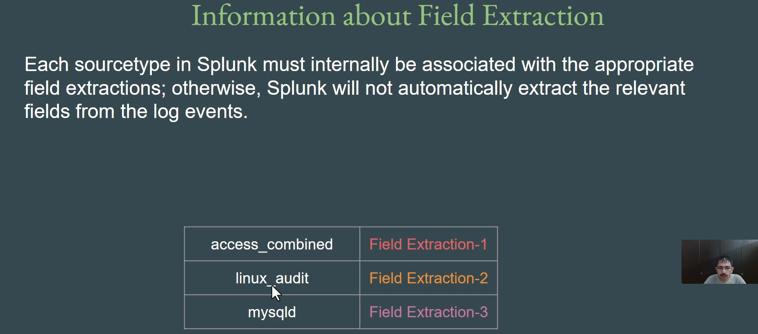

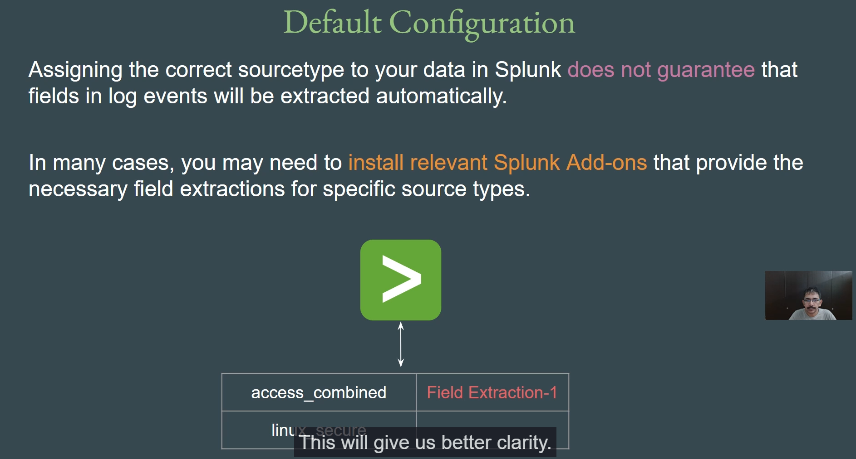

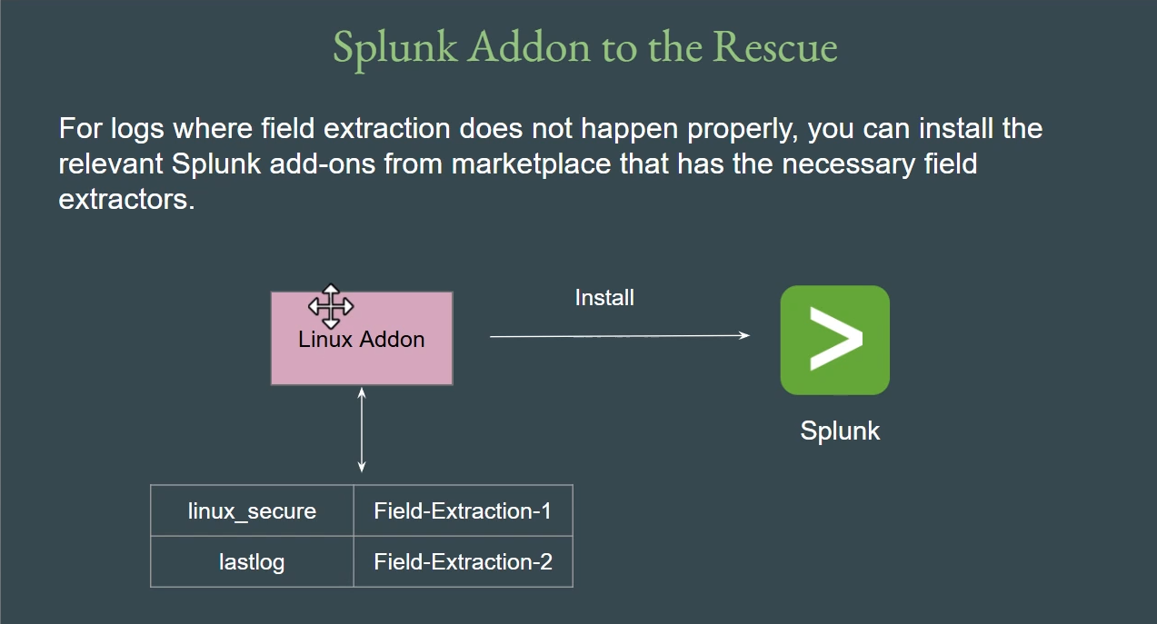

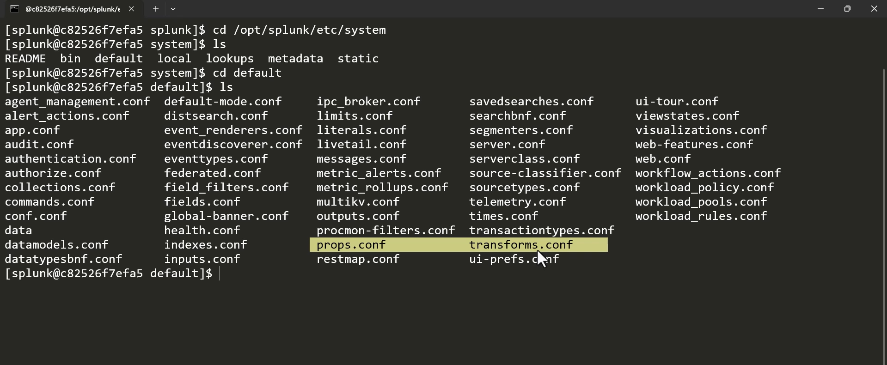

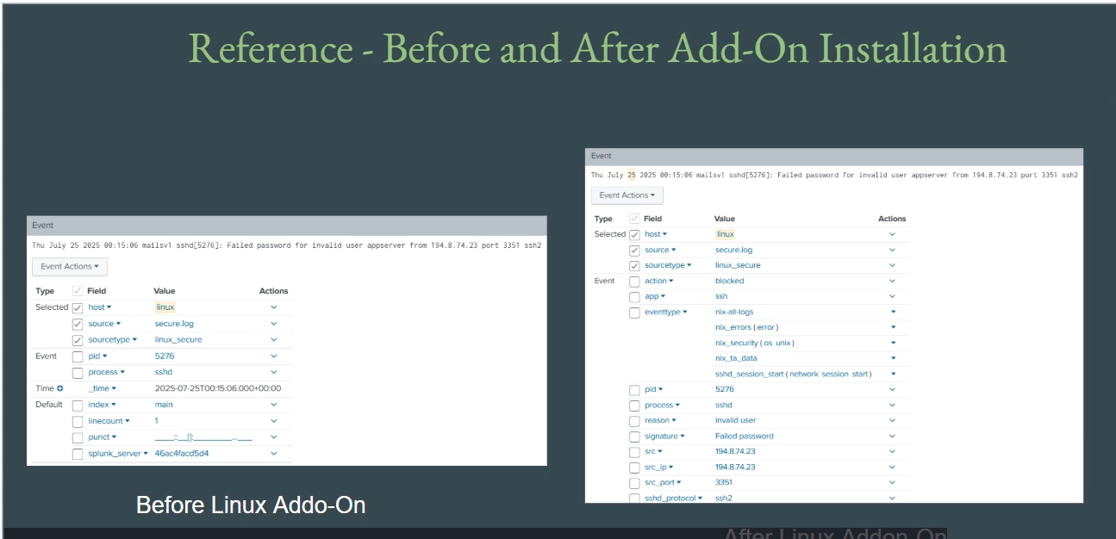

**Source Types and Field Extraction in Splunk Summary**

**1. The Importance of Field Extraction**

* **Definition:** **Field Extraction** is the critical process of identifying and isolating specific pieces of information from raw log entries, such as **timestamps, IP addresses, user IDs, request details, and status codes.**
* **Goal:** It breaks down a large, complex log event into smaller, named fields (e.g., client_IP, request_time, product_ID).
* **Why It Matters:** Correct field extraction is the foundation for all subsequent Splunk activities. If fields are extracted correctly, creating **dashboards, alerts, visualizations, and effective data analysis** becomes much simpler.

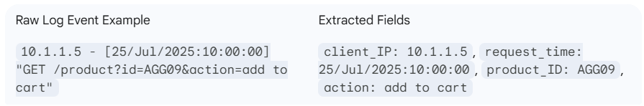

**2. The Role of Source Type**

* **Source Type Definition:** A **Source Type** is Splunk's way of identifying the **format of your incoming data**. It tells Splunk how to parse the data and which extraction rules to apply.
* **Mechanism:**
  1. When data is ingested, a **Source Type** is assigned (e.g., access_combined for Apache/Nginx logs).
  2. Splunk internally associates that Source Type with predefined **Field Extraction regular expressions (regex)**.
  3. The log event is passed through the regex, and individual fields are extracted.
* **Correct vs. Incorrect Source Type:**
  1. **Correct Source Type:** Ensures that the appropriate regex is used, leading to fields being perfectly extracted, making the data easily searchable and analyzable.
  2. **Incorrect Source Type:** Leads to improper or non-existent field extraction, effectively "messing up" the event and making it impossible to perform meaningful analysis or create effective queries.

**3. Field Extraction: Default Configuration vs. Add-ons**

* **Default Splunk Limitations:** Splunk provides default field extractions for common Source Types (e.g., access_combined has built-in regex to extract HTTP log fields). However, for many other log types, the **default configuration may lack the necessary, detailed regex** for proper field extraction.
  + *Example:* For the Linux_secure log, the default regex might only extract the **PID** and **Process**, leaving out critical fields like the **Source IP** or the **User Name**.
* **The Solution: Splunk Add-ons:** When default field extractions are insufficient, the recommended solution is to install the **relevant Splunk Add-ons** from Splunkbase.
  + **Add-on Function:** Add-ons (e.g., "Splunk Add-on for Unix and Linux," or the "AWS Add-on") come pre-configured with the **necessary, detailed field extraction regex** for that specific data source.
  + **Outcome:** Installing the correct add-on immediately enables complete and accurate field extraction for the associated logs.
* **Custom Regex (Worst Case):** For highly customized log events unique to an organization, where no add-on exists, users can **create their own custom regular expressions (regex)** to ensure proper field extraction.

**4. Key Takeaways**

* **Set the Right Source Type:** Always assign the correct, **standard Source Type** when ingesting data. This is crucial because add-ons are often configured to specifically look for and process data associated with those standard source types (e.g., the Linux add-on expects logs to be of source type Linux_secure).
* **Field Extraction is Core:** The ultimate goal is always to have correctly extracted fields, as this is what allows for powerful analysis, visualization (graphs showing top IP addresses, etc.), and command generation.

===================================================================================

1. **Importing Data to Splunk:**

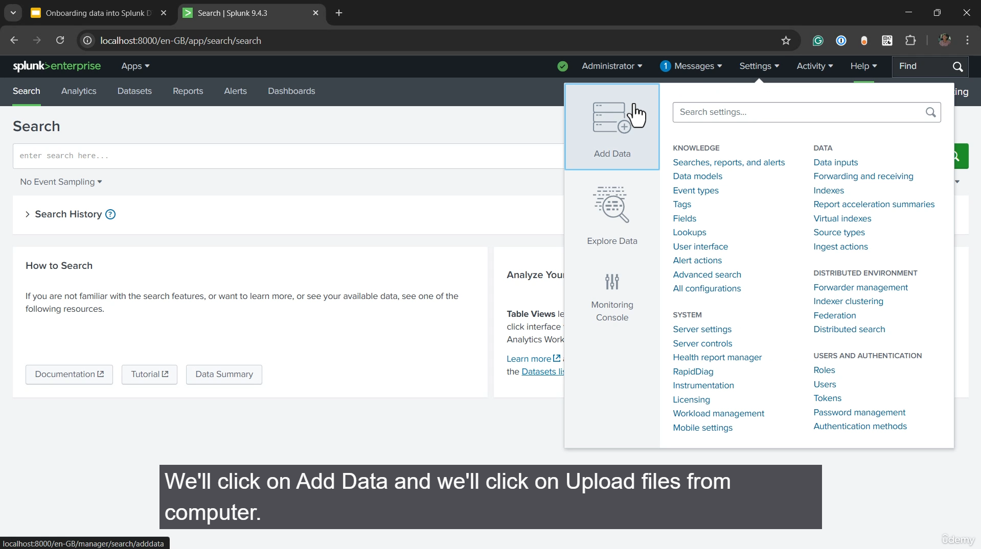

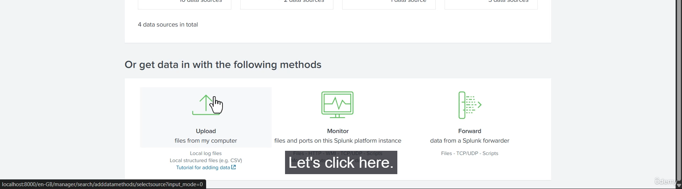

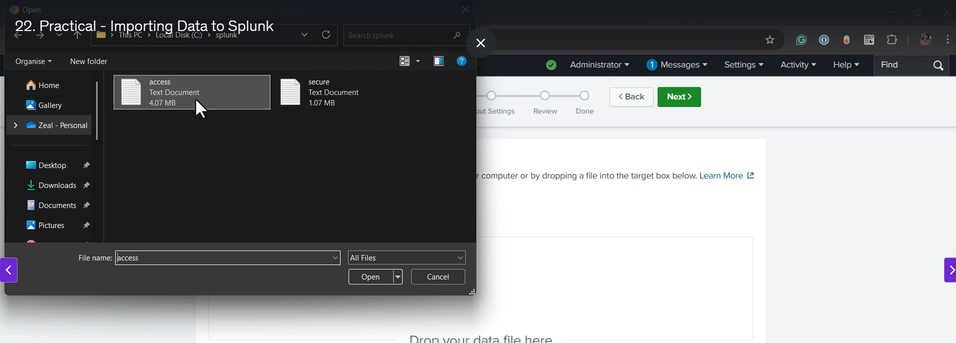

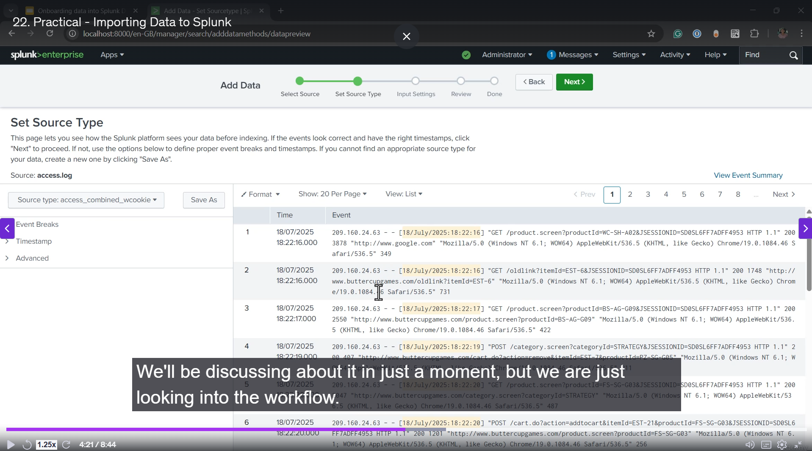

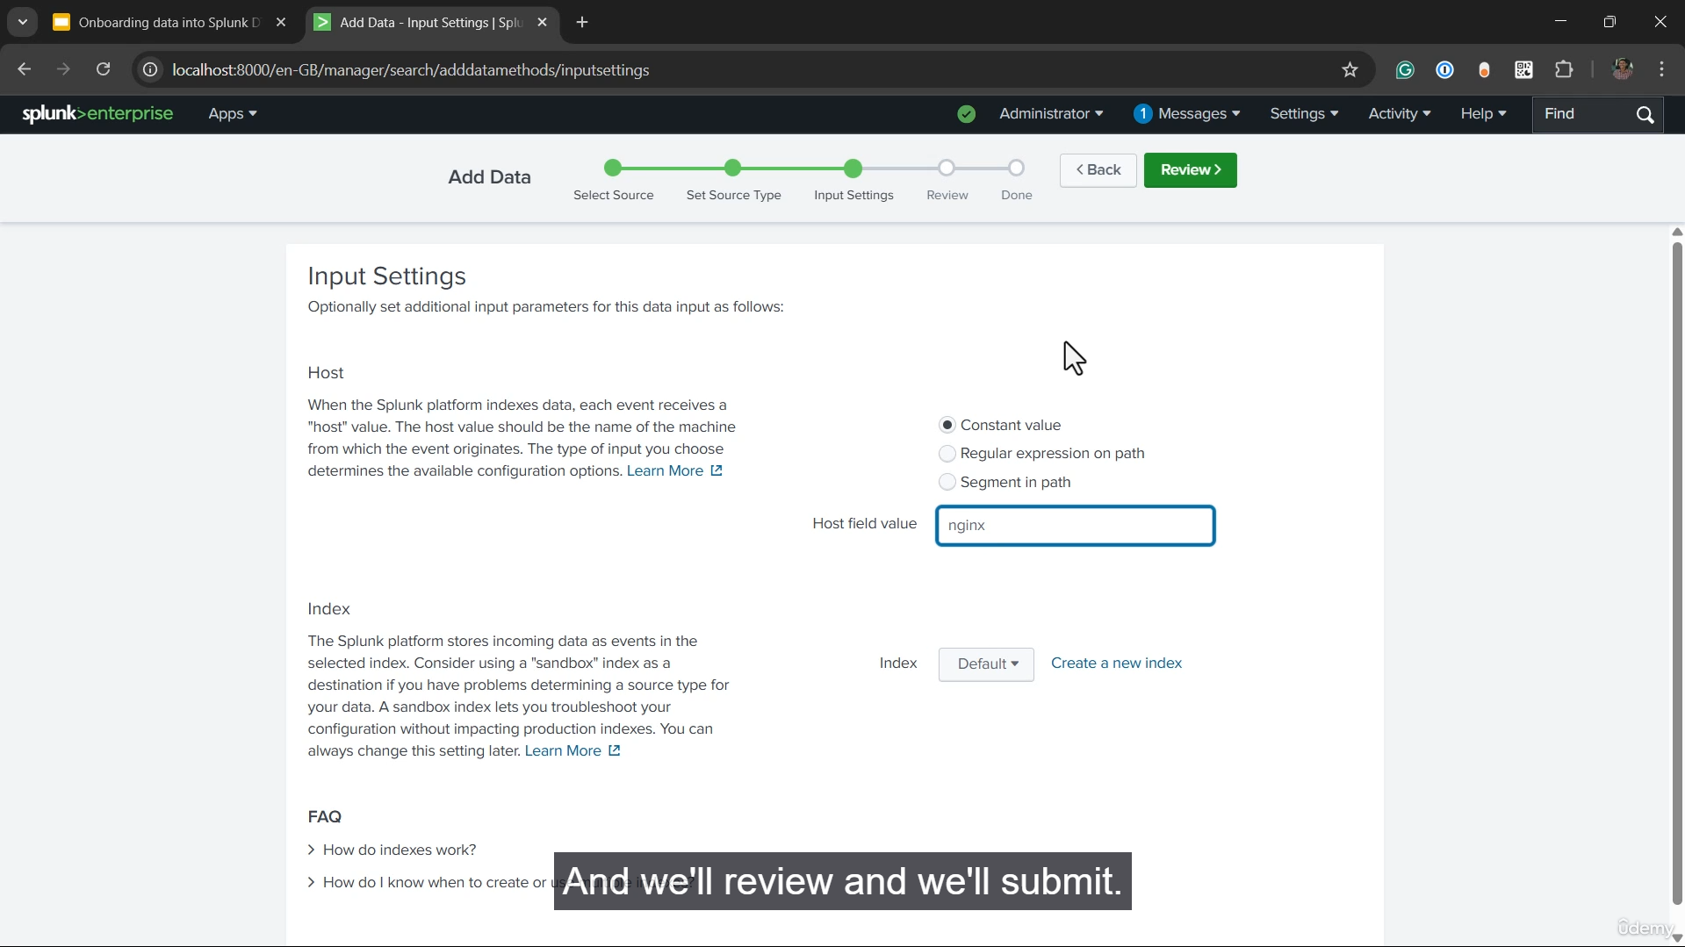\

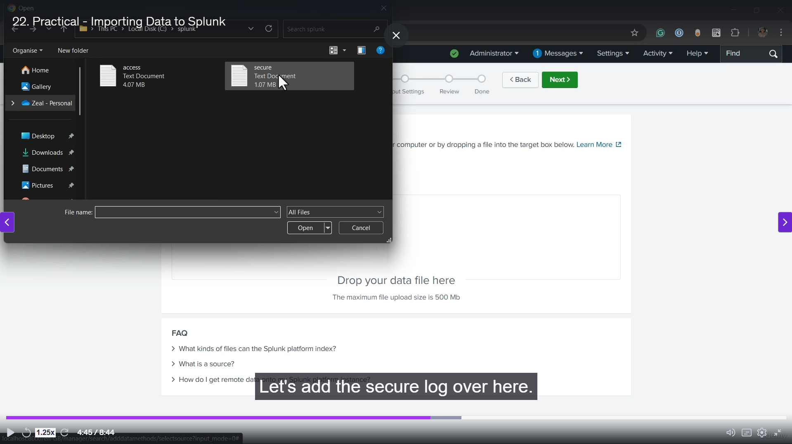

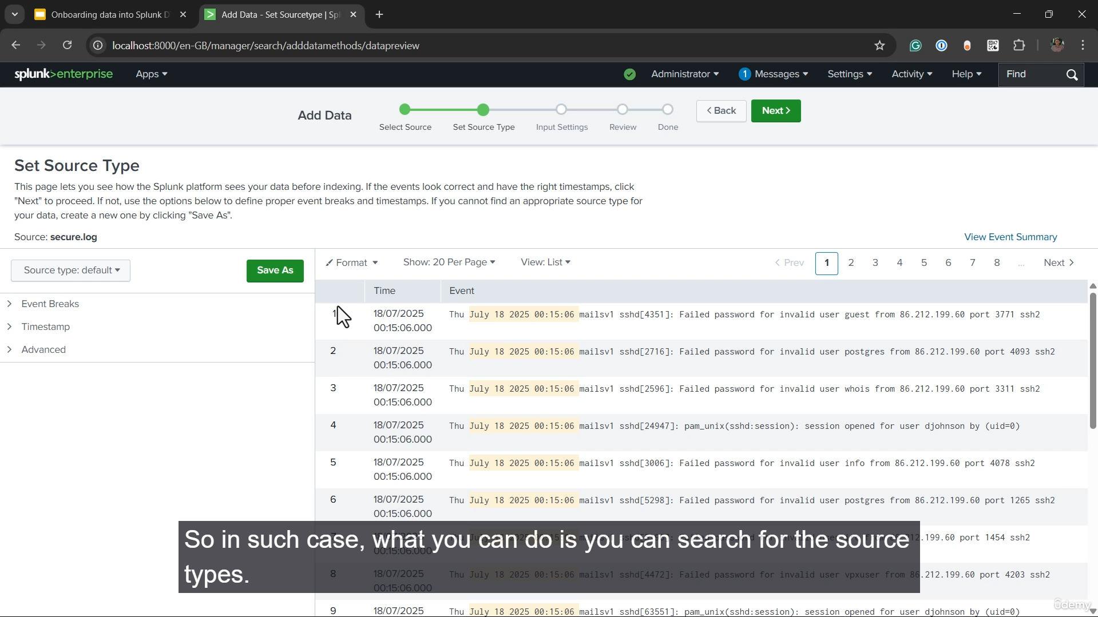

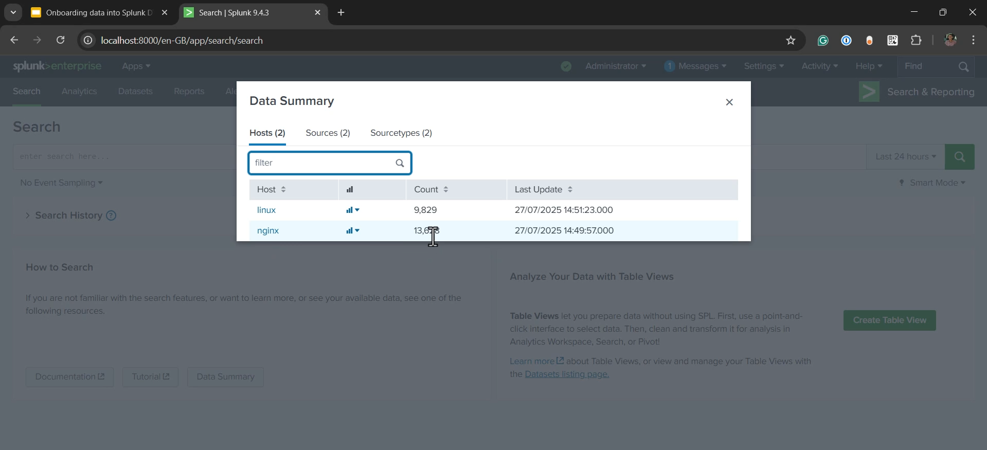

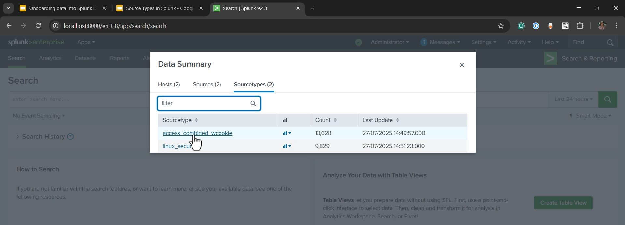

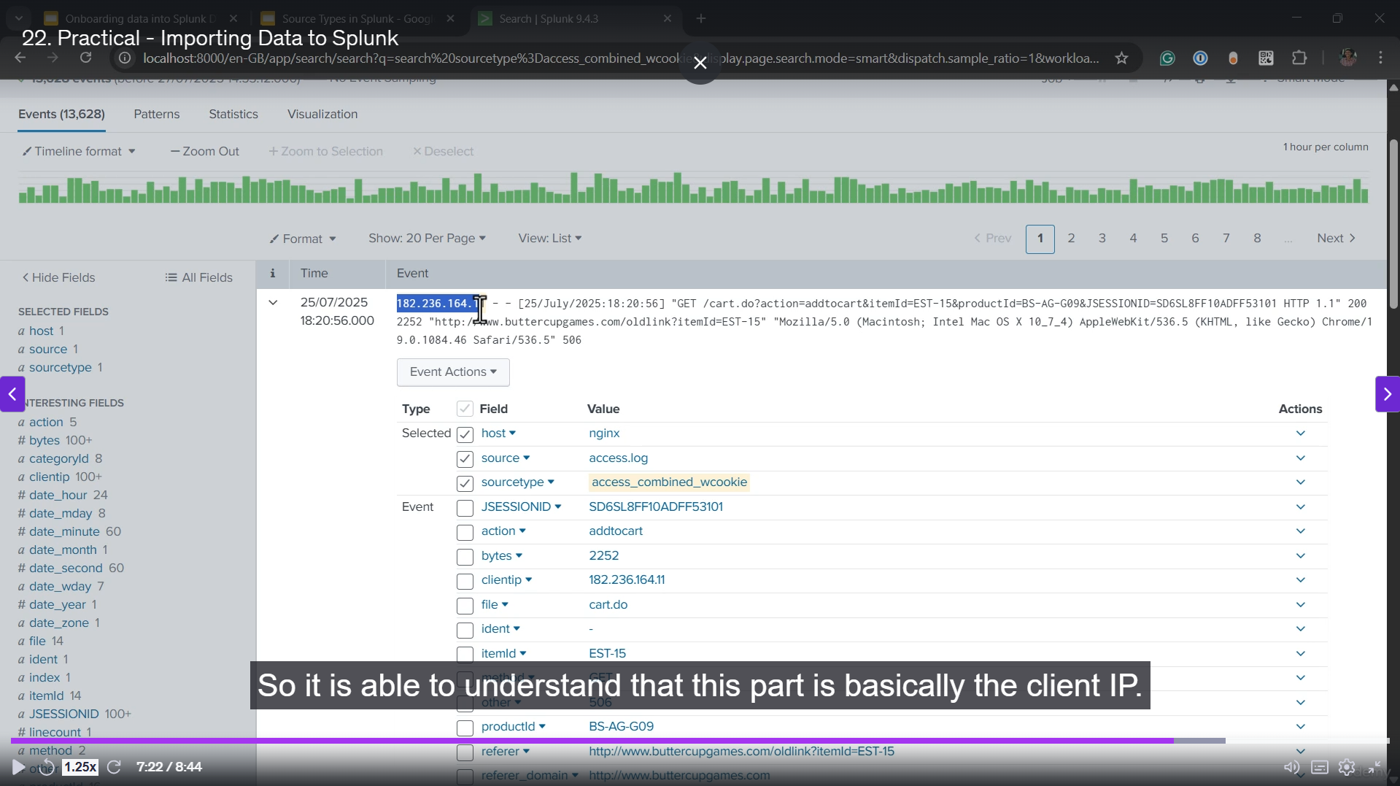

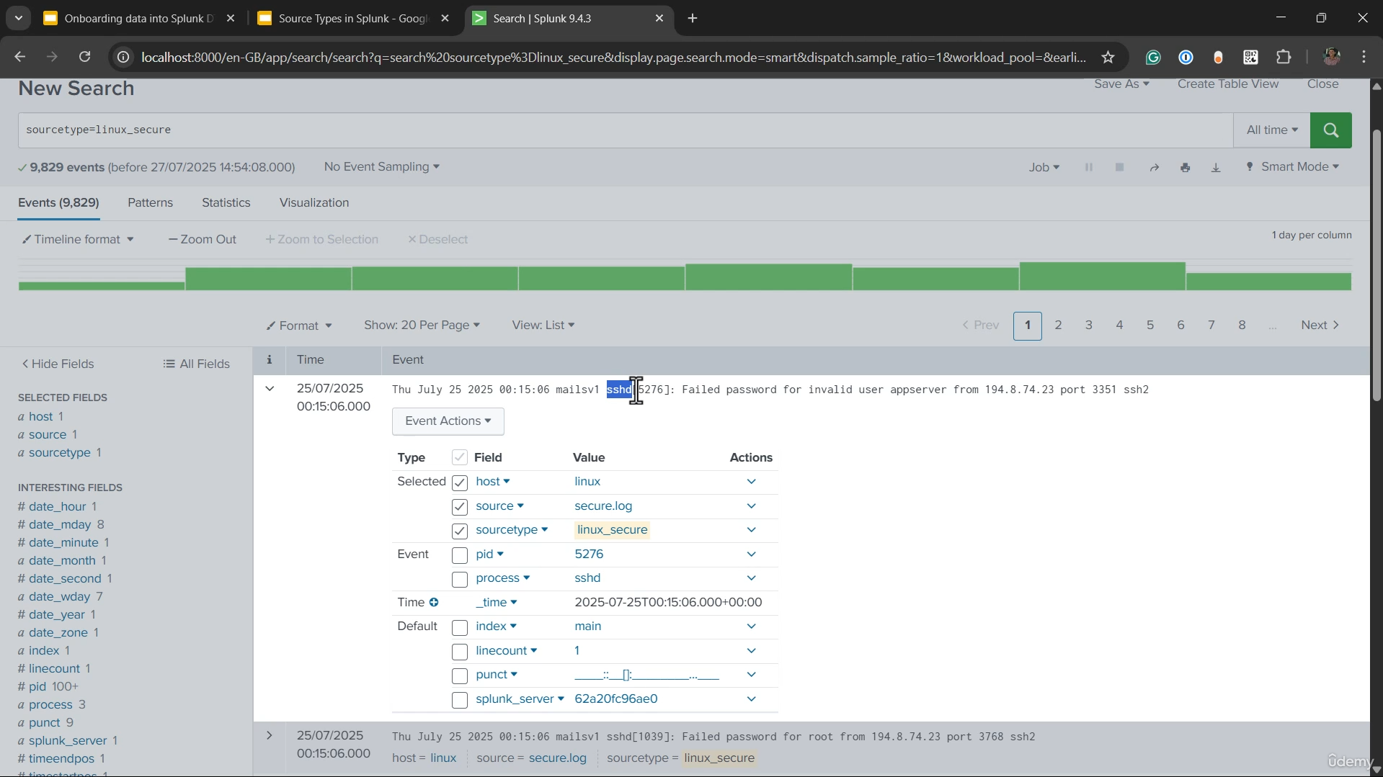

**Data Onboarding via Manual Upload Summary**

**1. Prerequisite and Goal**

* **Prerequisite:** Data is the essential prerequisite for building dashboards, creating alerts, and correlating information in Splunk.
* **Goal:** This video demonstrates the simplest ingestion method: **manual upload** of log files to a Splunk instance.
* **Future Focus:** The course will later cover more advanced, automated methods like installing the **Splunk Agent (Forwarder)** on Linux servers to push real-time logs.

**2. Log Files Used for Demonstration**

The demonstration uses two common log files found in production environments:

* **Access Log:**
  + Typically generated by web servers like **Apache** or **Nginx**.
  + Contains events related to every request the web server receives.
  + The sample file contains around 13,000 events.
* **Secure Log:**
  + Found on **Linux servers** (usually /var/log/secure).
  + Contains all security-related messages, such as successful or failed **SSH login attempts**.
  + The sample file contains around 10,000 events.

**3. Step-by-Step Manual Upload Process**

1. **Navigate to Upload:** Go to Settings $\rightarrow$ Add Data $\rightarrow$ Upload files from computer.
2. **Upload Access Log:**
   * Select the access.log file.
   * **Source Type Detection:** Splunk automatically detected the appropriate source type as **access_combined_w_cookie**, which simplifies the field extraction process.
   * **Host Assignment:** The host field was manually set to **nginx**.
   * The file was successfully submitted.
3. **Upload Secure Log:**
   * Select the secure.log file.
   * **Source Type Selection:** Splunk was **not able to automatically detect** the source type for this file.
   * **Manual Assignment:** The instructor manually searched the source types under the "Operating System" category and selected **linux_secure** (described as the format for /var/log/secure).
   * **Host Assignment:** The host field was manually set to **Linux**.
   * The file was successfully submitted.

**4. Verification and Field Extraction Revisited**

After both files were uploaded, the **Data Summary** showed approximately 13,000 events for the Access Log and 10,000 events for the Secure Log.

* **Access Log (access_combined_w_cookie):**
  + **Result:** Field extraction worked **automatically**. Splunk successfully broke down the events into fields like client_IP, referrer, URI_path, and user_agent.
  + **Reason:** This is a very common source type for which the necessary field extraction rules are available by default in Splunk.
* **Secure Log (linux_secure):**
  + **Result:** Field extraction **did not work properly** by default. Only basic fields like **process (sshd)** and **PID** were extracted. Critical details like the **username, failure reason, or source IP** were missed.
  + **Reason:** The default Splunk configuration does not have detailed field extraction rules for all source types.
  + **Solution (Future Topic):** The necessary solution is to install the relevant **Splunk Add-on for Linux** (as discussed in the previous video) to enable proper field extraction.

===================================================================================

1. **Field Extraction – Linux Secure Logs:**

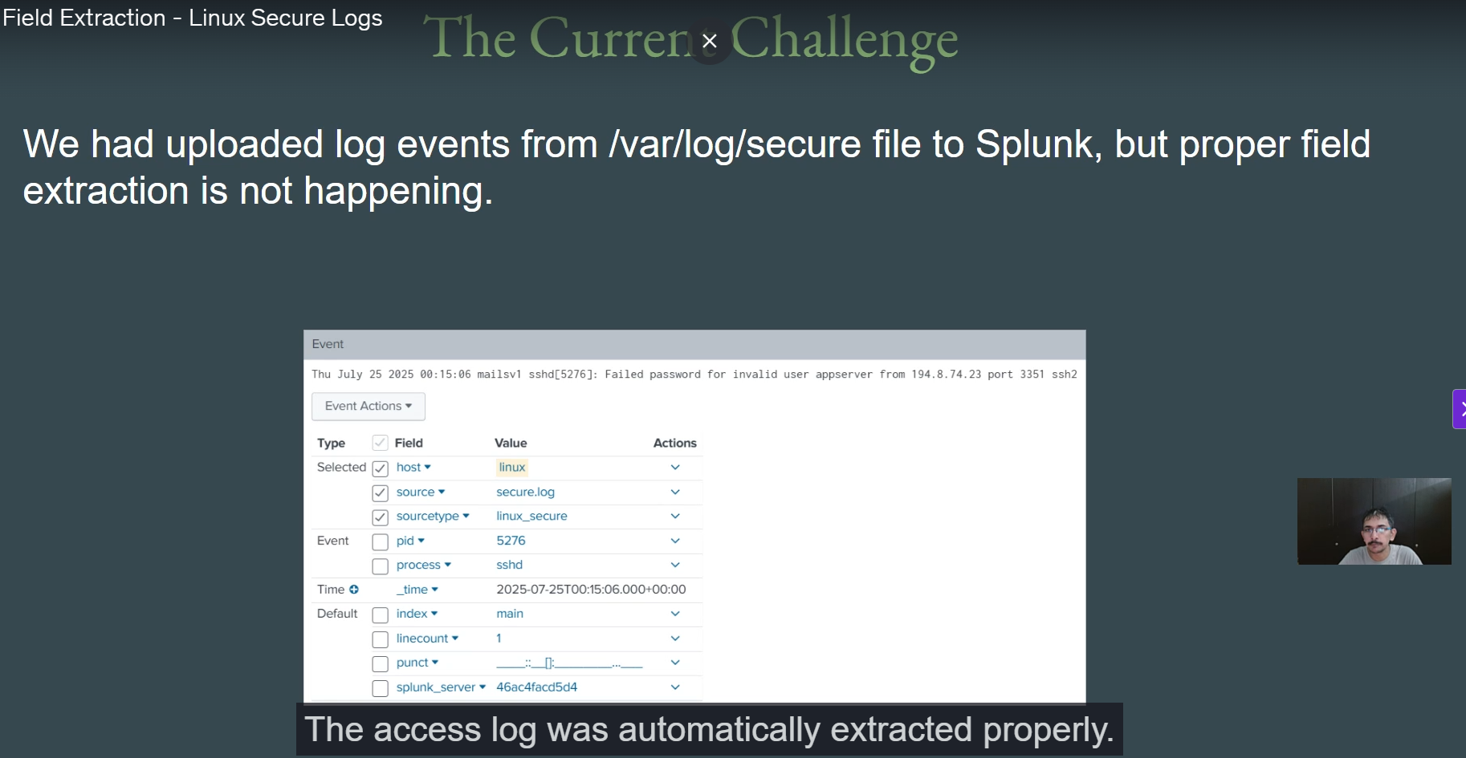

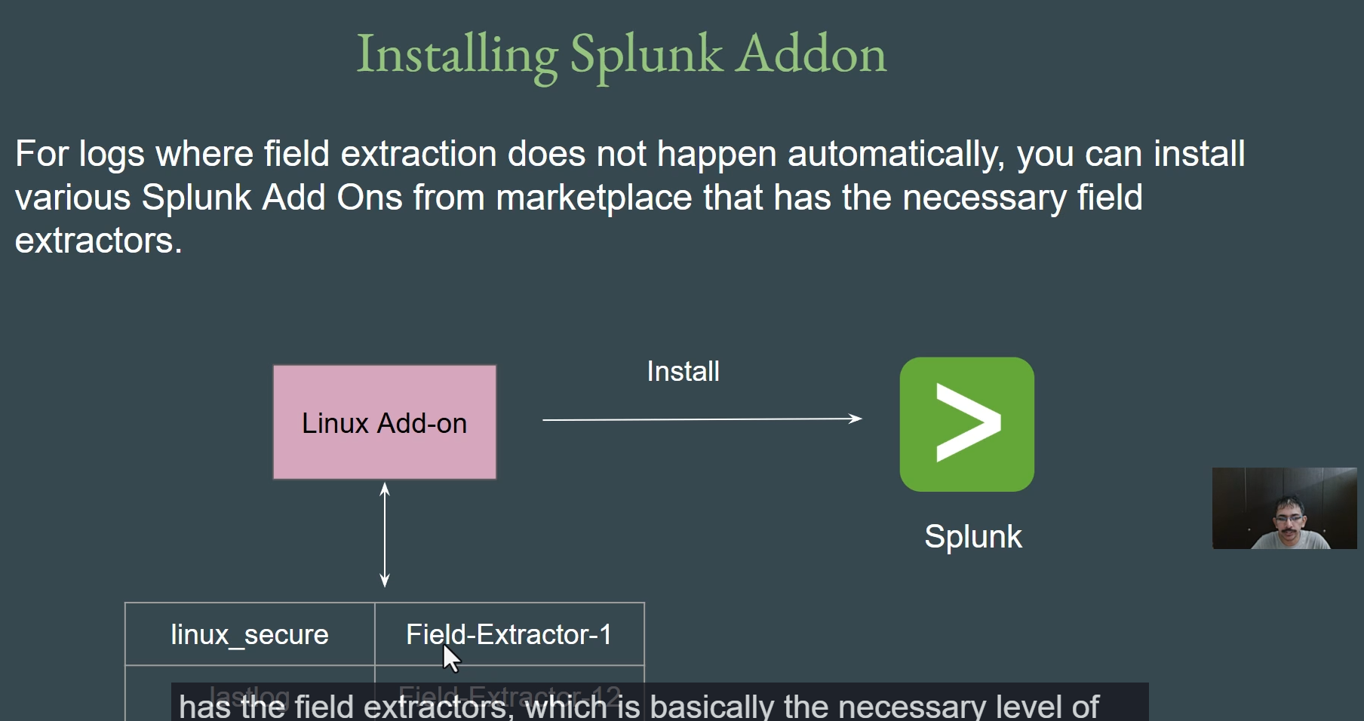

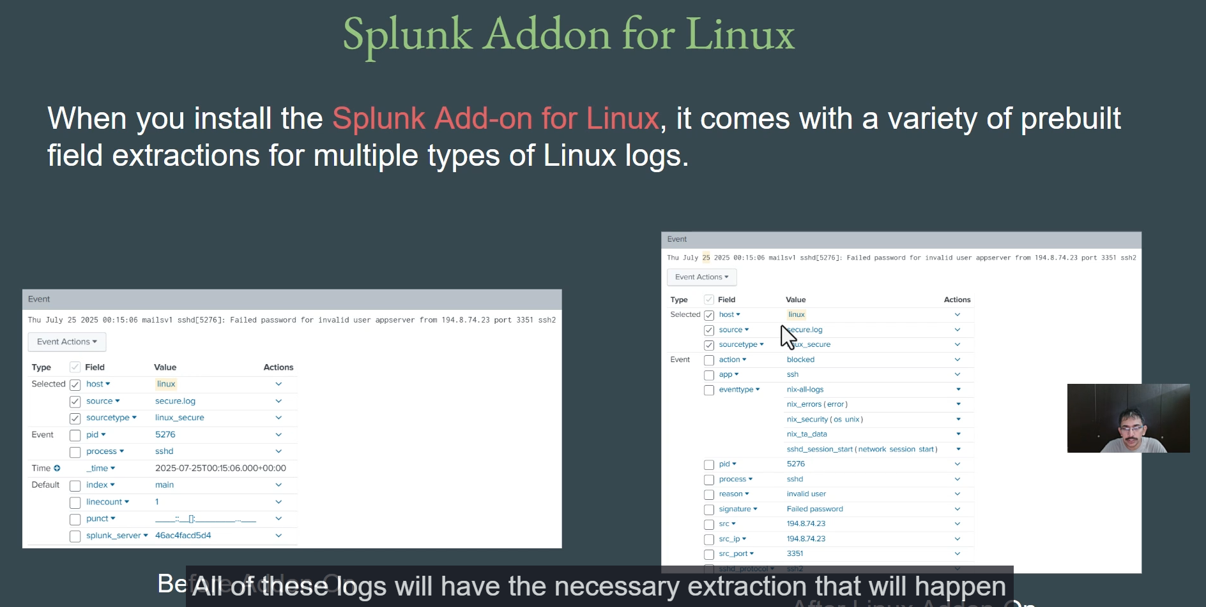

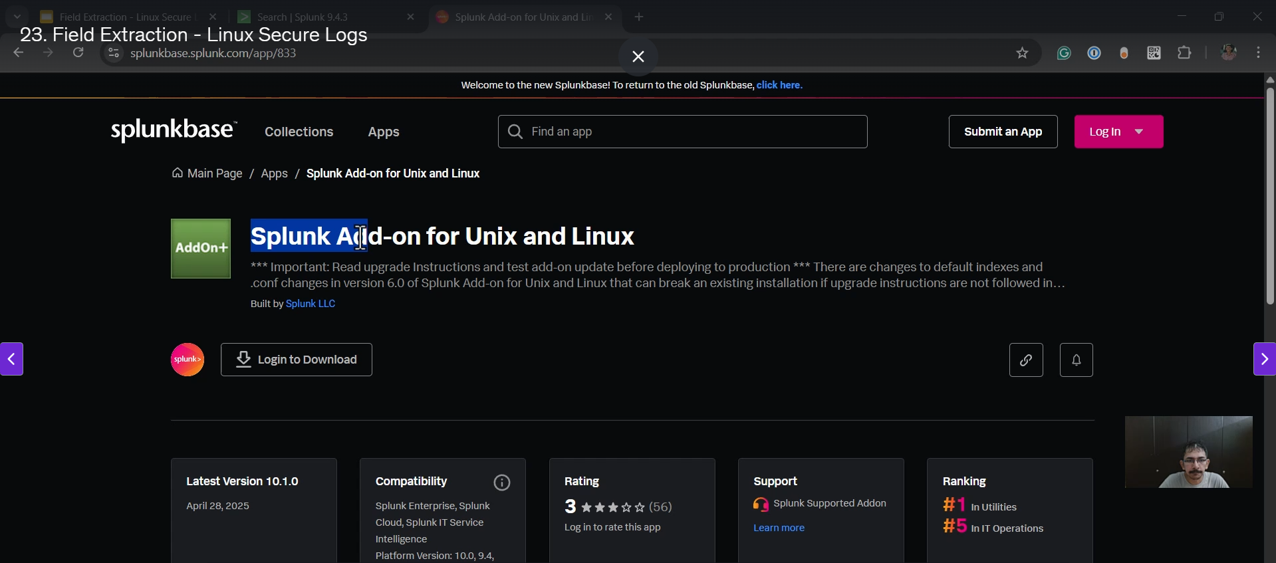

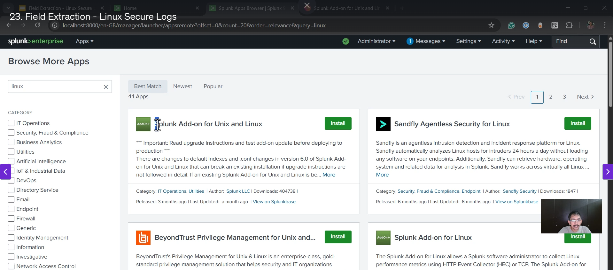

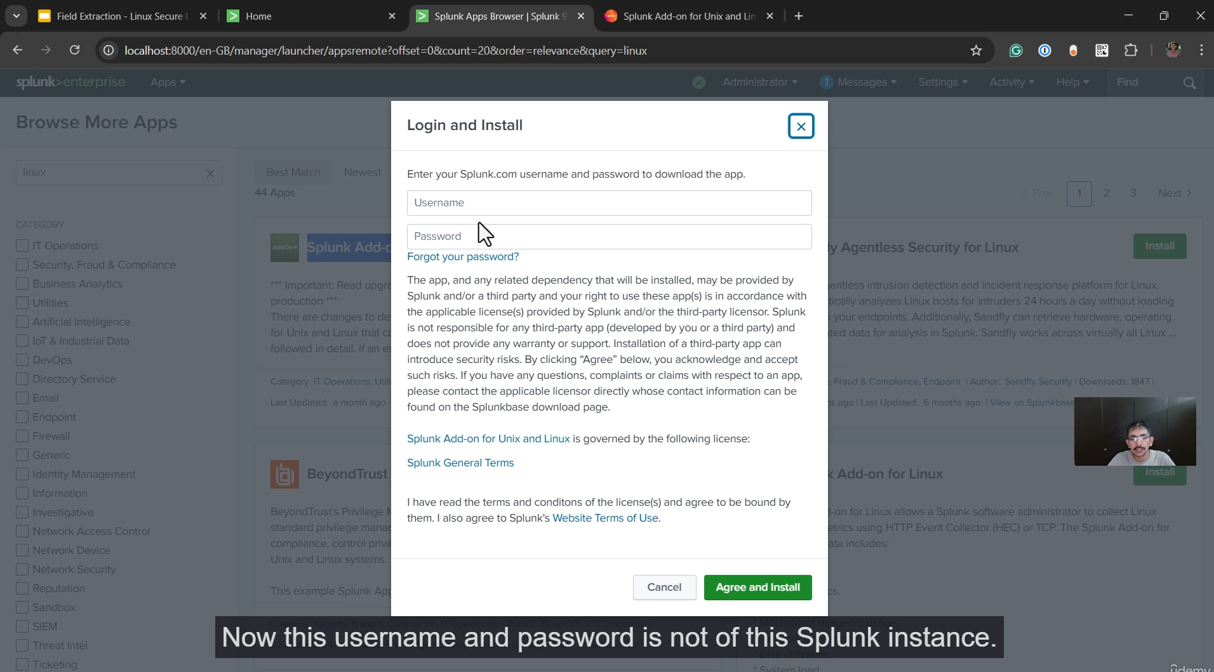

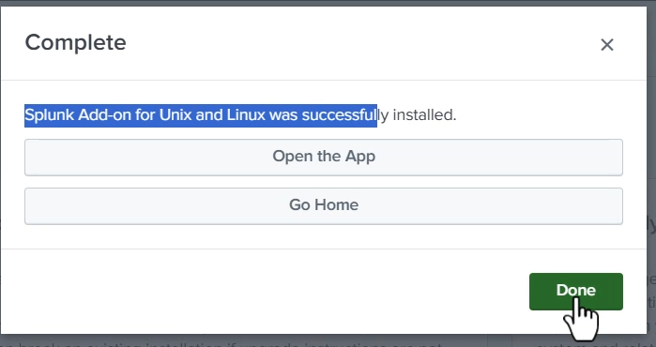

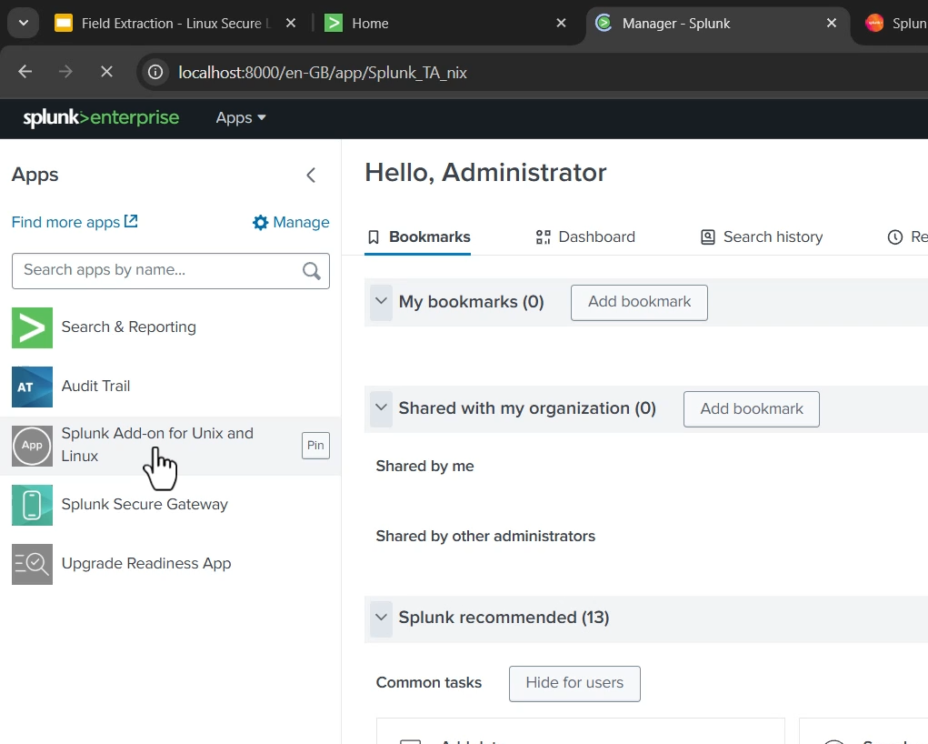

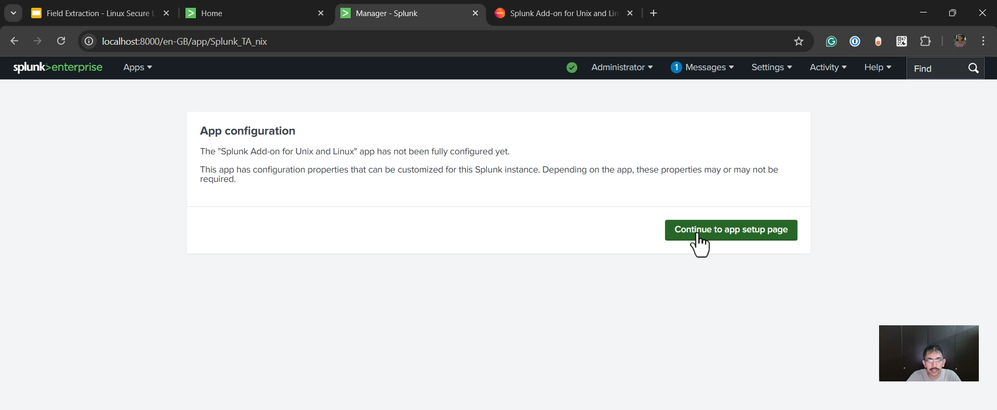

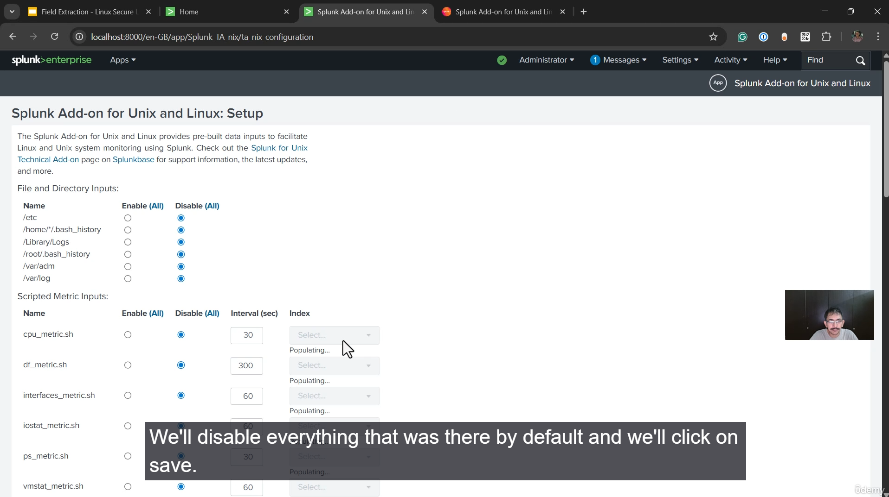

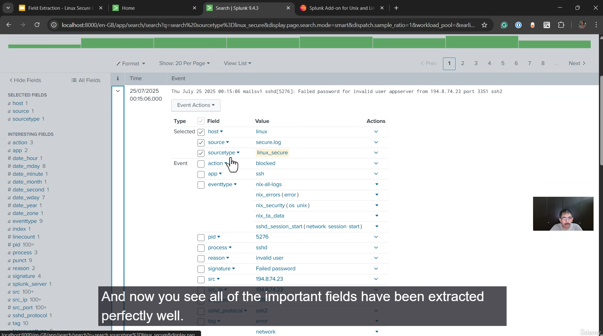

**Achieving Proper Field Extraction for Linux Secure Logs Summary**

**1. The Problem**

* In the previous step, two log files were manually uploaded: **Access Log** and **Secure Log**.
* The **Access Log** had its fields extracted **automatically** because its source type (access_combined_w_cookie) had built-in extraction rules.
* However, the **Secure Log**, despite being assigned the correct source type (linux_secure), had **improper field extractions** (only basic fields like process and PID were extracted, missing critical details like the source IP, port, and username).

**2. The Solution: Installing a Splunk Add-on**

* The easiest way to fix missing or incomplete field extractions is to install a **necessary Add-on** that provides the appropriate **Regular Expressions (regex)** for the specific log format.
* For Linux-level logs (like /var/log/secure), the required application is the **"Splunk Add-on for Unix and Linux."**

**3. Step-by-Step Installation Process**

1. **Locate the Add-on:** Navigate to the Splunk interface and click on **"Find More Apps."**
2. **Search and Install:** Search for the **"Splunk Add-on for Unix and Linux"** (built by Splunk LLC).
3. **Authentication:** Click "Install" and provide the **username and password for the user's Splunk account** (not the local Splunk instance login).
4. **Initial Configuration:** After successful installation, navigate to the new Add-on's page. The instructor disabled all default configurations and clicked **"Save"** to keep the initial setup simple.

**4. Verification of Field Extraction**

* After the Add-on installation and a brief waiting period (a minute or two), the instructor returned to the Search & Reporting app.
* By searching for the **Secure Log** events (sourcetype=linux_secure), the results showed that all **important fields were extracted perfectly well**:
  + **Source IP**
  + **Source Port**
  + **User Name** (e.g., app server)
  + **Reason** (e.g., invalid user)
  + **Main Message** (e.g., Failed password)

**5. Conclusion**

* Installing the correct Add-on is crucial for ensuring that field extractions are done properly for all ingested data, which is a prerequisite for building reliable dashboards and alerts in the later stages of the course.

===================================================================================

1. **Basics Of Search:**

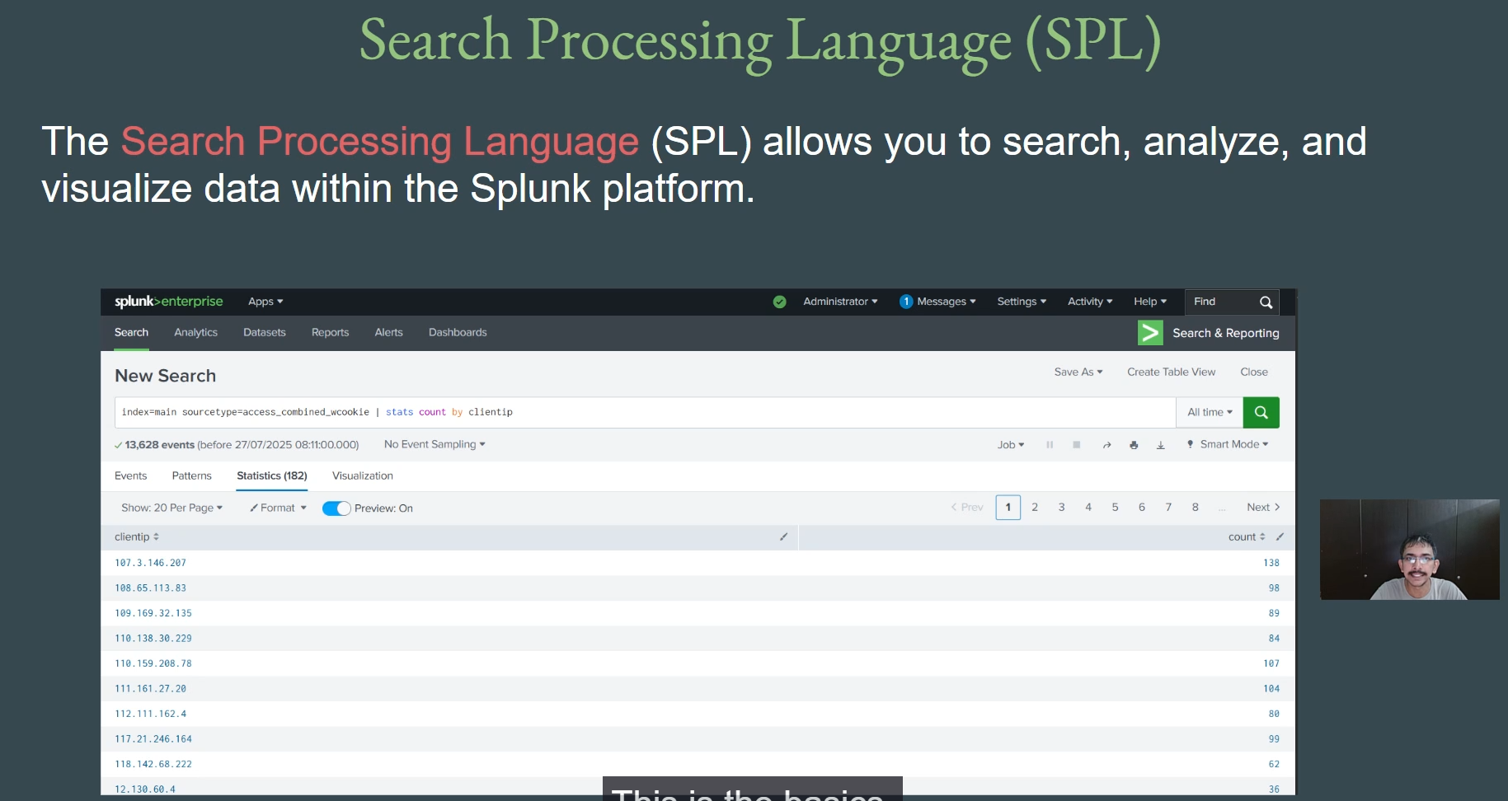

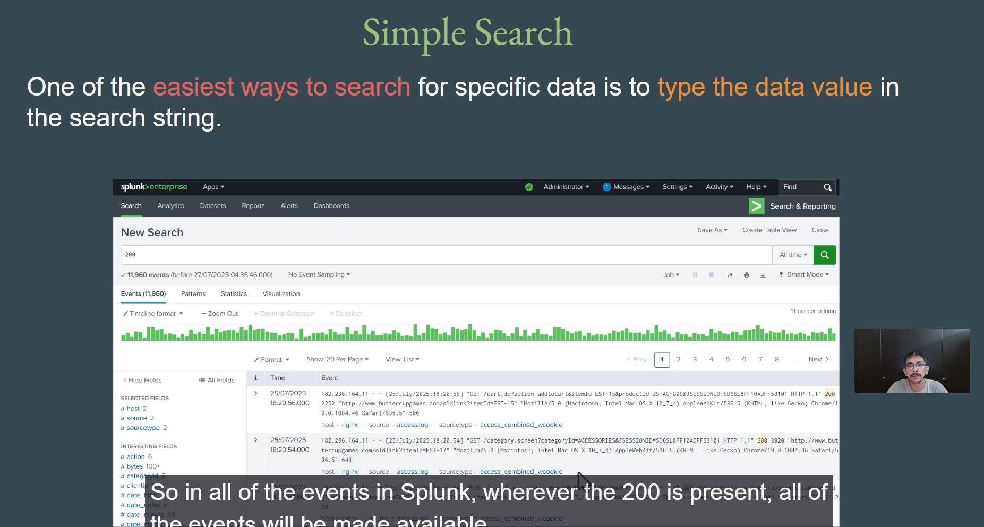

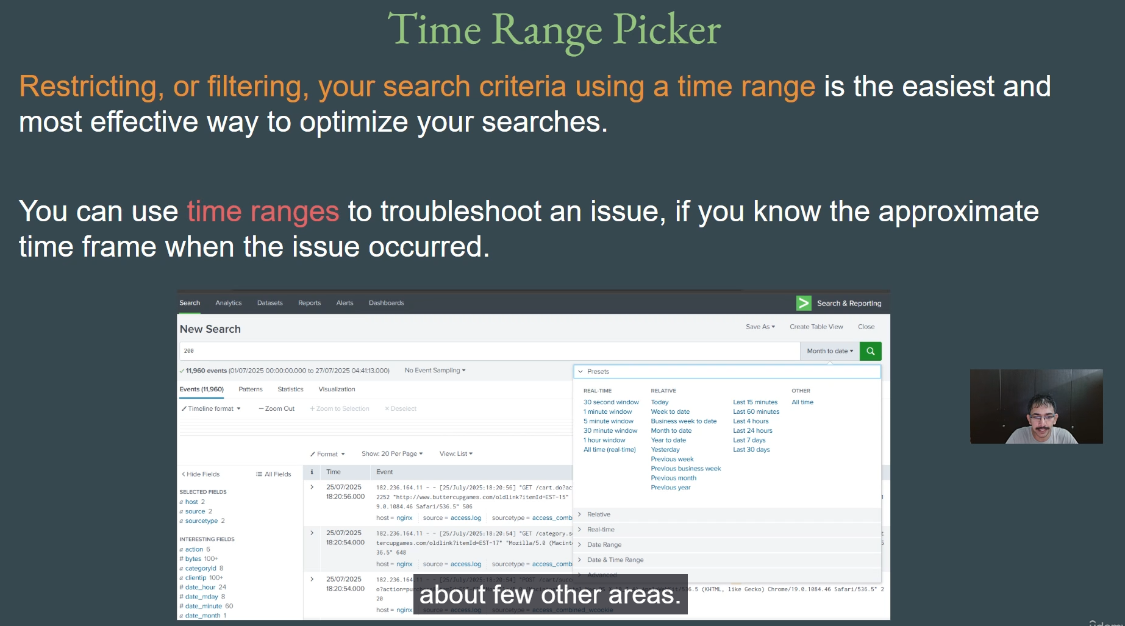

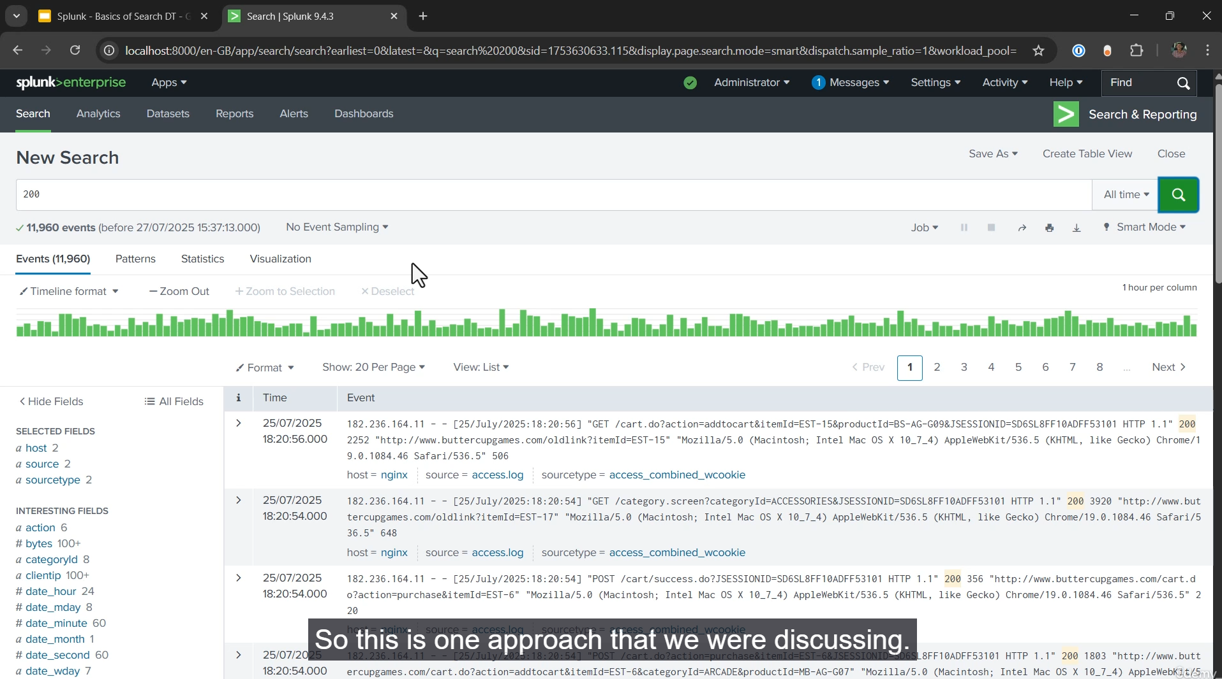

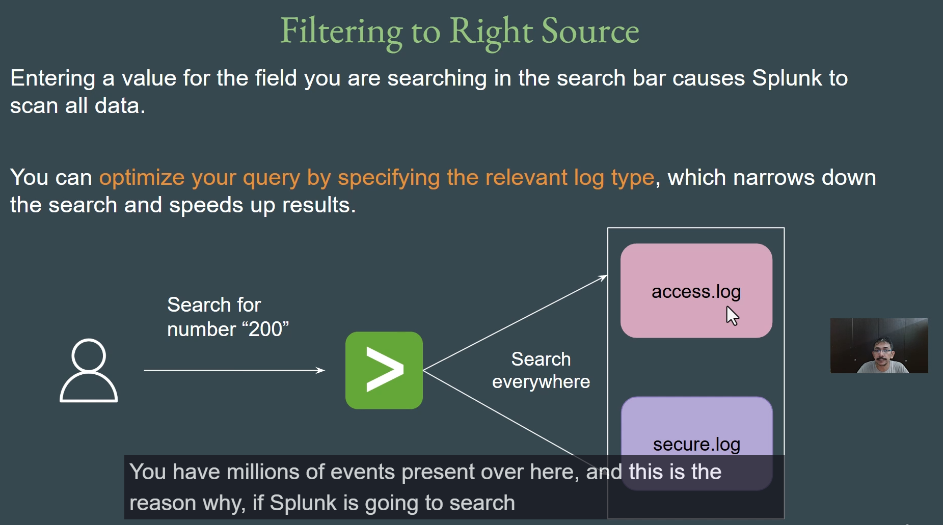

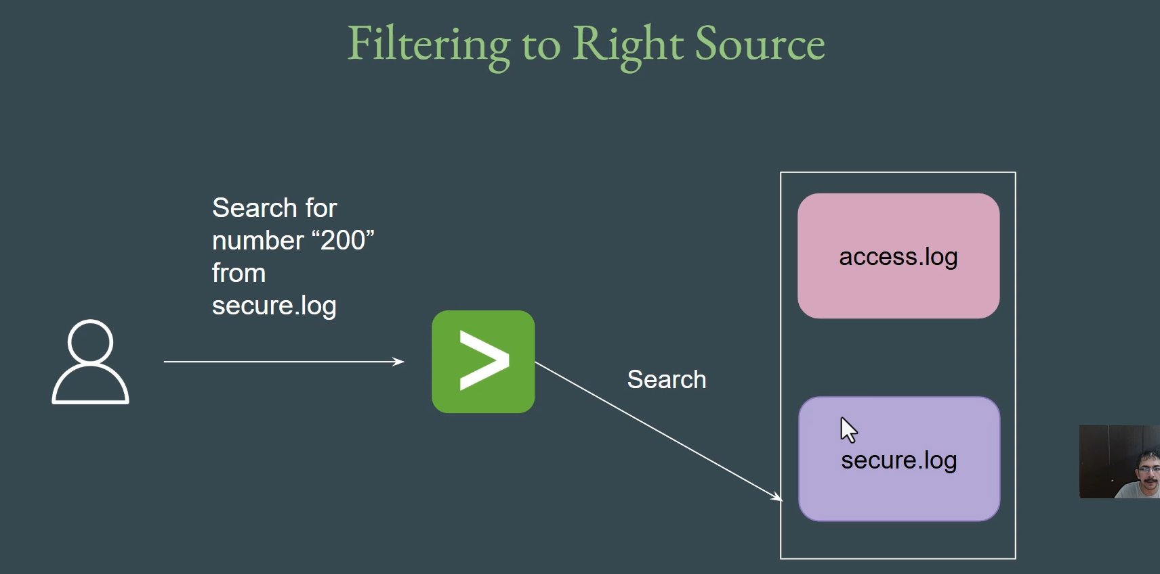

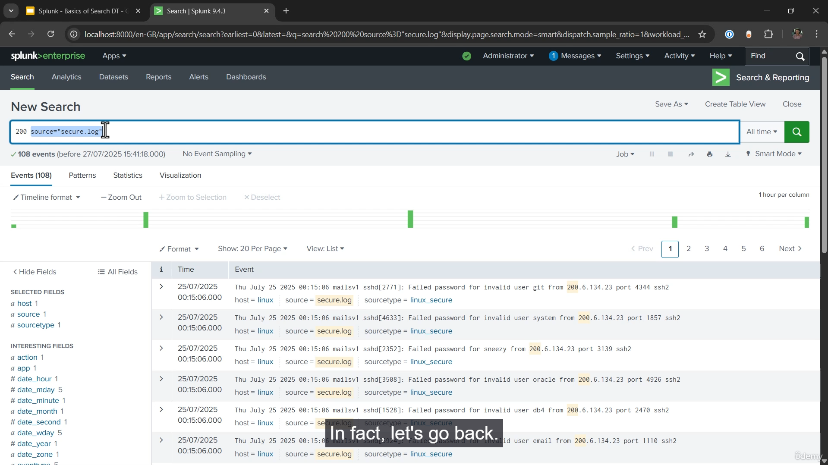

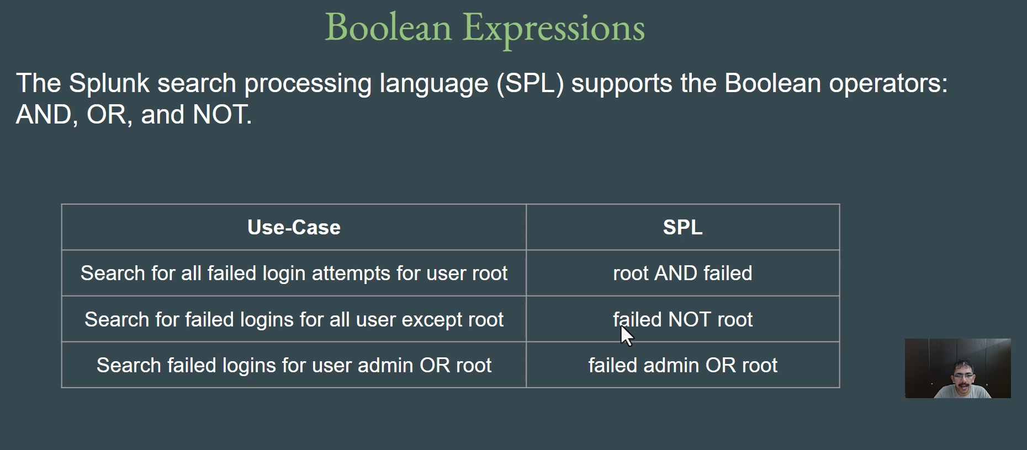

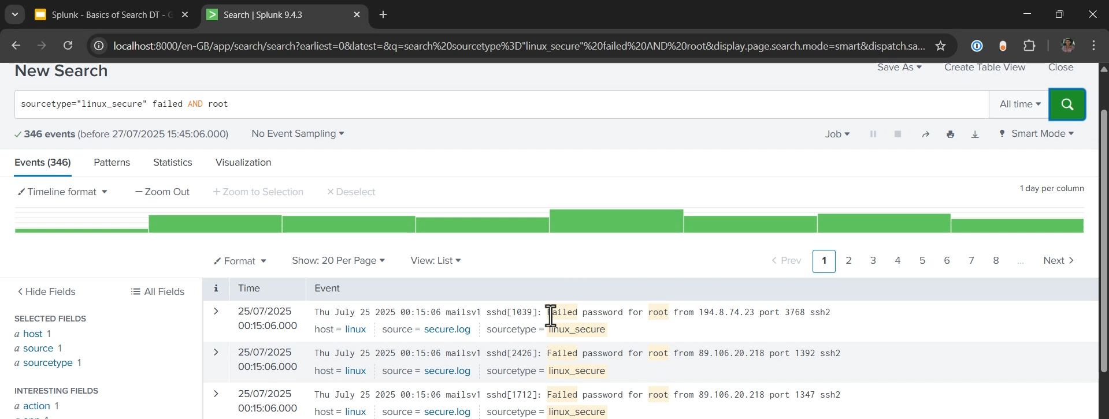

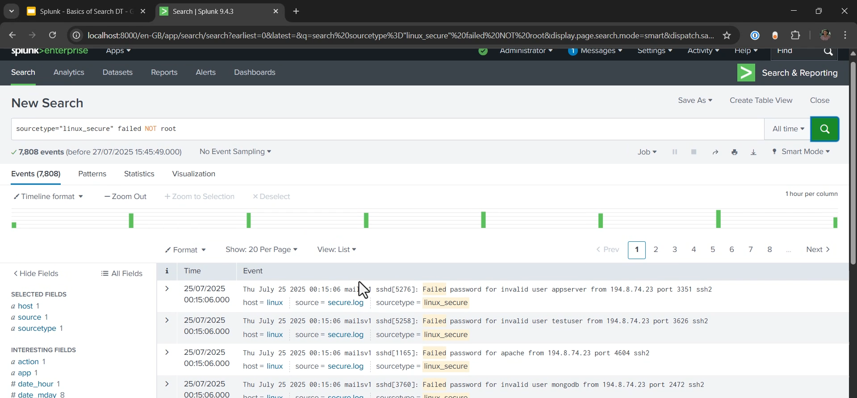

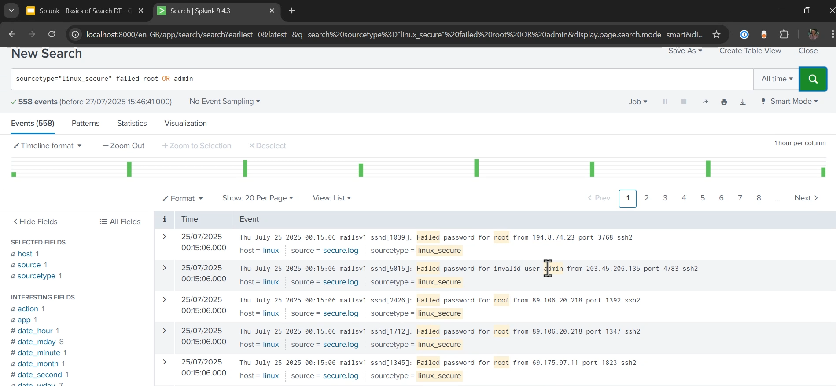

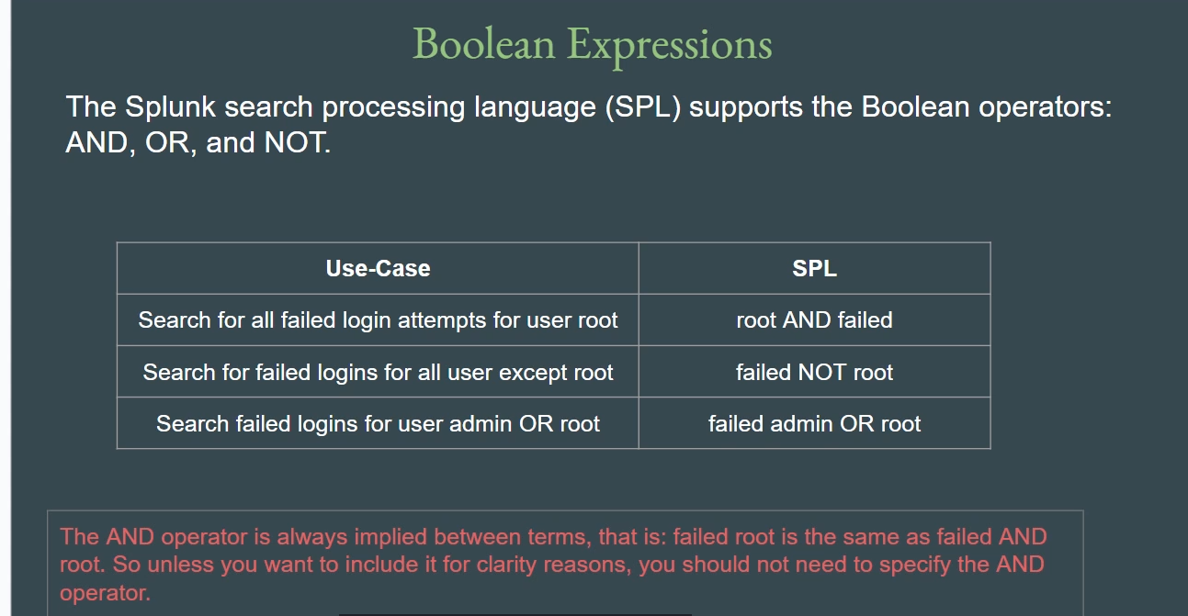

**Searching Data in Splunk: Introduction to SPL Summary**

**1. Introduction to Splunk Processing Language (SPL)**

* **Definition:** To search, analyze, and visualize data in Splunk, you use the **Splunk Processing Language (SPL)**.
* **Ease of Use:** SPL is designed to be easy to learn, especially for those familiar with **Linux commands** or basic **SQL** concepts.
* **Core Function:** SPL queries are used to retrieve and process the specific data required for analysis, alerts, or visualizations.

**2. Basic Search and Time Range Optimization**

* **Simplest Search:** The most basic way to search is by simply entering a value in the search bar (e.g., 200). Splunk will return all events where that value is present.
* **Importance of Time Range:** Time range is a **critical factor for query optimization**.
  + In large organizations, logs can span years (e.g., 3-5 years). Searching "All Time" is computationally expensive, consuming significant **CPU and RAM**.
  + **Optimization:** Always restrict or filter your search using an appropriate **time range** (e.g., "past 30 minutes," "past 7 days," or "today") unless historical data is explicitly required.

**3. Filtering to the Right Source**

* **The Problem:** Searching for a term without specifying a source (e.g., just searching 200) causes Splunk to **scan all available data** (Access logs, Secure logs, etc.). If one log type (e.g., Access logs) has millions of events, this unnecessary scanning will **slow down the query** and the entire Splunk instance.
* **The Solution: Optimized Querying:** Always filter your search to the relevant log source using **Source** or **Source Type**.
  + **Source Filter:** Use the exact log file name (e.g., source="secure.log").
  + **Source Type Filter:** Use the assigned source type (e.g., sourcetype="linux_secure").
* **Example:** Searching for the term 200 only within Secure logs: sourcetype="linux_secure" 200.

**4. Using Boolean Operators**

SPL supports **Boolean Operators** to allow for precise filtering of events:

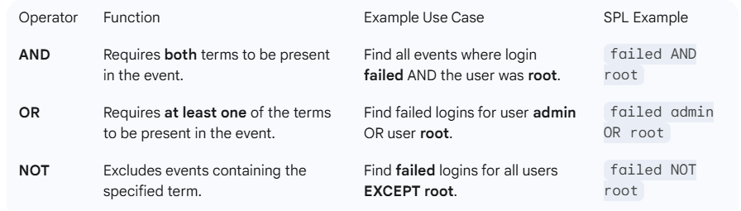

**Implicit AND Operator:** The **AND operator is always implied** between two terms.

* The query failed root is exactly the same as failed AND root. The AND can be omitted for brevity unless needed for clarity.
* *Note:* Using AND for mutually exclusive fields (like user names in a single login event) will return no results (e.g., failed admin AND root won't work). Use OR instead.

===================================================================================

1. **Basics Splunk SPL Commands:**

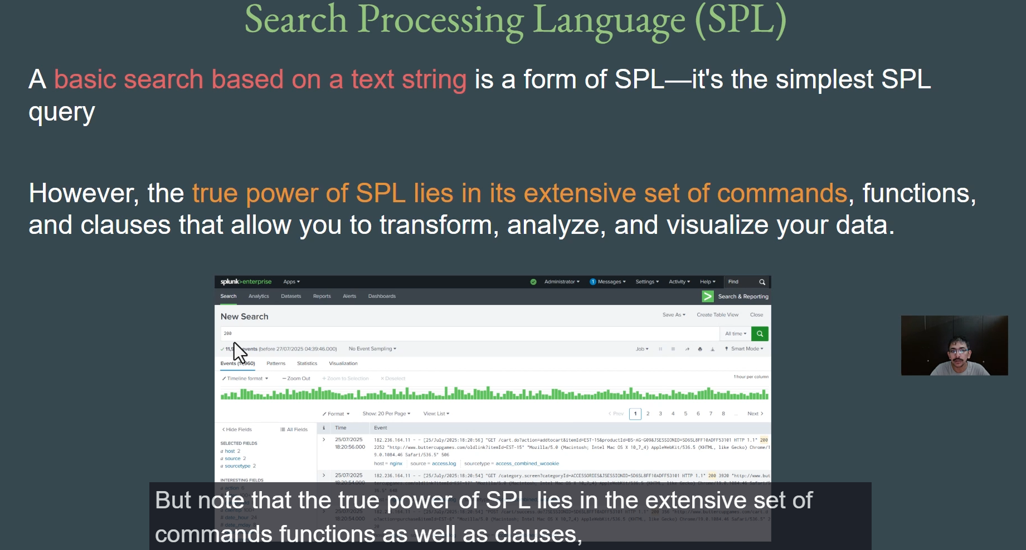

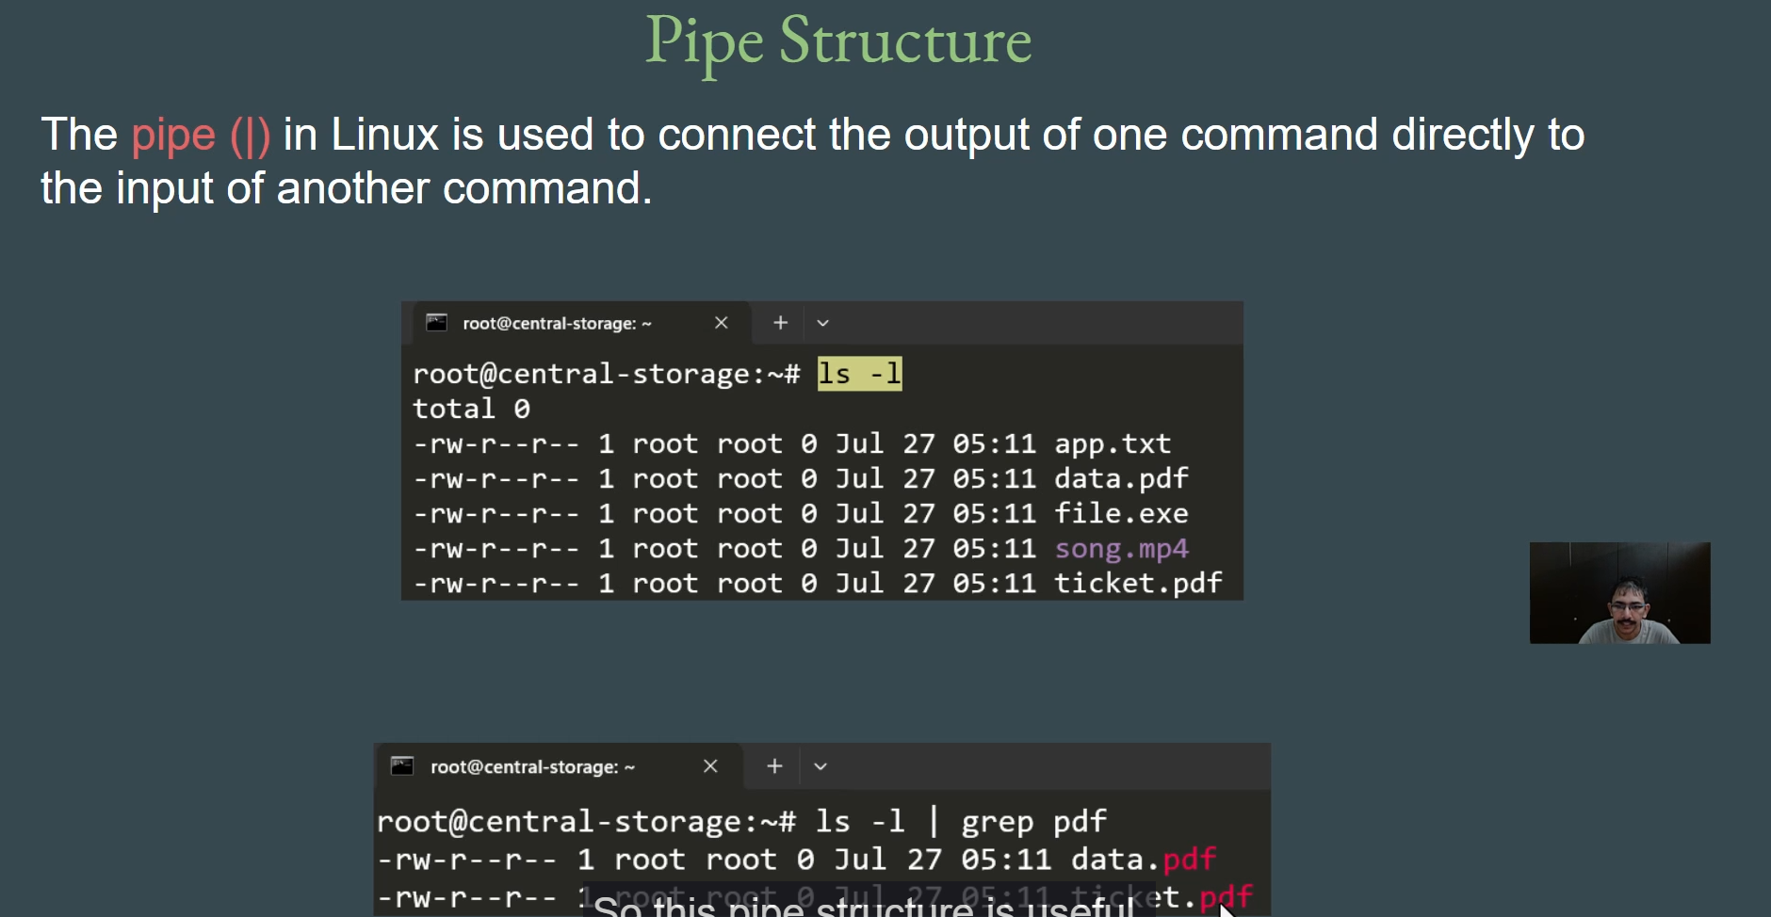

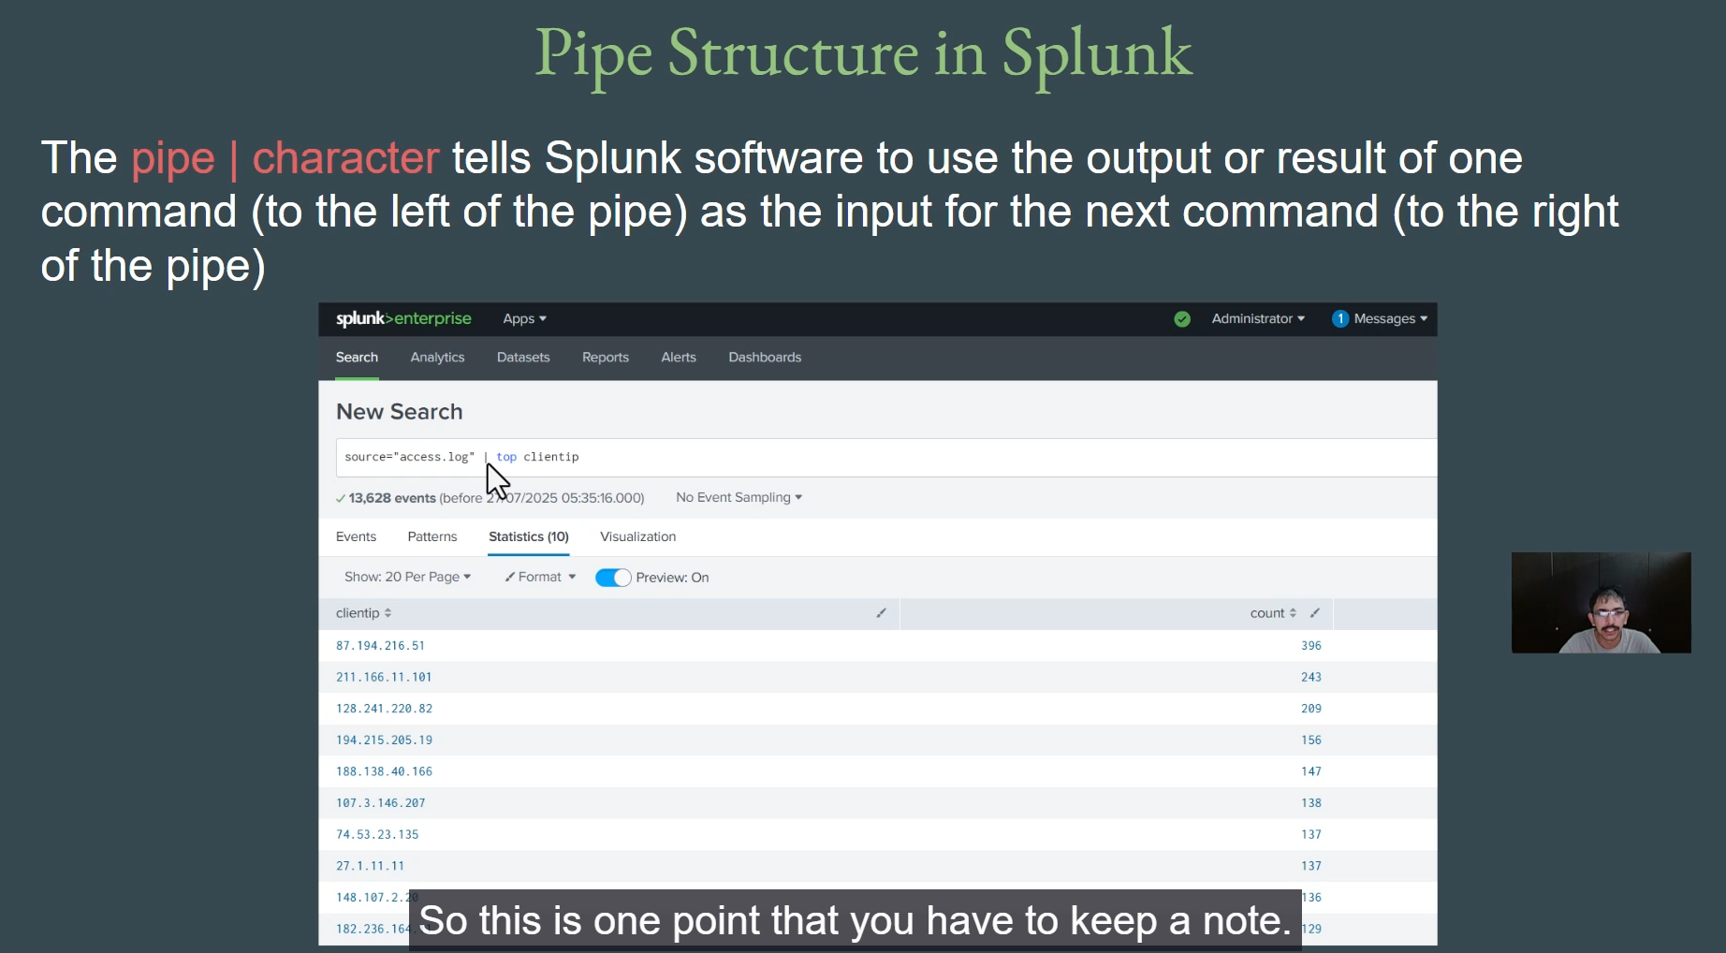

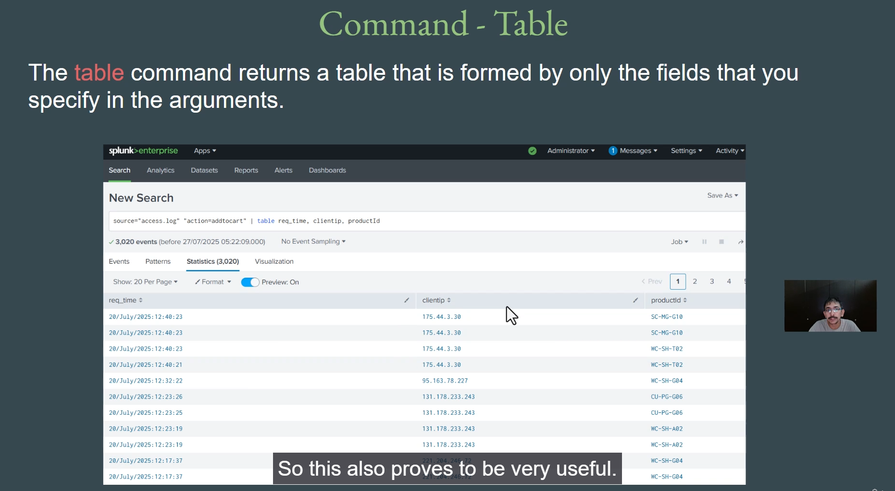

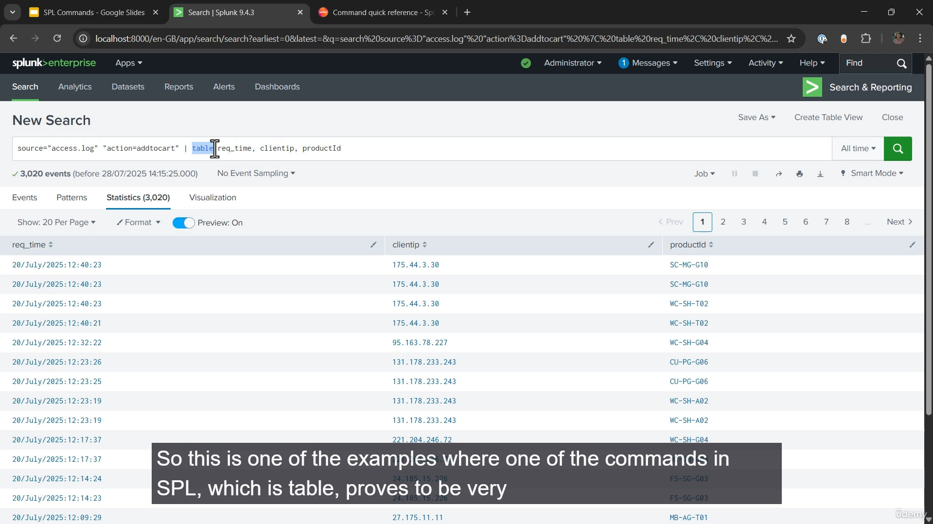

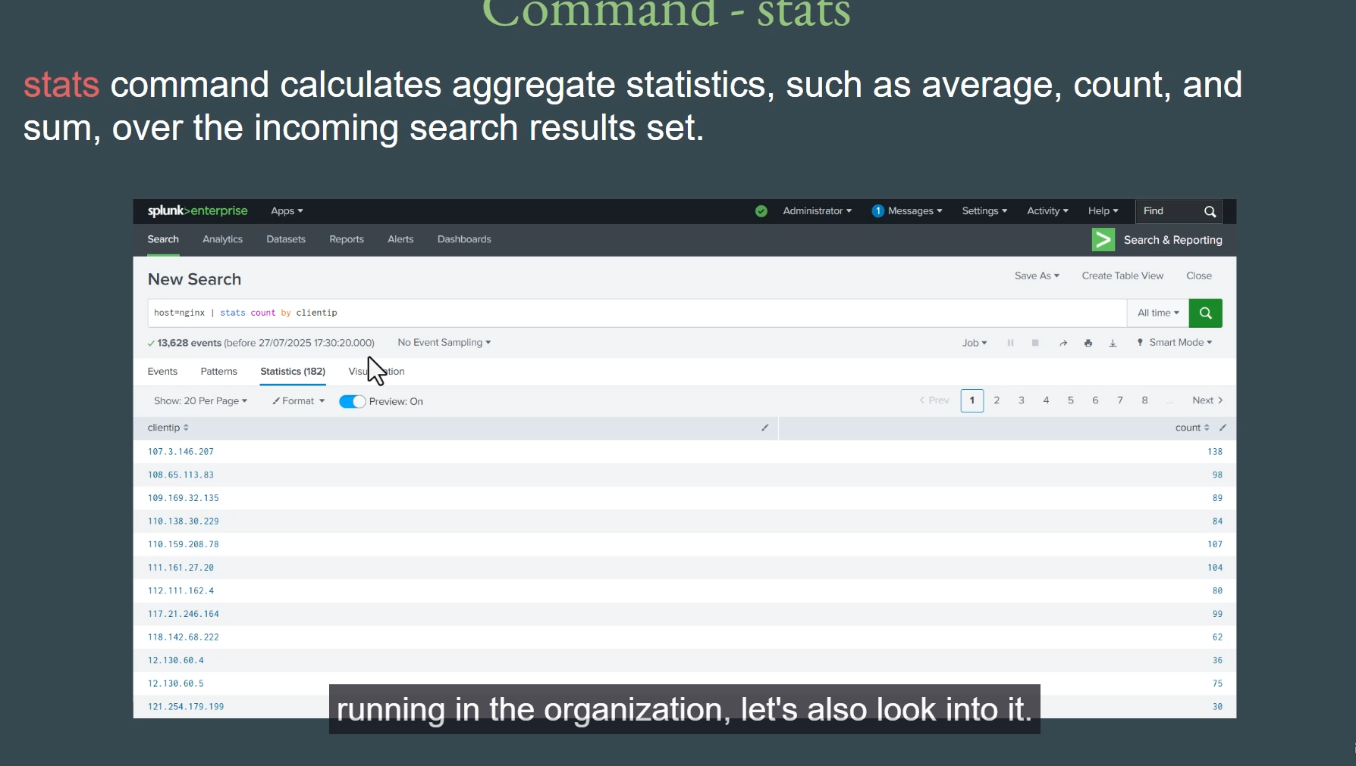

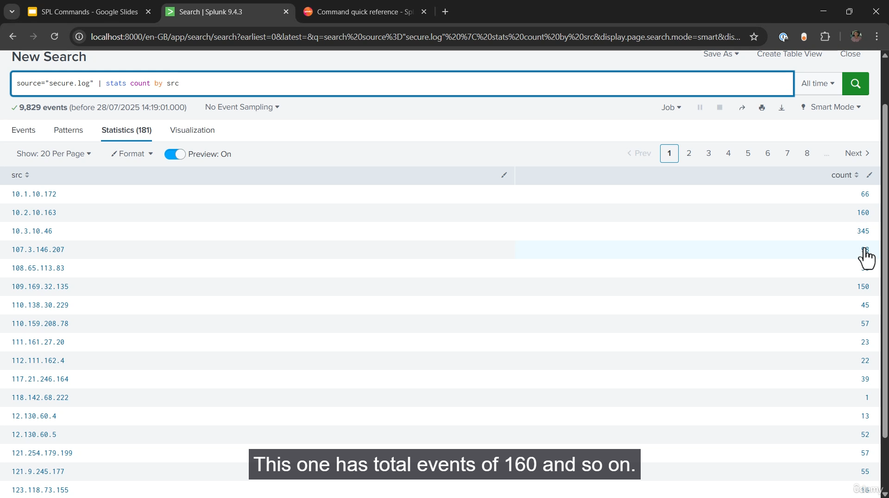

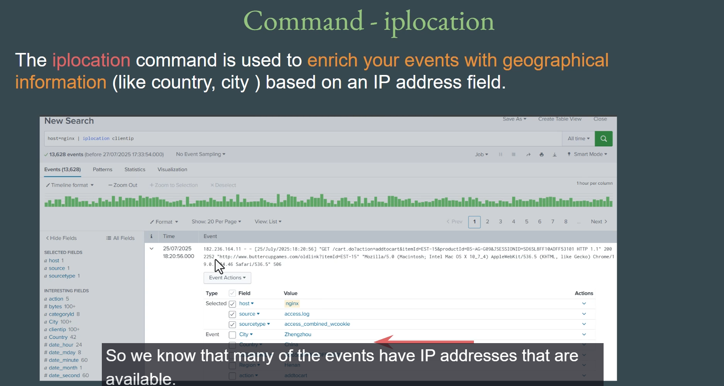

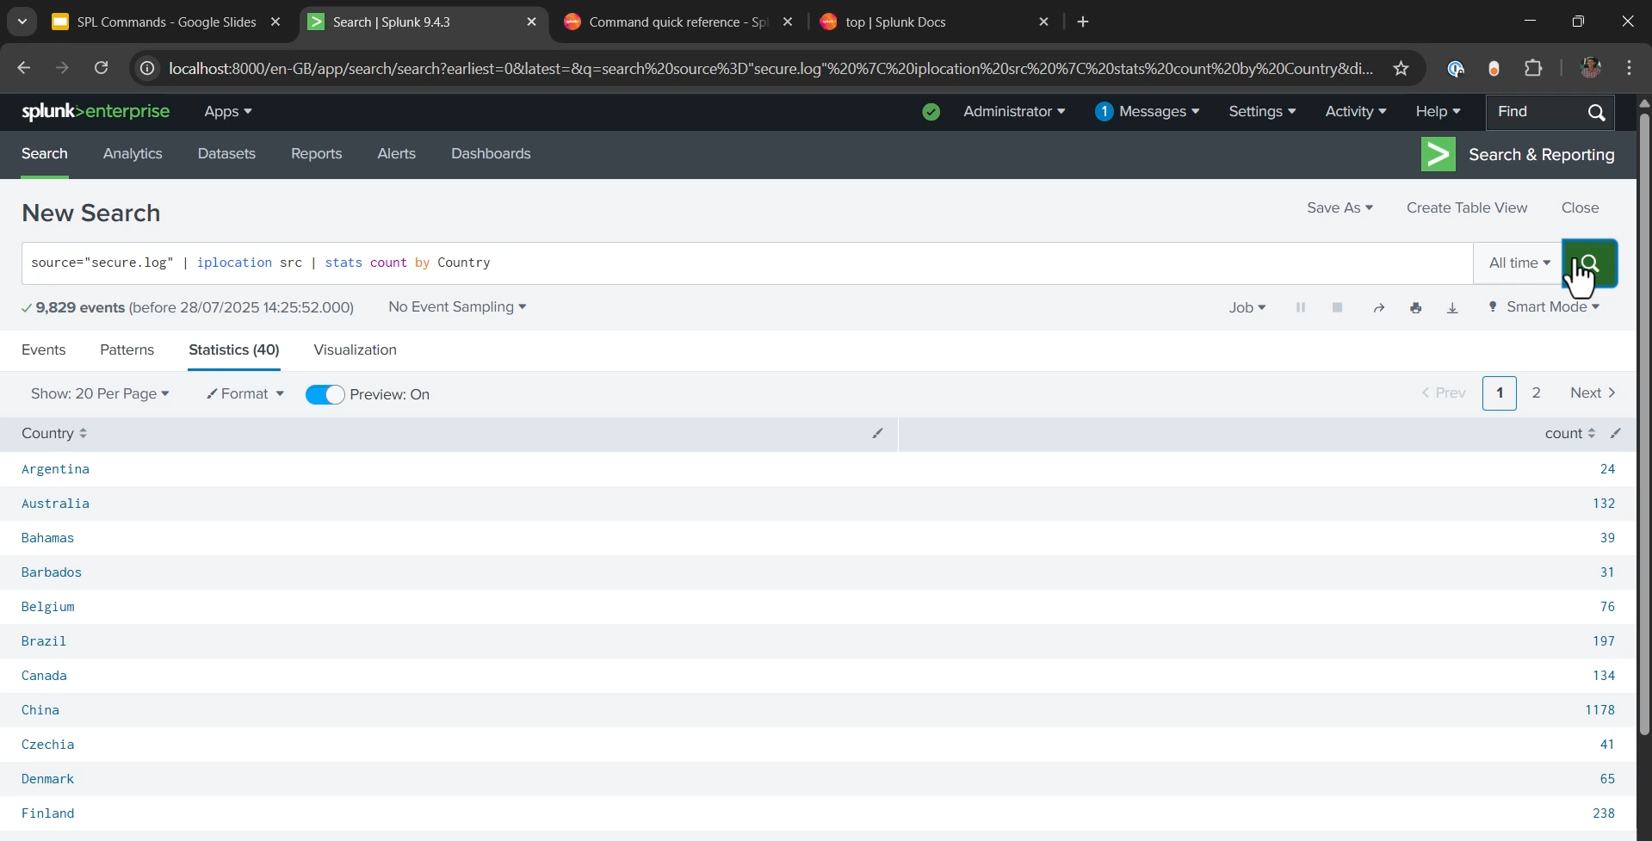

**Introduction to SPL Commands Summary**

**1. The Power of SPL Commands**

* **Simple vs. Powerful Search:** While a basic text string search works, the true power of the **Splunk Processing Language (SPL)** lies in its extensive set of **commands, functions, and clauses**.
* **Purpose:** SPL commands tell Splunk **what to do** with the data retrieved from the index, allowing users to **transform, analyze, and visualize** the information.
* **Command Categories:** Commands are categorized based on function (e.g., filtering, transforming, field manipulation).

**2. The Pipe Structure (|)**

* **Concept:** Similar to the pipe (|) in Linux, the pipe character in SPL is used to **chain commands**.
* **Function:** It takes the **output (or result) of the command to its left** and feeds it as the **input to the command on its right**.
* **Structure Example:** source="access.log" | table client_IP (The output of the search filter is piped as input to the table command).

**3. Essential SPL Commands**

The video introduced four important SPL commands:

**A. table Command**

* **Purpose:** Returns a simplified table containing **only the fields specified** in the arguments.
* **Use Case:** Ideal for filtering out irrelevant data and presenting only the necessary fields to a specific user/team (e.g., providing a sales team with only req_time, client_IP, and product_ID for "add to cart" events).
* **Example:** action="add to cart" | table req_time, client_IP, product_ID

**B. stats Command**

* **Purpose:** Calculates **aggregate statistics** (such as average, count, and sum) over the incoming search results.
* **Use Case:** Analyzing frequency or totals. For security, it helps see how many attempts a specific IP address has made to connect (e.g., via SSH).
* **Example:** sourcetype="linux_secure" | stats count by src_IP (Shows the total number of events for each source IP).

**C. top Command**

* **Purpose:** Finds the **most common values** for the specified field. By default, it returns the top **10** results.
* **Use Case:** Quickly identifying the most frequent occurrences of a certain value, such as which IP addresses are making the most requests to the server.
* **Example:** sourcetype="linux_secure" | top src_IP

**D. iplocation Command**

* **Purpose:** **Enriches** the events by adding **geographical information** based on an IP address field.
* **Mechanism:** Splunk uses an internal database to map the IP address to its location and automatically adds new fields to the events.
* **Added Fields:** **country**, **city**, **region**, **latitude**, and **longitude**.
* **Use Case:** Highly valuable for visualization and security analysis (e.g., identifying the top countries connecting to an SSH server).
* **Example Chain:** sourcetype="linux_secure" | iplocation src_IP | stats count by country (First adds country data, then counts events by country).

===================================================================================

1. **Basics Of Visualization:**

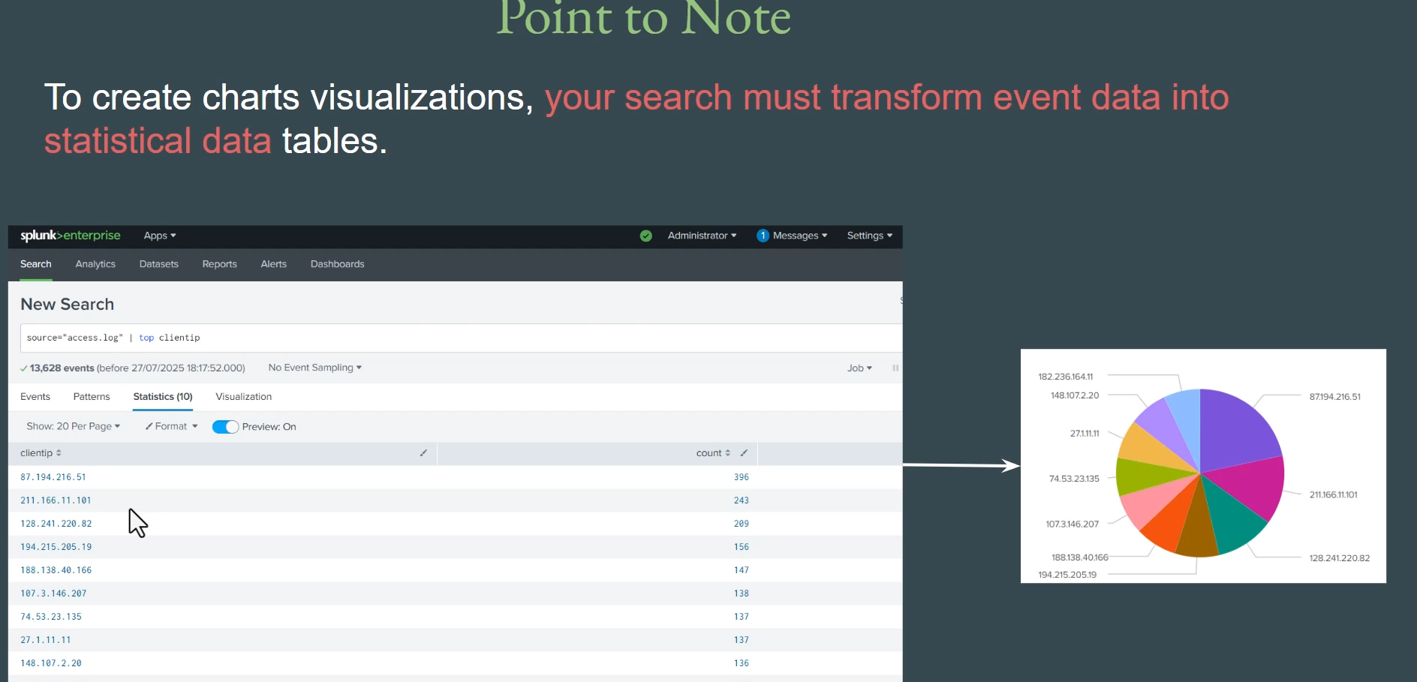

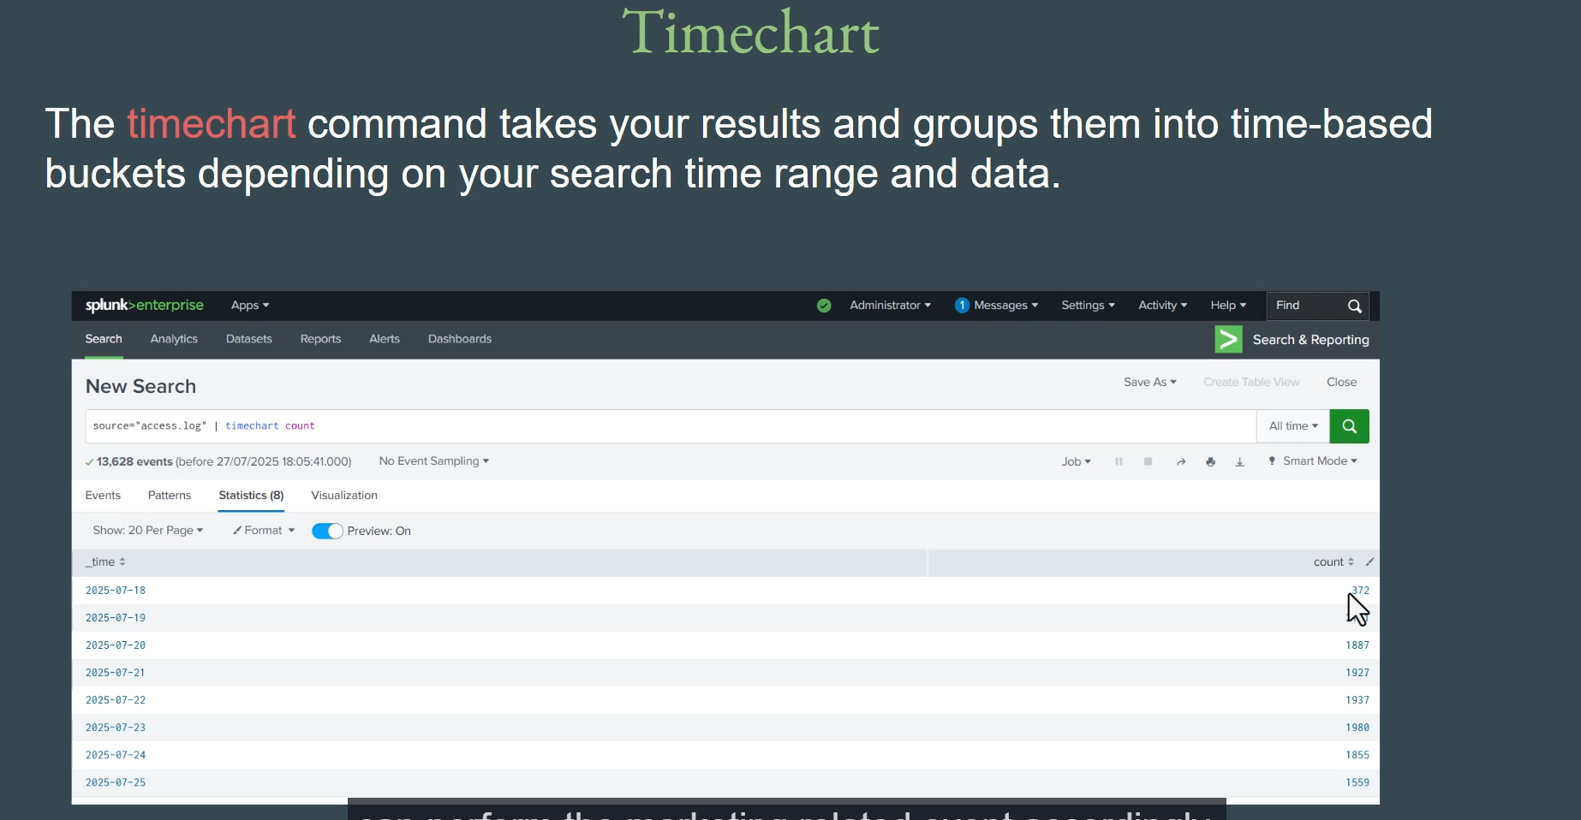

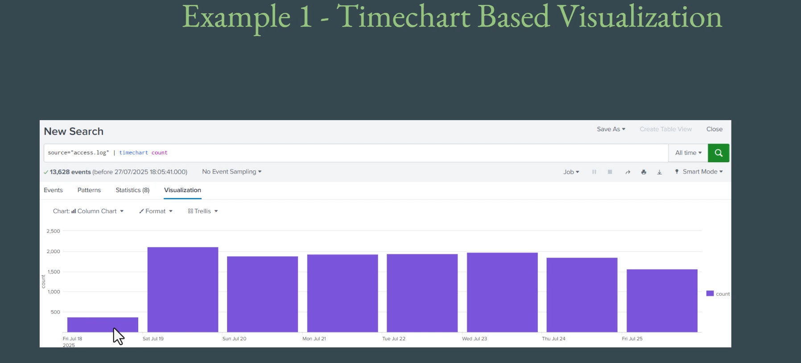

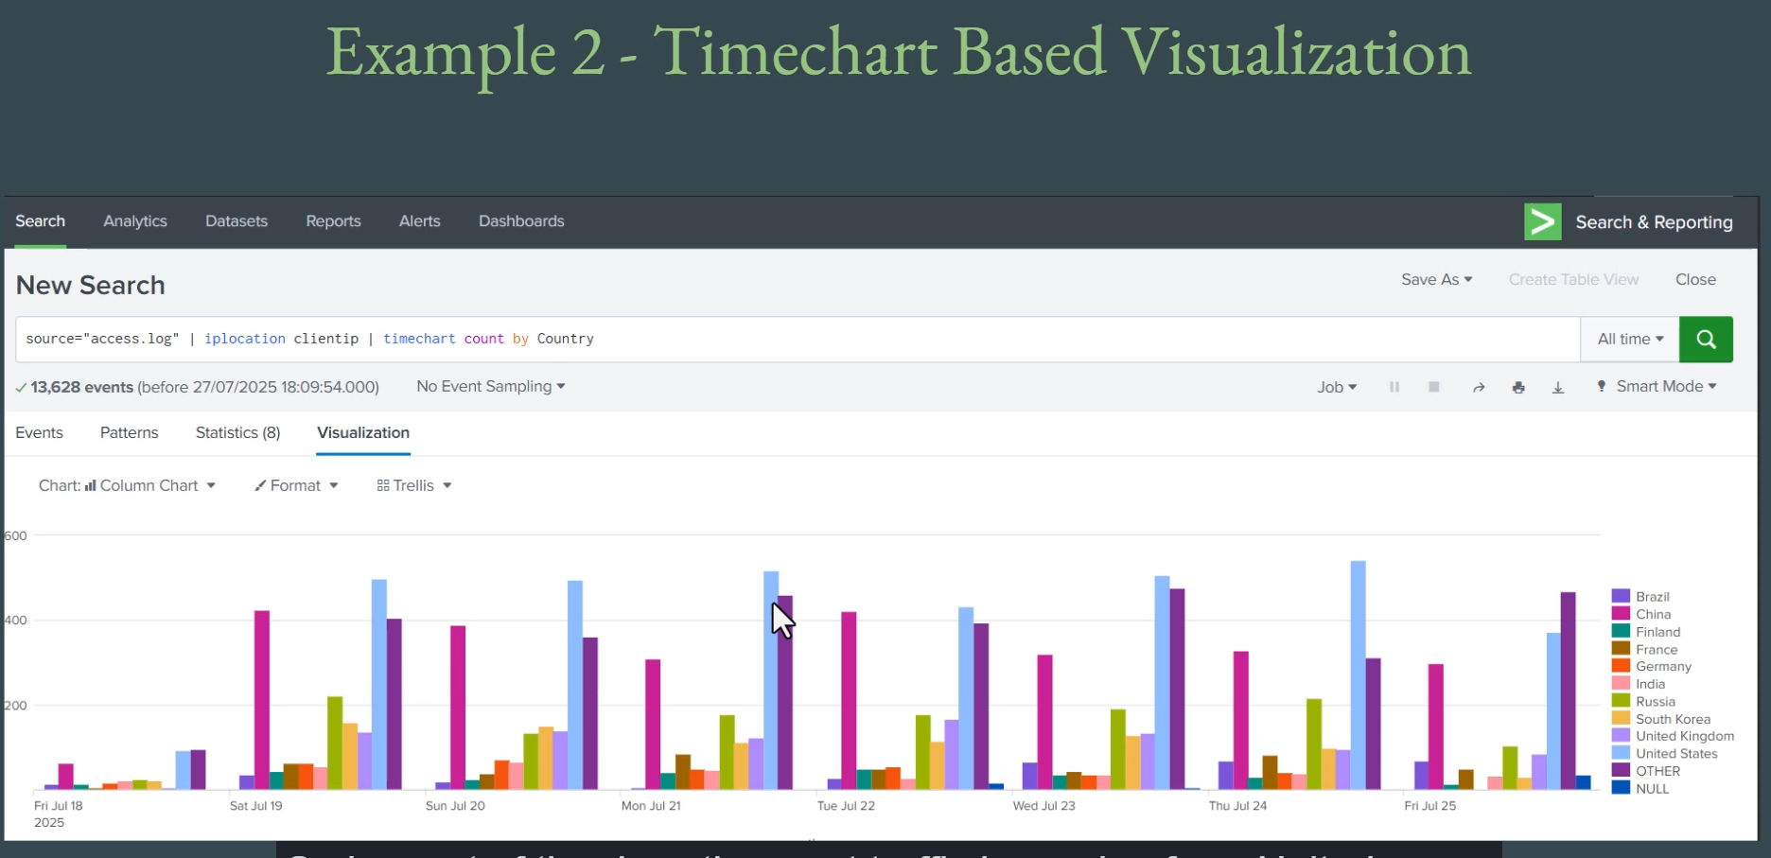

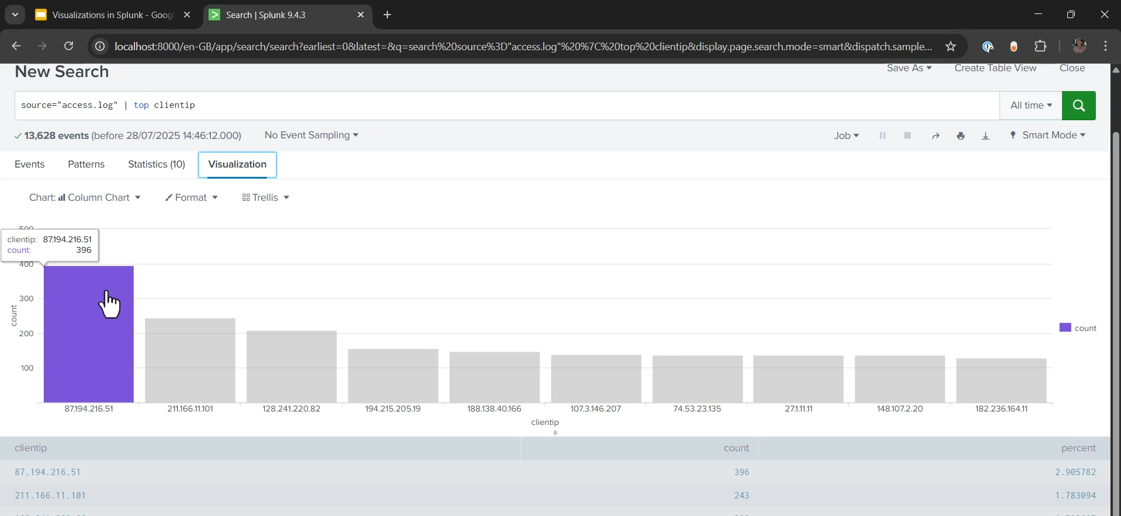

**Basic Visualization in Splunk Summary**

**1. Prerequisite for Visualization**

* **The Rule:** To create any form of chart or visualization in Splunk, your search must first **transform the raw event data into statistical data tables**.
* **Method:** This transformation is achieved by using **Transforming SPL Commands** (like top, stats, or timechart).
* **Output:** The output of these commands (the resulting table, which contains fields like count and specific values like client_IP) is the key element Splunk uses to generate visual charts (e.g., bar charts, pie charts).

**2. The timechart Command**

* **Purpose:** The timechart command is one of the most important transforming commands; it **groups results into time-based buckets** (e.g., by day, hour, etc.).
* **Use Case (Basic Count):** It allows analysis of traffic trends over time.
  + **Query:** source="access.log" | timechart count
  + **Result:** A table showing a timestamp (e.g., date) and the total number of requests (count) received on that day.
  + **Application:** Useful for sales/marketing teams to analyze traffic peaks and valleys to plan campaigns.
* **Use Case (Multi-Series Analysis):** Combining timechart with field enrichment.
  + **Query:** source="access.log" | iplocation client_IP | timechart count by country
  + **Result:** A visualization showing multiple data series, where each series represents the count of requests for a specific country over the selected time range.

**3. Creating and Interpreting Visualizations**

* **Workflow:**
  1. Run an **SPL query** that includes a **transforming command** (e.g., timechart).
  2. View the resulting **Statistics** table.
  3. Click on the **Visualization** tab.
* **Automatic Chart Generation:** Splunk automatically generates a default chart (often a column or line chart) based on the statistical table data.
* **Selecting Chart Types:** A wide variety of visualization types are available (e.g., **column charts, line charts, pie charts**). The choice of visualization depends entirely on the data points and the specific reporting requirement.
  1. **Advantage:** Visualizations simplify the process of identifying trends, peaks, or outliers in large datasets, which is much harder to do by manually reading the raw count numbers in the statistics table.

**4. Other Transforming Commands for Visualization**

* **Any transforming command** can generate the necessary statistical data:
  + **top:** Used to find the top values for a field (e.g., | top client_IP). The resulting table can be visualized as a pie chart or column chart to show the request distribution among top IP addresses.
  + **stats:** Can also be used (e.g., | stats count by client_IP), but if it returns an excessive number of results, the visualization may become unwieldy.

===================================================================================

1. **Challenge – Find Attack Vectors:**

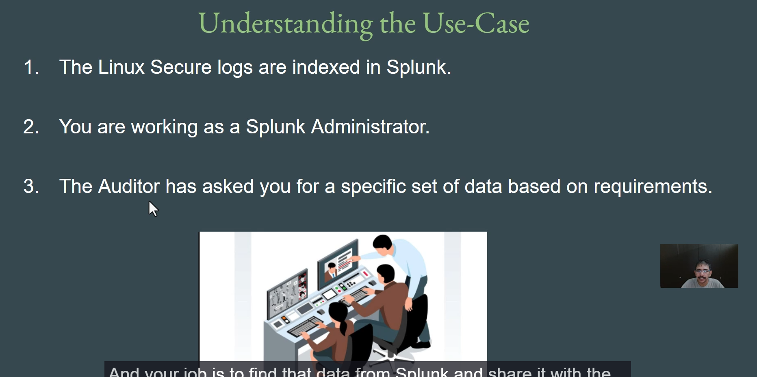

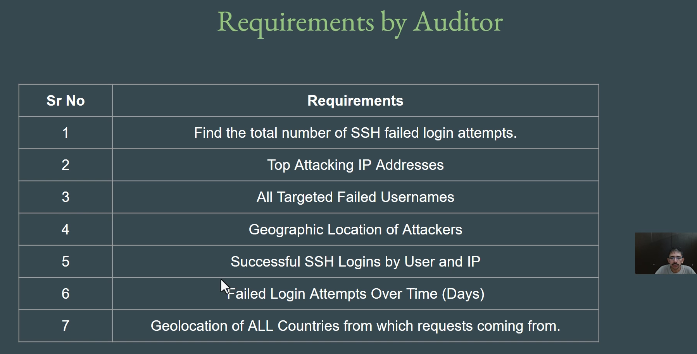

**Challenge: Finding Attack Vectors in Linux Secure Logs Summary**

The user is presented with a hands-on challenge to act as a **Splunk Administrator** and use the **Splunk Processing Language (SPL)** to retrieve specific security-related data from the indexed **Linux secure logs** to fulfill an auditor's request.

**Context**

* **Log Source:** Linux secure logs (sourcetype=linux_secure).
* **Role:** Splunk Administrator / Security Analyst.
* **Goal:** Use optimized SPL queries to find specific attack and login statistics.

**==================================================================================**

1. **Solutions – Finding Attack Vectors:**

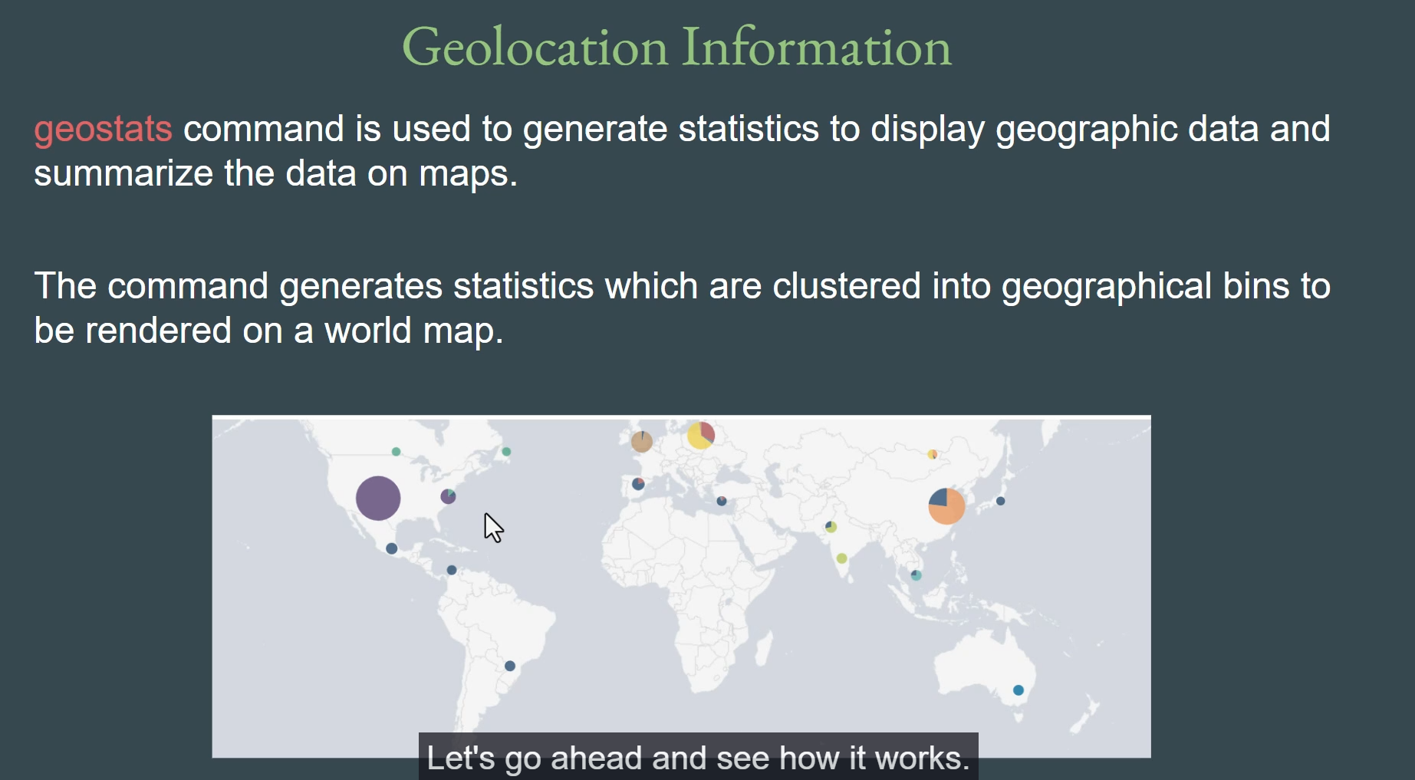

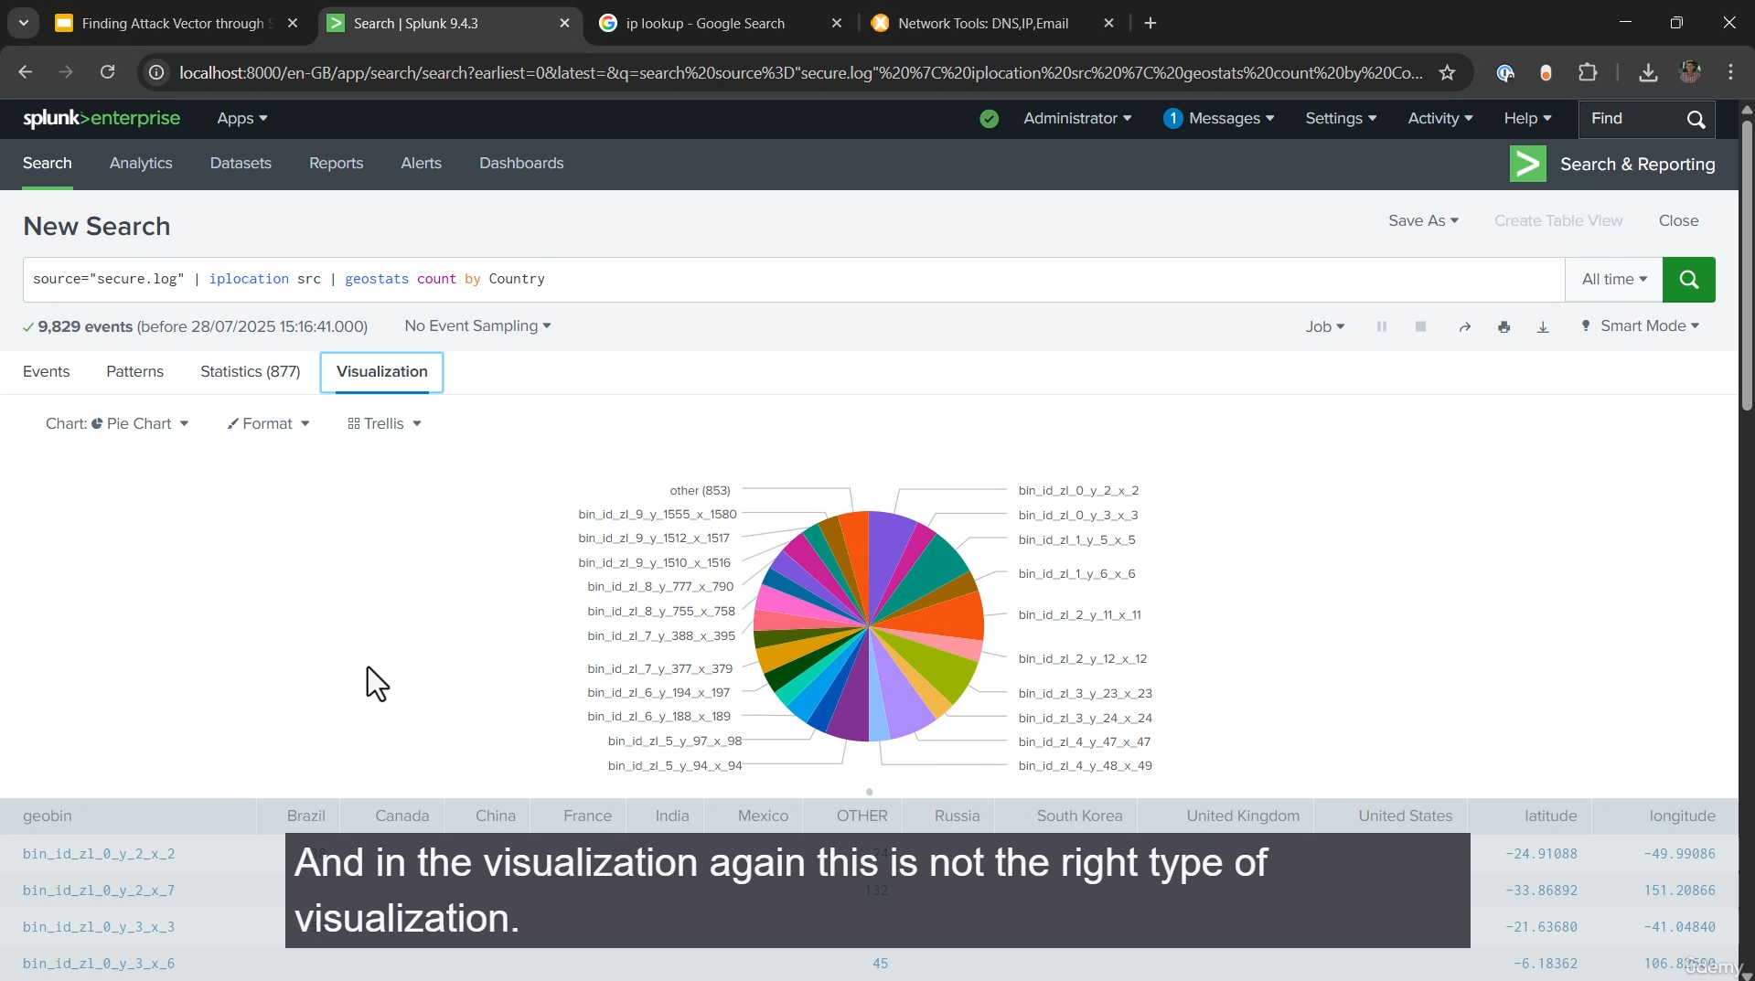

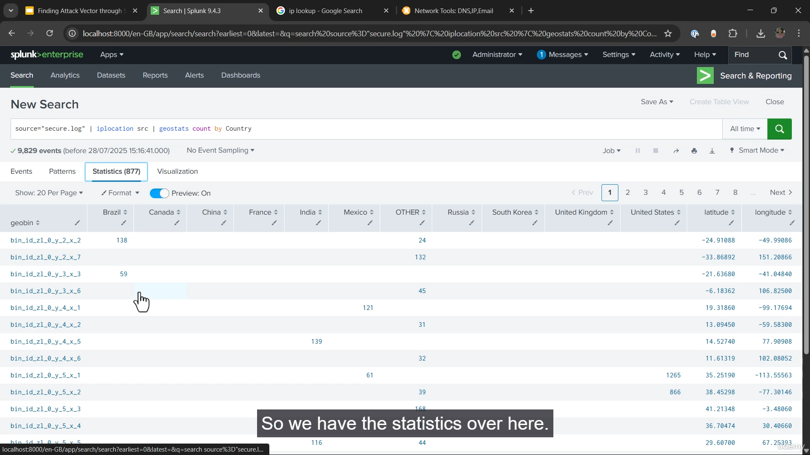

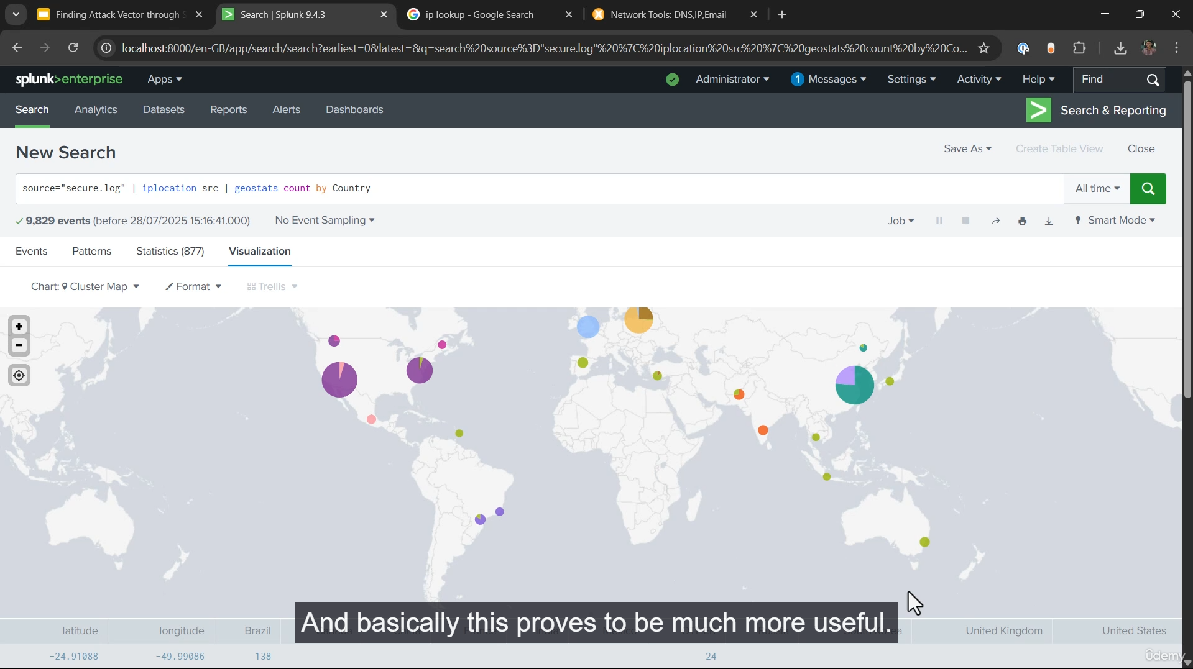

**Solution: Finding Attack Vectors in Linux Secure Logs**

The following solutions use the **Splunk Processing Language (SPL)** on the **Linux secure logs** (source="secure.log" or sourcetype="linux_secure") to meet each auditor requirement.

**1. Total Number of SSH Failed Login Attempts**

**Goal:** Count all events that indicate a failed SSH login attempt.

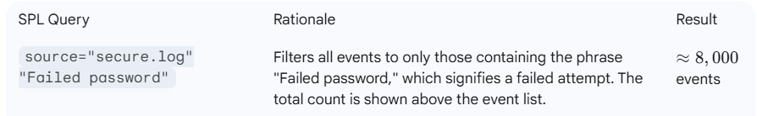

**2. Top Attacking IP Addresses**

**Goal:** Identify which source IP addresses are responsible for the most failed attempts.

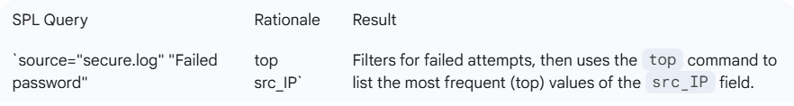

**3. All Targeted Failed Usernames**

**Goal:** Identify the most frequently targeted usernames in the failed login attempts.

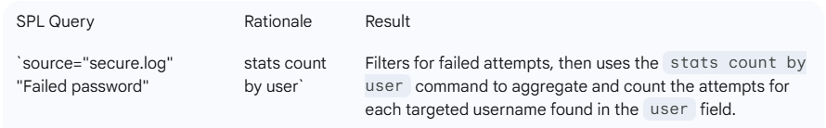

**4. Geographic Location of the Attackers (Top Countries)**

**Goal:** Show the countries from which the most failed login attempts are originating.

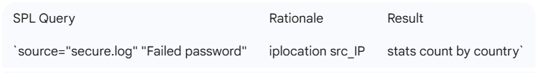

**5. Successful SSH Logins by User and IP**

**Goal:** Identify successful SSH logins and list the user and IP involved.

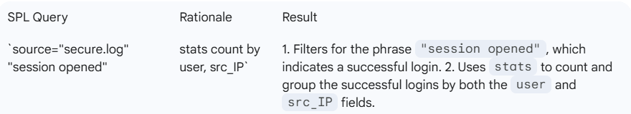

**6. Failed Login Attempts Over Time (Days)**

**Goal:** Visualize the trend of failed login attempts over time.

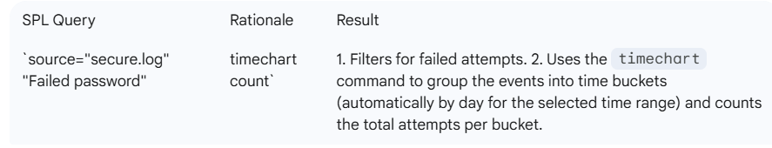

**7. Geolocation of All Countries (Map Visualization)**

**Goal:** Generate a map visualization showing the geographic distribution of all requests (failed and successful).

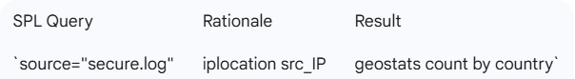

**Note on Exporting Data:** The video also highlights the importance of using the **Export** function in Splunk to save the statistical table results as a **CSV** file, which can then be emailed to the auditor for documentation and evidence.

===================================================================================

1. **Splunk Search Assistant:**

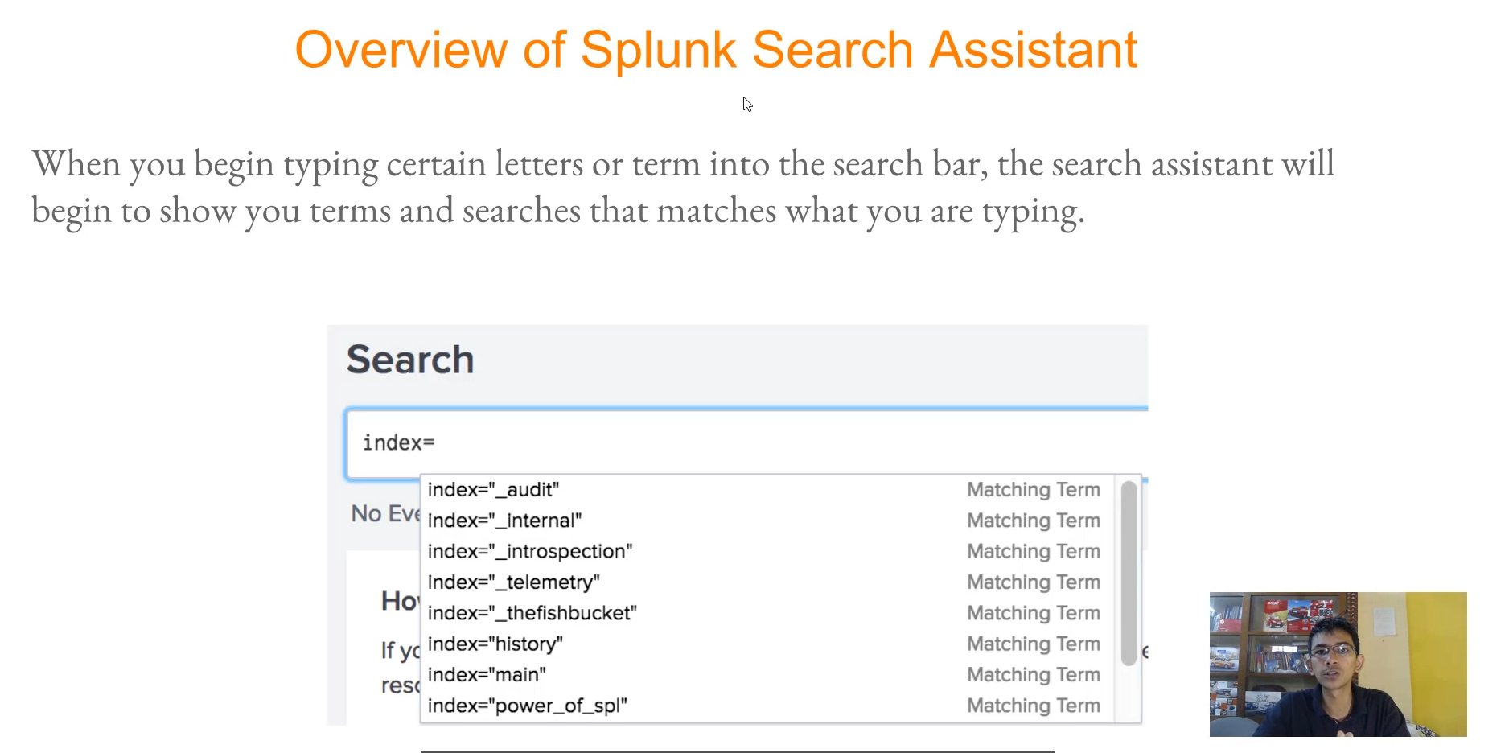

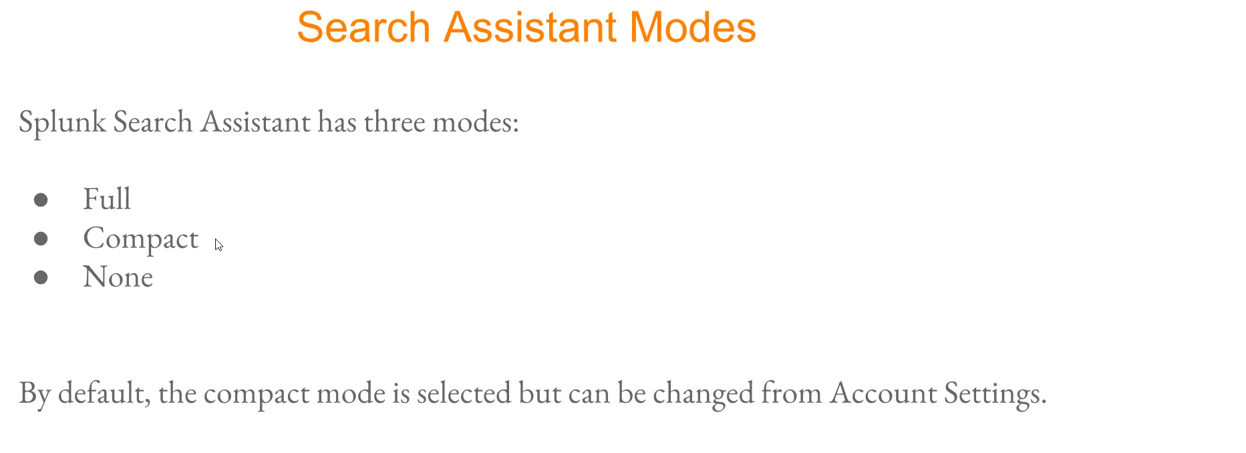

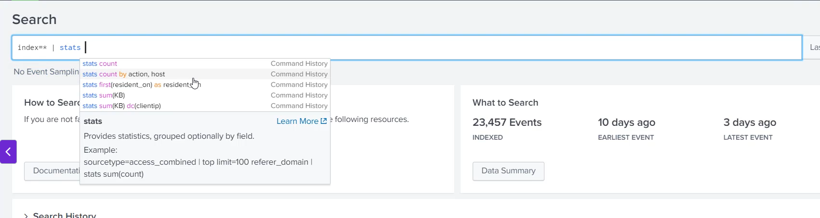

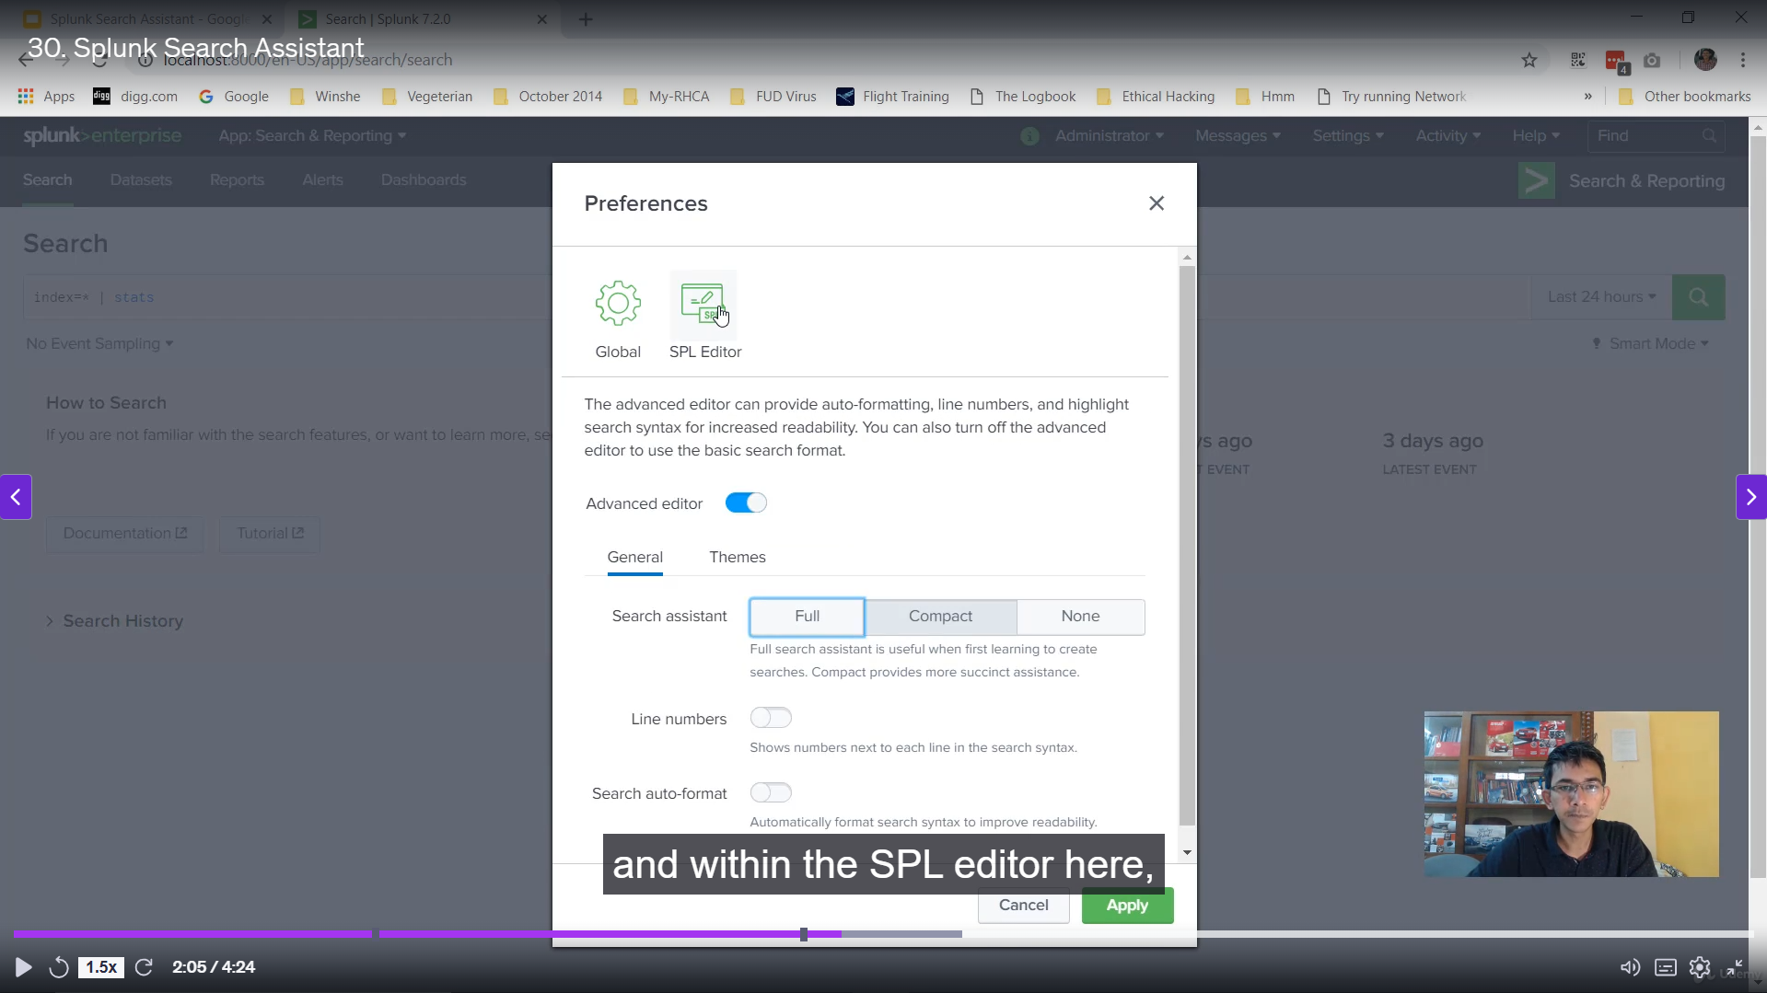

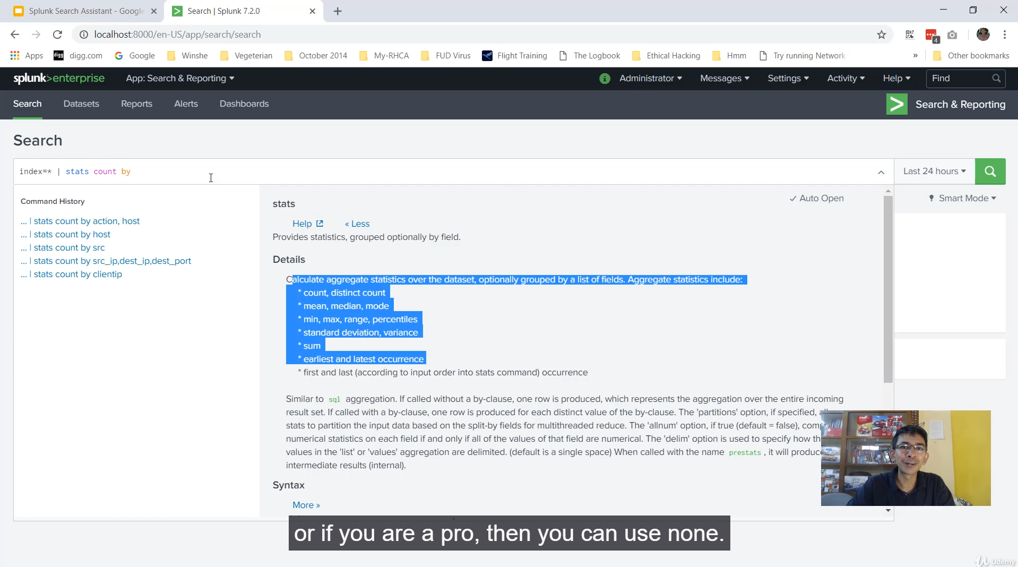

**Splunk Search Assistant Summary**

The **Splunk Search Assistant** is a useful feature that aids users in writing **Splunk Processing Language (SPL)** queries within the Splunk search bar by providing an **autocomplete or auto-fill-like feature**.

**1. Functionality**

* **Autocompletion:** As a user begins typing characters in the search bar, the Splunk Search Assistant provides matching **terms, commands, and search history** (similar to suggestions provided by a search engine like Google).
* **Source of Suggestions:** The suggestions come from two primary sources:
  + **History:** Previous SPL queries used by the user.
  + **Commands/Fields:** Matching Splunk commands and field names.

**2. Search Assistant Modes**

The Splunk Search Assistant operates in three distinct modes, which can be configured per user in the **User Preferences** settings:

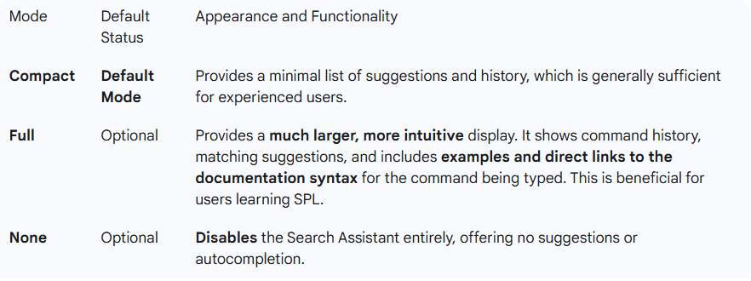

**3. User Preferences**

* Users can change their preferred mode by navigating to **User** $\rightarrow$ **Preferences** $\rightarrow$ **SPL Editor**.
* **Per-User Setting:** Any changes made to the Search Assistant mode are **specific to the individual user account** and will not affect other users on the same Splunk instance.

===================================================================================

1. **Splunk Reports:**

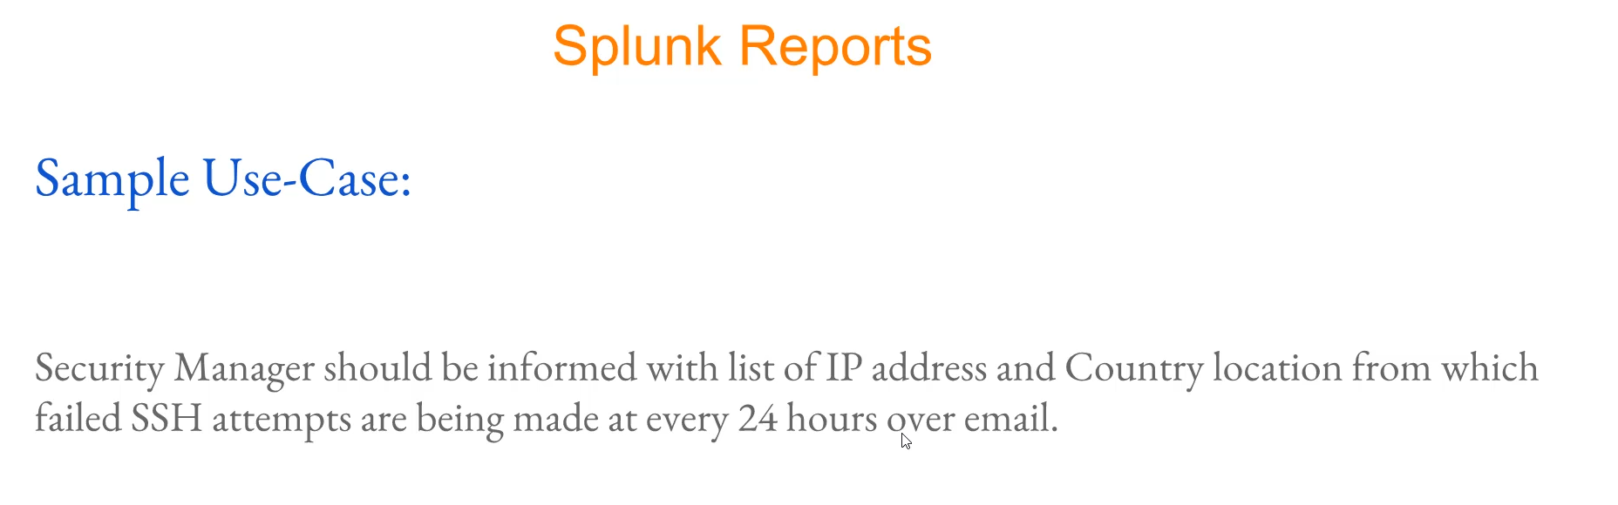

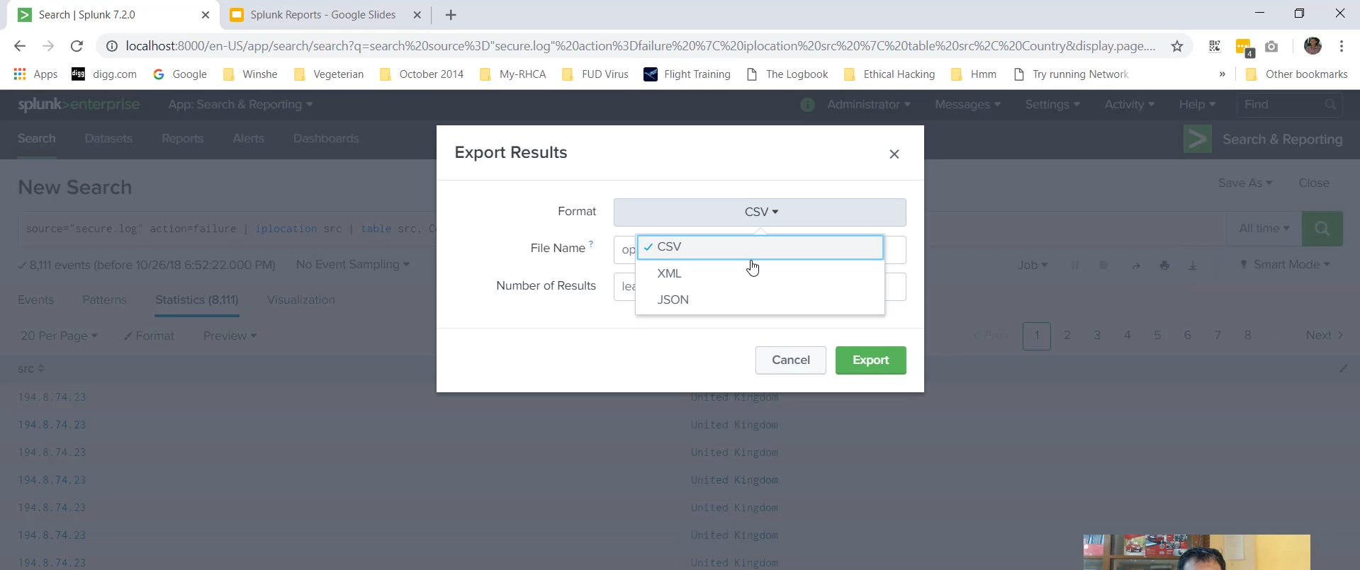

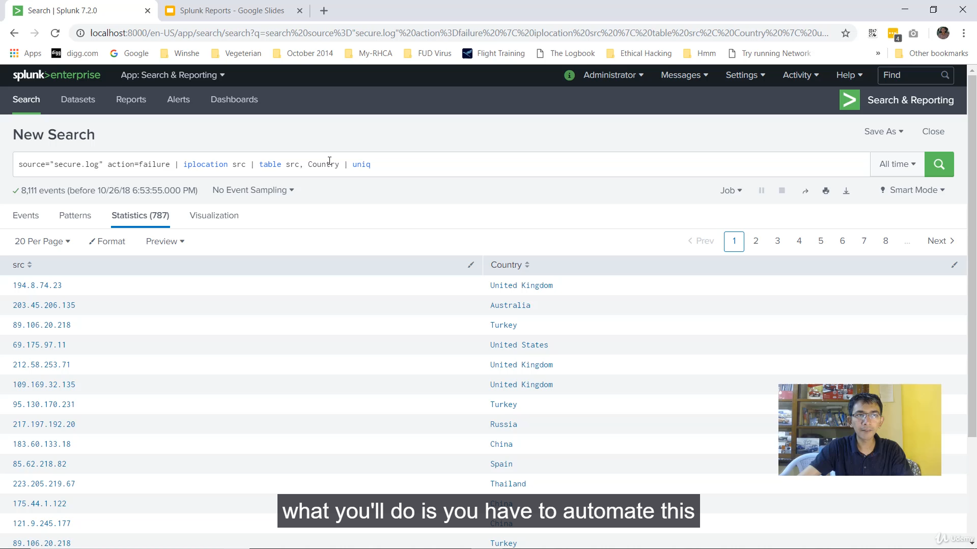

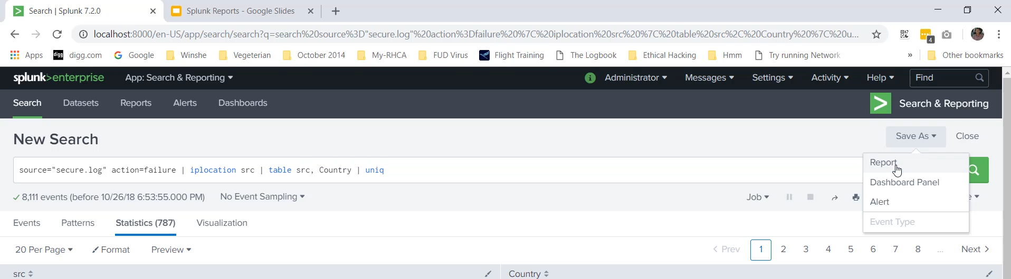

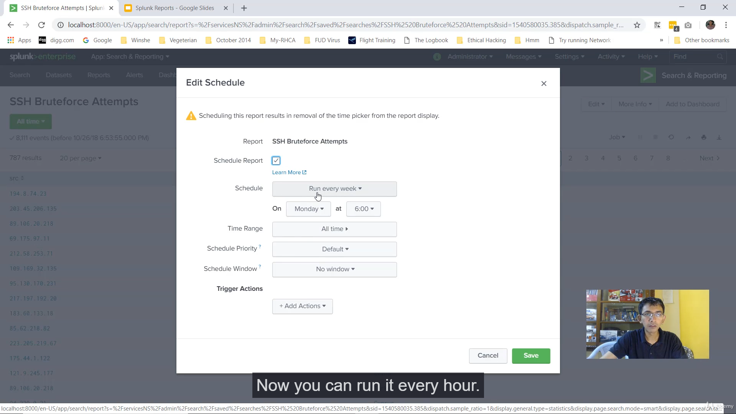

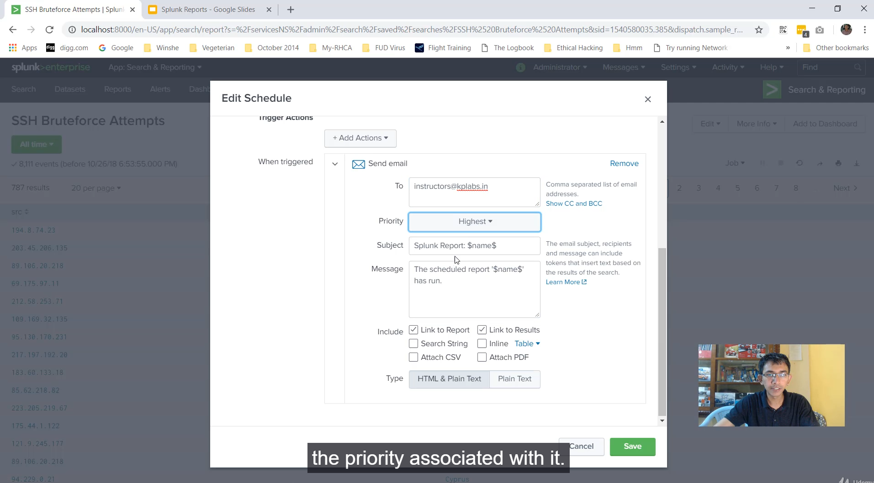

**Splunk Reports: Automation and Scheduling Summary**

Splunk Reports allow users to **save a search query** and automate its execution and delivery, eliminating the need for manual daily searches and exports. This is crucial for operational tasks like compliance checks and security monitoring.

**Sample Use Case: Automated Security Notification**

A security manager requires a daily list of **unique IP addresses** and their **geographic location (country)** from which **failed SSH authentication attempts** were made, delivered via email every 24 hours.

**1. Constructing the Search Query**

The first step is to create a search that provides the required data fields (src_IP and country) and ensures the list contains only unique entries.

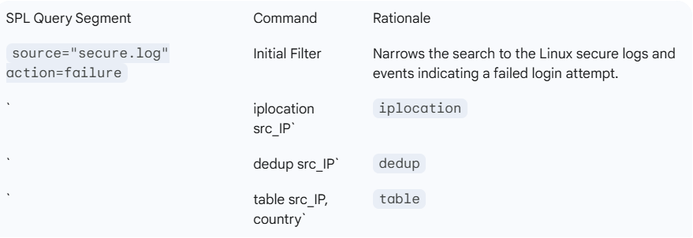

**2. Saving the Search as a Report**

Once the query is finalized and shows the correct output, it is saved as a report:

1. Click **Save As** $\rightarrow$ **Report**.
2. Provide a **Report Title** (e.g., "SSH Brute Force Attempts").
3. Set the **Time Range Picker** (optional, but often kept to allow on-demand historical viewing).

**3. Scheduling and Automating the Report (Post-Action)**

To automate the delivery, the report is scheduled:

1. Navigate to **Reports** $\rightarrow$ **Edit** $\rightarrow$ **Edit Schedule**.
2. Select the **Schedule Report** checkbox.
3. Set the **Schedule:** Select a predefined interval (e.g., **Run every day**) and a specific time (e.g., 12:00 AM).
4. Set the **Time Range:** Specify the period the report should cover (e.g., "Last 24 hours").
5. Set **Schedule Priority** (optional): Used to manage resource contention during high-load periods.2
6. Configure **Trigger Actions** $\rightarrow$ **Send Email**:
   * Specify the recipient's email address (e.g., the Security Manager).
   * Customize the subject line.
   * Under **Include**, attach the **CSV** file (or PDF) to deliver the raw list of IPs and countries directly in the email.
7. Click **Save**.

The report is now automated to run daily and deliver the unique list of failed SSH IPs and their countries to the recipient's email. You can manage and monitor all scheduled reports under **Search and Reporting** $\rightarrow$ **Reports**.

===================================================================================

1. **Understanding Add-Ons and Apps:**

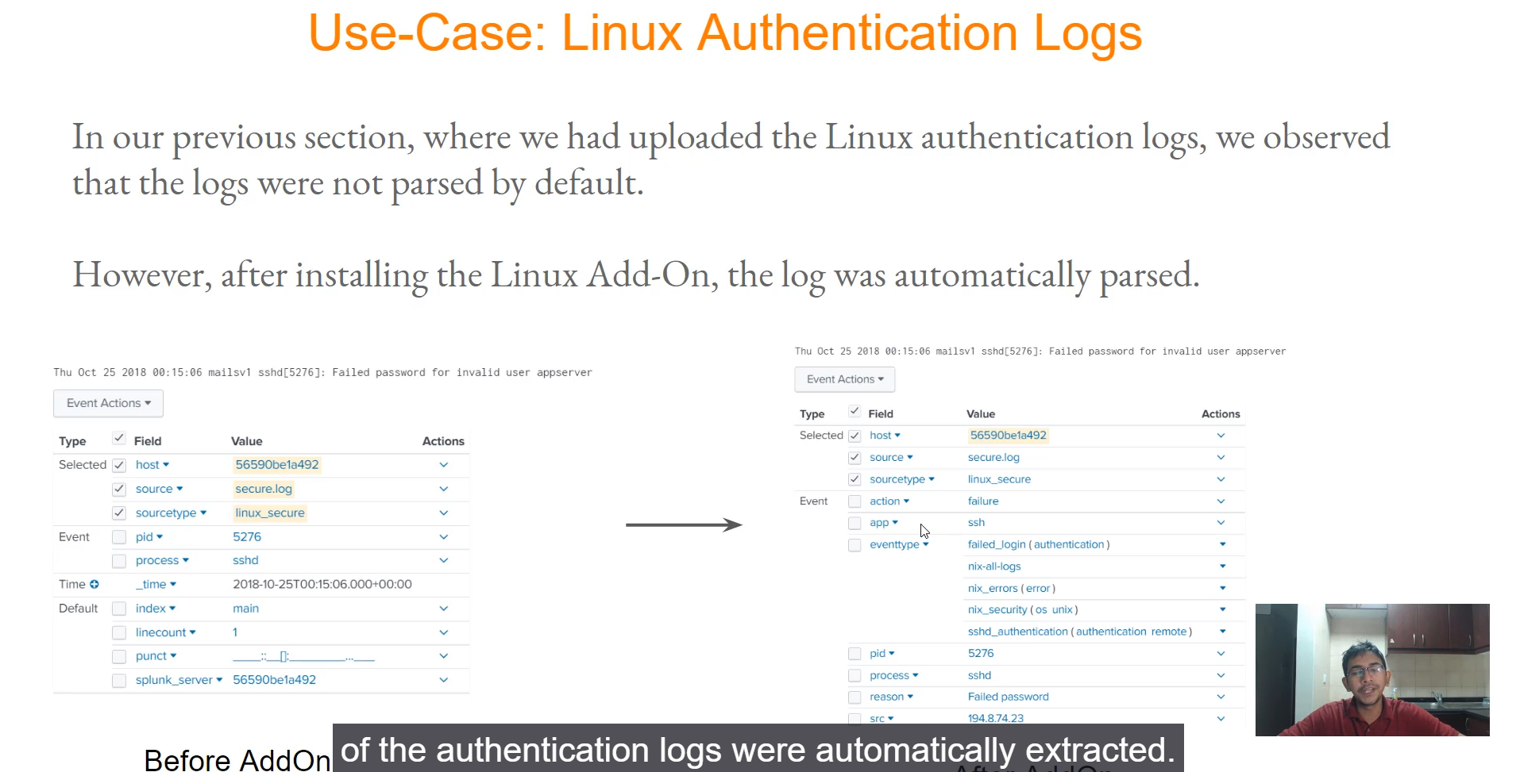

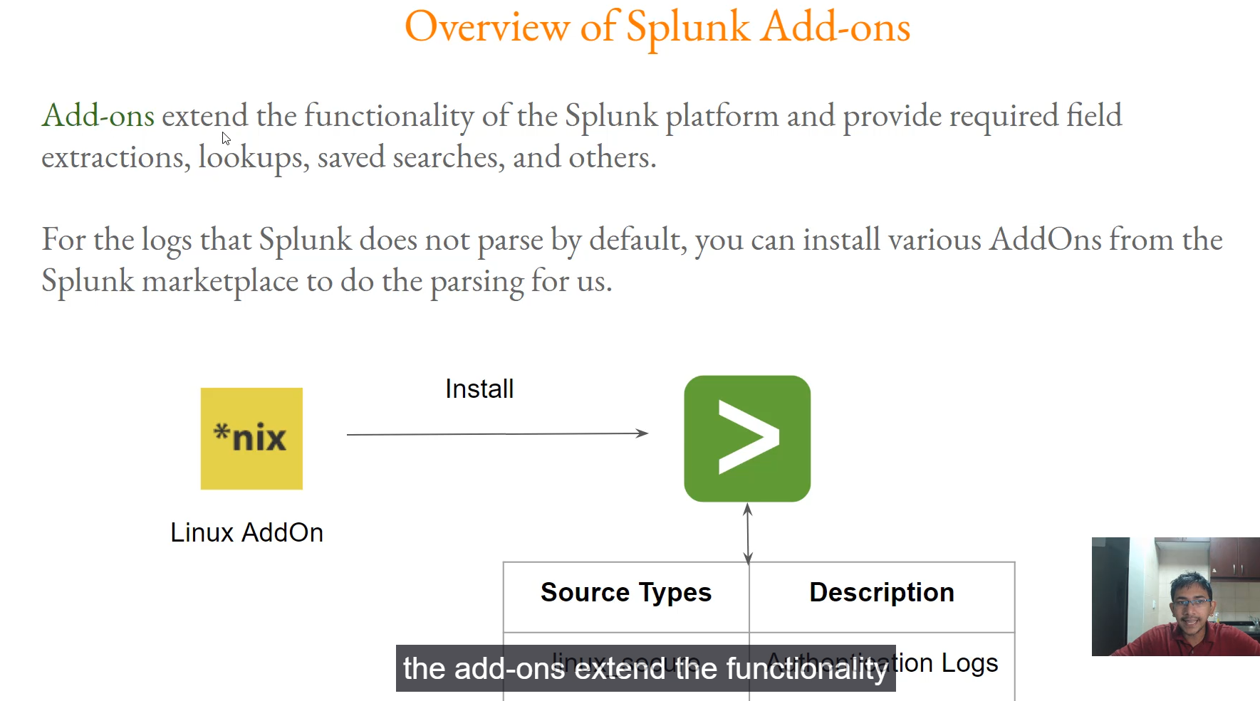

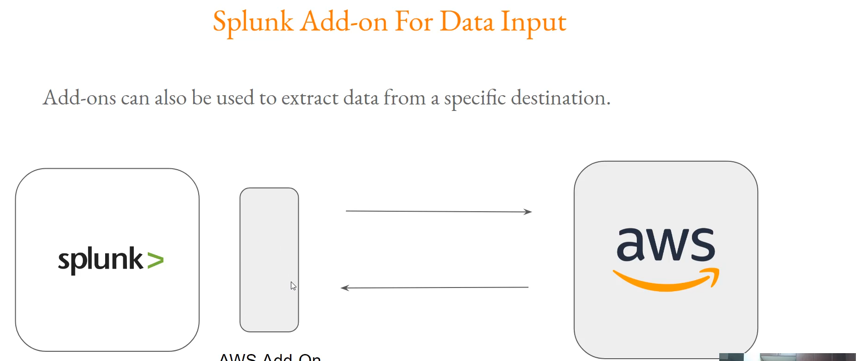

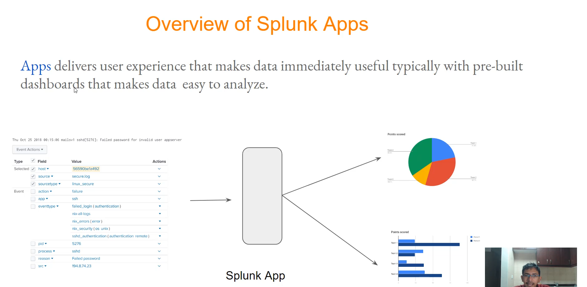

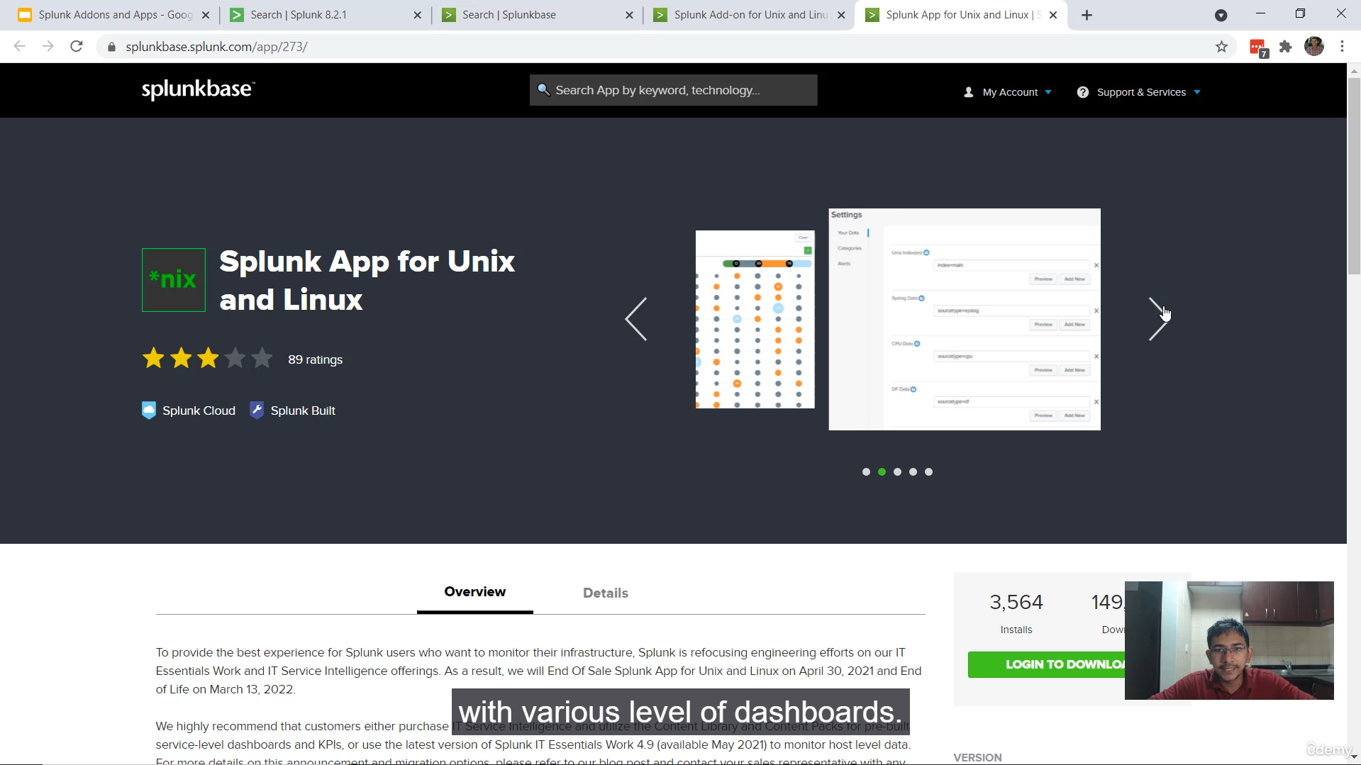

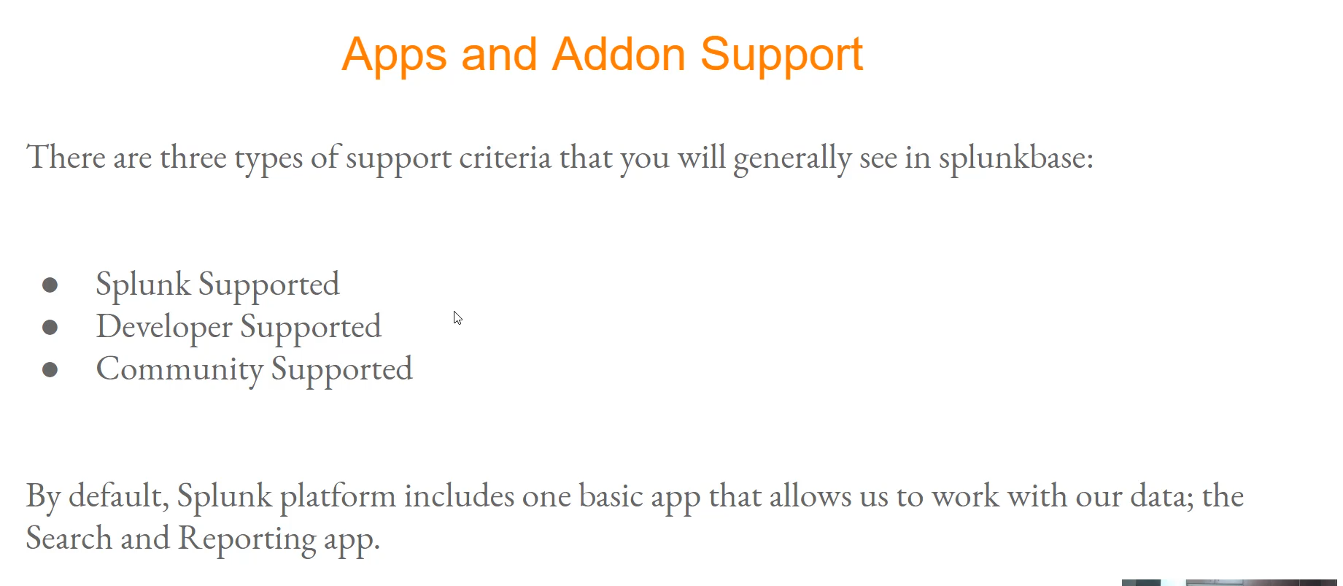

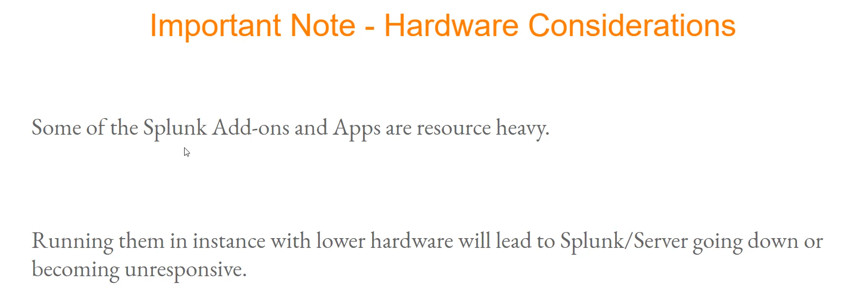

**Splunk Add-ons (TAs - Technology Add-ons)**

Add-ons primarily serve a **back-end** function, focusing on **data processing and ingestion**. They typically **do not have a navigable user interface**.

**Key Use Cases of Add-ons:**

* **Field Extraction and Parsing:** They contain the necessary logic (parsers) to correctly identify and extract various fields from raw log data (e.g., Splunk Add-on for Unix and Linux extracting fields from authentication logs).
* **Data Input:** They provide scripts or modular inputs to fetch data from external sources (destinations) into Splunk.
  + *Example:* An AWS add-on can connect to your AWS environment to fetch logs and metadata (like EBS volume information, S3 details, billing data, VPC flow logs, etc.) and bring them into Splunk.
* **Data Enrichment:** They can contain knowledge objects like look-ups or saved searches to enhance the incoming data.

**Splunk Apps**

Apps are more **comprehensive offerings** that deliver a **user experience** and provide **front-end** functionality. They typically come with a **navigable user interface**.

**Key Use Cases of Apps:**

* **Visualization and Analysis:** They make data immediately useful by providing pre-built content.
* **Dashboards and Reports:** Apps usually include a set of pre-configured dashboards, reports, and workflows, allowing users to analyze a huge volume of events without creating dashboards from scratch (e.g., Splunk App for Unix and Linux provides dashboards for data collected by the corresponding add-on).
* **Targeted Use Cases:** Apps often target a specific domain or operational visibility, such as Security, IT Operations, or a specific technology.

**Hardware and Performance Consideration ⚠️**

A critical note for installing any app or add-on, especially in an enterprise environment, is to **consider the hardware requirements**.

* Some apps, like the **Splunk Enterprise Security (ES) app**, are **resource-heavy** (requiring significant CPU and RAM, often with minimum specifications like 16 physical CPU cores and 32 GB RAM for search heads/indexers in production).
* Installing a resource-heavy app or add-on on a system with insufficient hardware can cause the Splunk instance, or even the underlying server, to become **unresponsive** or **crash**.
* **Best Practice:** Always read the **documentation** for hardware and software requirements, sizing, and performance considerations for new apps and add-ons and **test them in a non-production (dev) environment** first.

**Splunkbase Support Criteria**

Apps and Add-ons on Splunkbase have different support classifications:

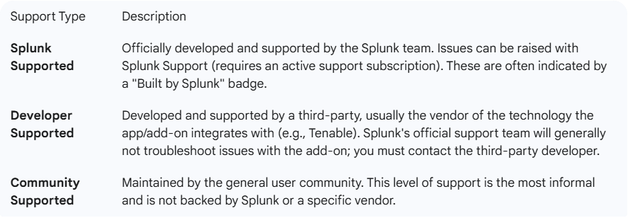

===================================================================================

1. **Installing Splunk Add-On for AWS:**

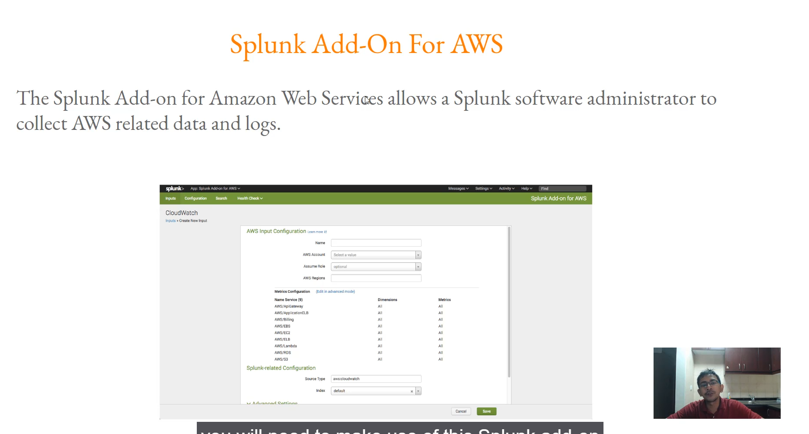

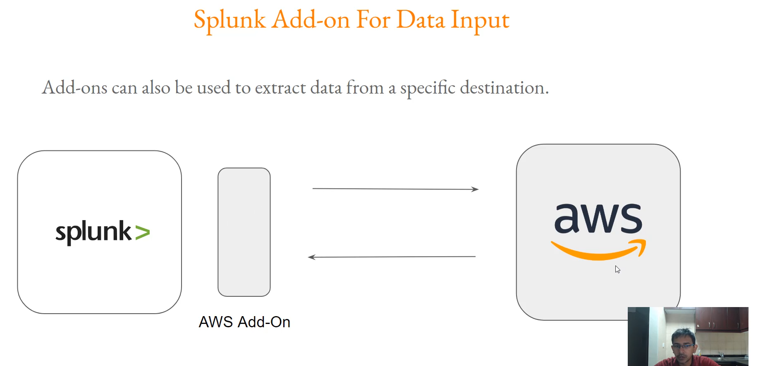

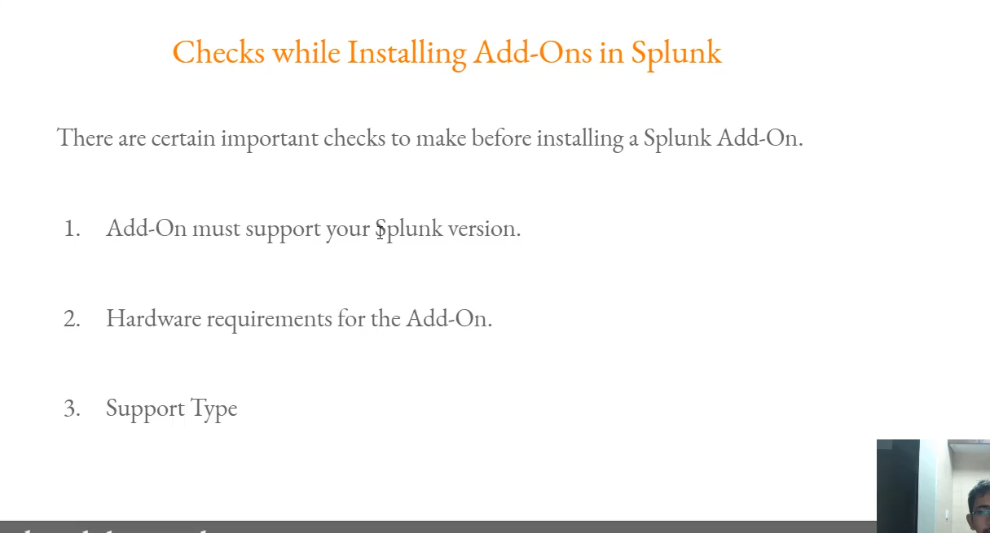

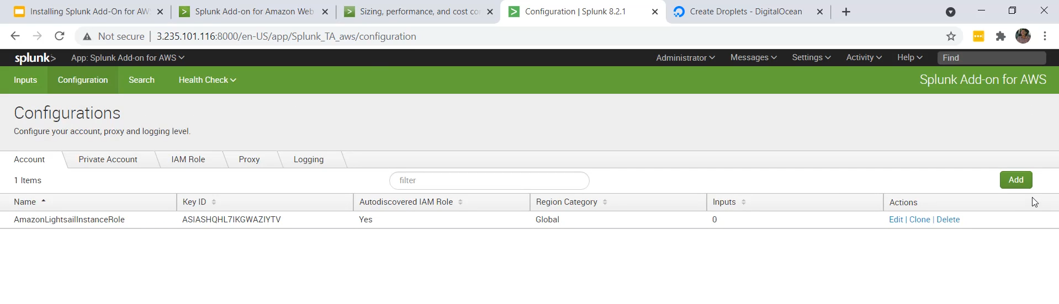

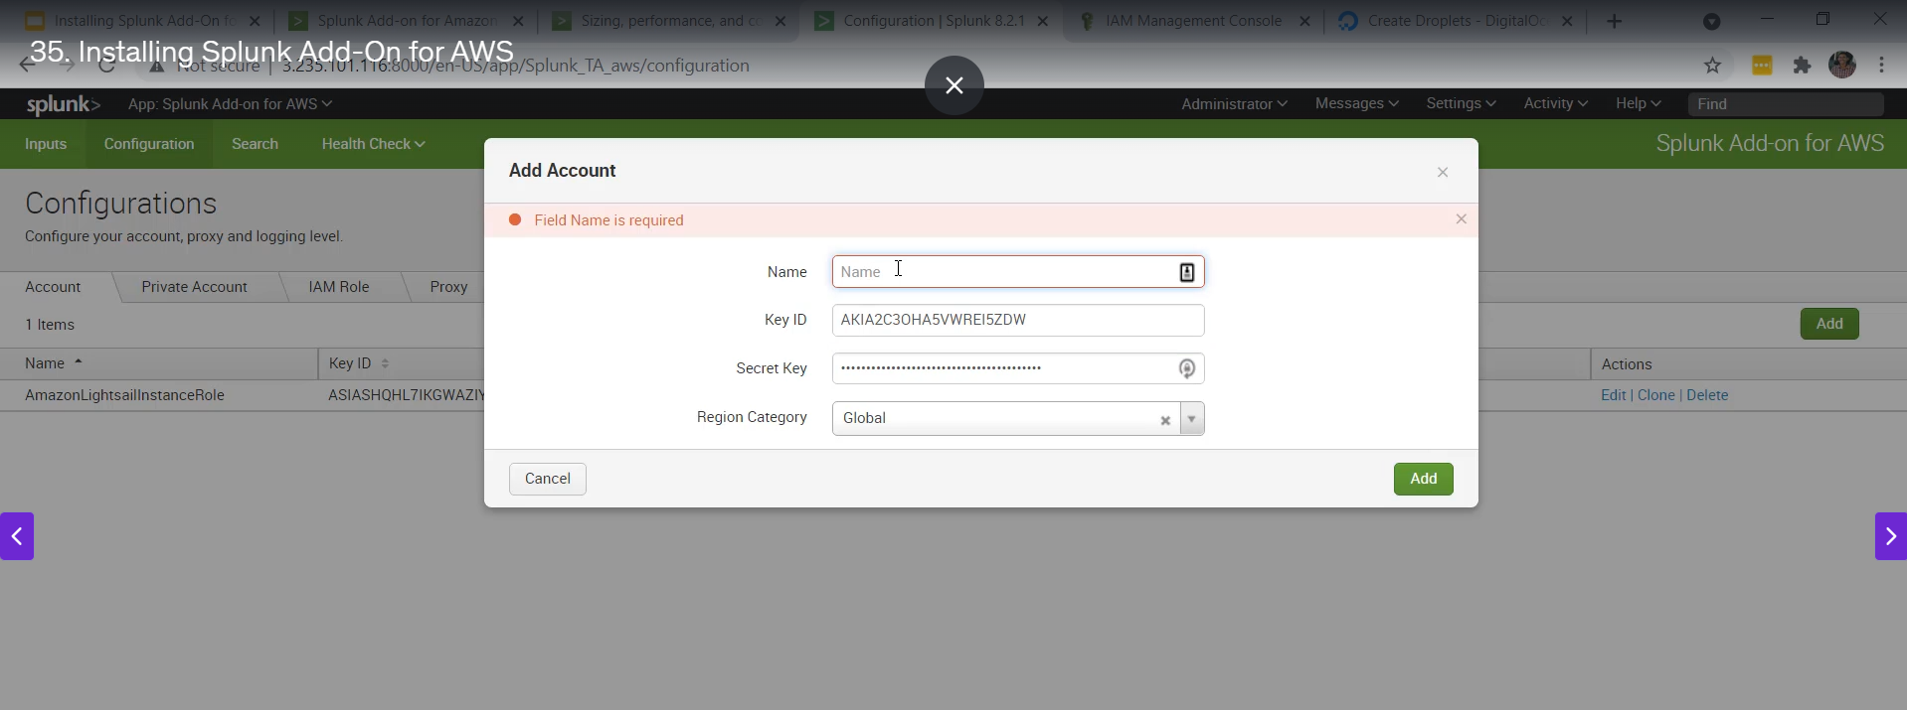

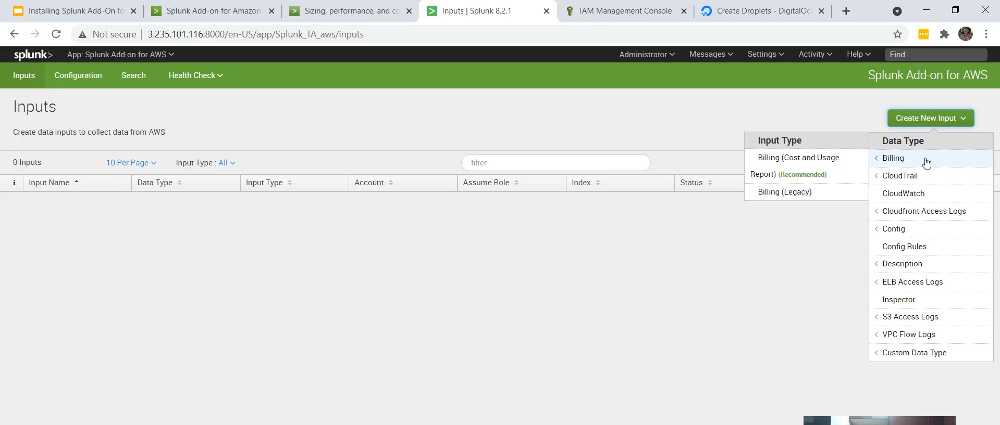

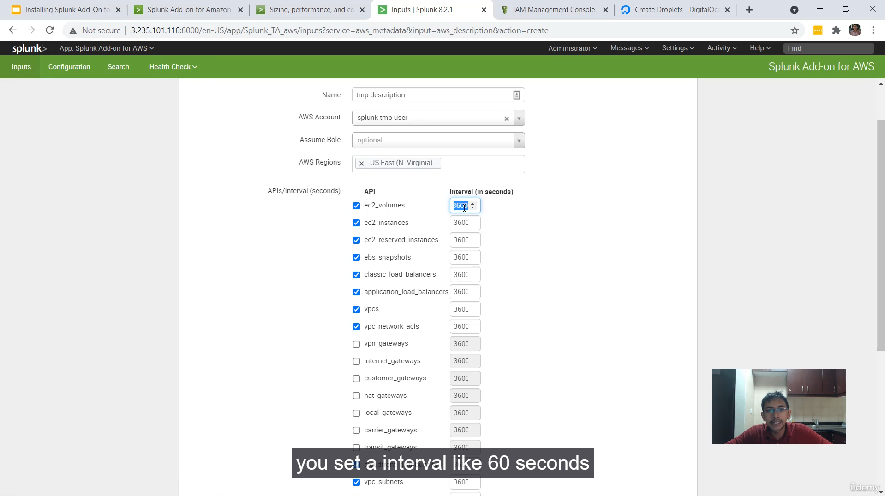

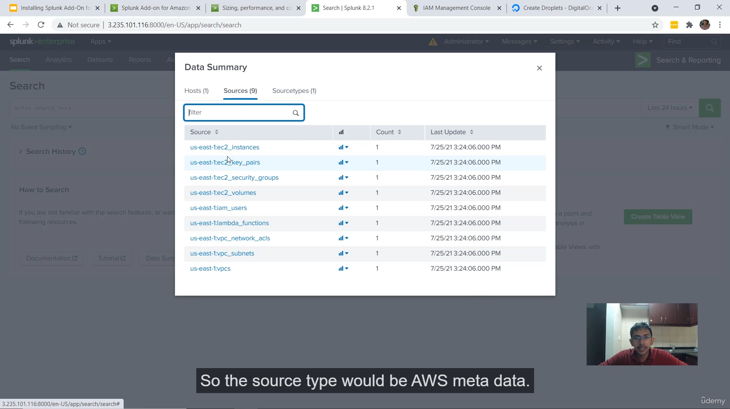

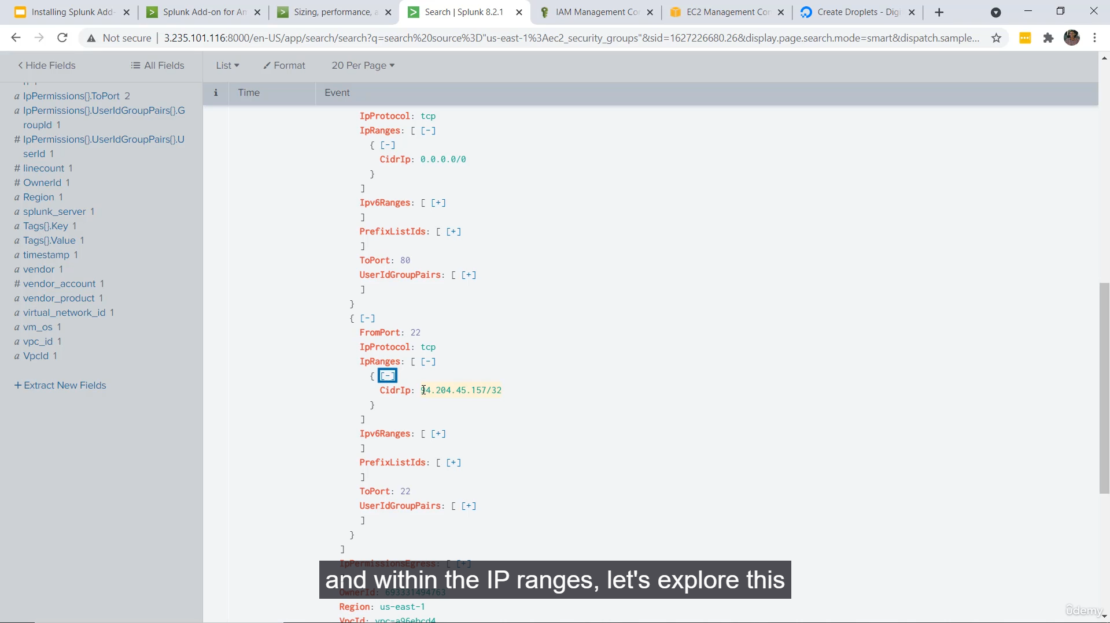

The video is a practical guide on installing and configuring the **Splunk Add-on for AWS (Amazon Web Services)**, emphasizing critical preliminary checks, hardware considerations, and the process of connecting the add-on to an AWS account for data collection.

Here is a summary of the key points discussed in the video:

**1. Basics of Splunk Add-on for AWS**

* **Purpose:** It allows Splunk administrators to collect AWS-related data and logs from multiple AWS environments into Splunk.
* **Architecture:** Splunk $\rightarrow$ Splunk Add-on for AWS $\rightarrow$ Configure AWS Credentials $\rightarrow$ Connects to AWS $\rightarrow$ Fetches required logs/data.

**2. Important Pre-Installation Checks (The "Three Checks")**

1. **Splunk Version Compatibility:**
   * The add-on **must** support the specific Splunk version you are using.
   * Checking the **Compatibility** section on Splunkbase is essential, as some add-ons may only support older major versions (e.g., Splunk 7, not Splunk 8).
2. **Hardware Requirements:**
   * Add-ons can have significant hardware needs, primarily concerning **CPU and memory**.
   * The video shows a **recommended reference architecture** for the Splunk Add-on for AWS: **m4.4xlarge** (AWS instance type) with **64GB RAM** and **16 vCPU**.
   * Failing to meet these requirements can lead to severe performance degradation.
3. **Support Type:**
   * Check if the add-on is **built by Splunk** and is **Splunk supported**.
   * For large enterprises and production environments, official Splunk support is beneficial for troubleshooting unexpected errors when dealing with terabytes of data.

**3. Practical Hardware Demonstration (1GB vs. 4GB RAM)**

* The presenter tested the add-on on two newly created servers: one with **1GB RAM** (IP 117) and one with **4GB RAM** (IP 116).
* **Result on 1GB RAM Server:** After installation, the add-on's configuration page immediately went into a **loading state** and failed to load. Attempting to open the Splunk web UI in a new tab showed it was not loading at all, demonstrating that insufficient hardware can completely cripple the Splunk instance.
* **Result on 4GB RAM Server:** The add-on's input page successfully loaded (albeit with a slight lag), confirming it is the minimum practical requirement for a demo/testing environment.
* **Conclusion:** Hardware requirements are critical; running the add-on on a low-spec server (like 1GB RAM) will make the server unusable. The minimum recommended for a test is **4GB RAM**.

**4. Connecting the Add-on to AWS**

* **Configuration:** Go to the add-on's **Configuration** page to set up AWS access.
* **Credential Types:**
  + **Access Key ID and Secret Key:** A user named "Splunk" was created in AWS IAM with **Programmatic Access** and a **Read Only Access** policy to obtain the keys for the demo.
  + **IAM Role (Recommended):** If the Splunk servers are hosted within the AWS environment, using an **IAM Role** is the more secure and recommended best practice.

**5. Configuring Data Collection (Inputs)**

* **Creating an Input:** Go to the **Inputs** tab and create a new input. The demo uses the **Metadata Boto 3** input type for simplicity to verify functionality.
* **Input Parameters:**
  + **AWS Account:** Select the configured access/secret key (e.g., Splunk temp user).
  + **Region:** Select the AWS region from which to collect data (e.g., North Virginia).
  + **Services:** Select what to collect (e.g., EC2, IAM, S3, VPCs).
  + **Interval:** This is a **very important practical consideration**.
    - Do **not** set a very low interval (e.g., 60 seconds).
    - A low interval can **slow down the Splunk instance** and, more importantly, cause a huge number of AWS API calls, potentially leading to **API throttling** or impacting a large production environment.
    - The recommended starting interval for testing is **3,600 seconds**.
* **Verifying Data:** Once the input is saved, the add-on connects and fetches data. The presenter verified the fetched data by searching in Splunk (e.g., sourcetype=aws:metadata for security groups) and comparing the results (like inbound rules) with the actual AWS EC2 console.

**6. Best Practices After Practical Completion**

* **Security:** After finishing the practical, it is crucial to **disable the specific input** in the Splunk add-on and, ideally, **delete the IAM user** (or disable the access/secret key) to prevent the keys from being leaked or misused.

===================================================================================

1. **Overview of Splunk Reports:**

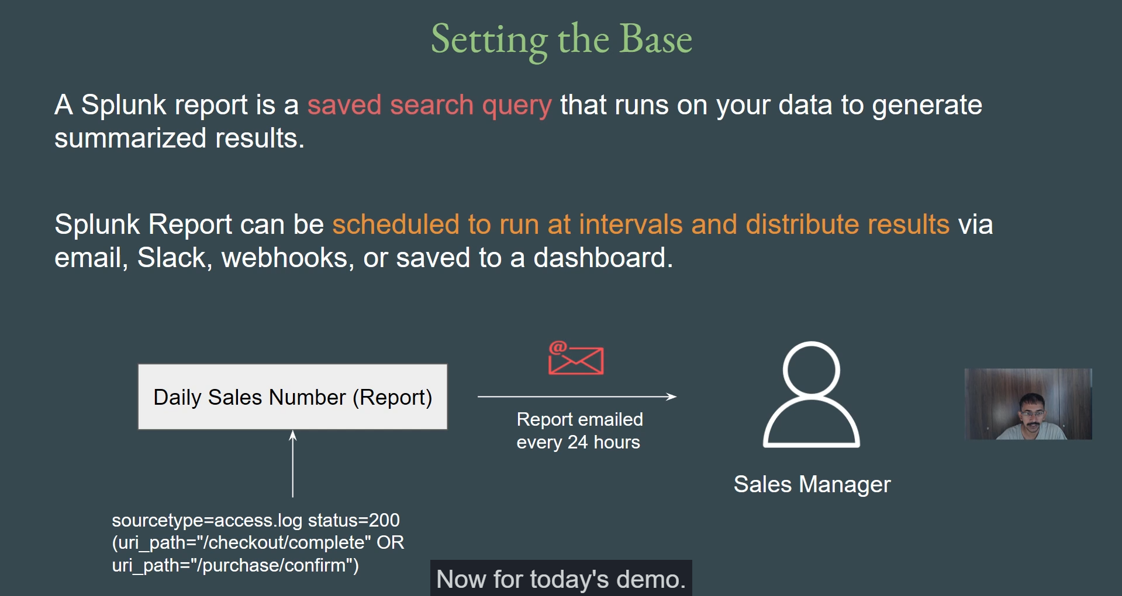

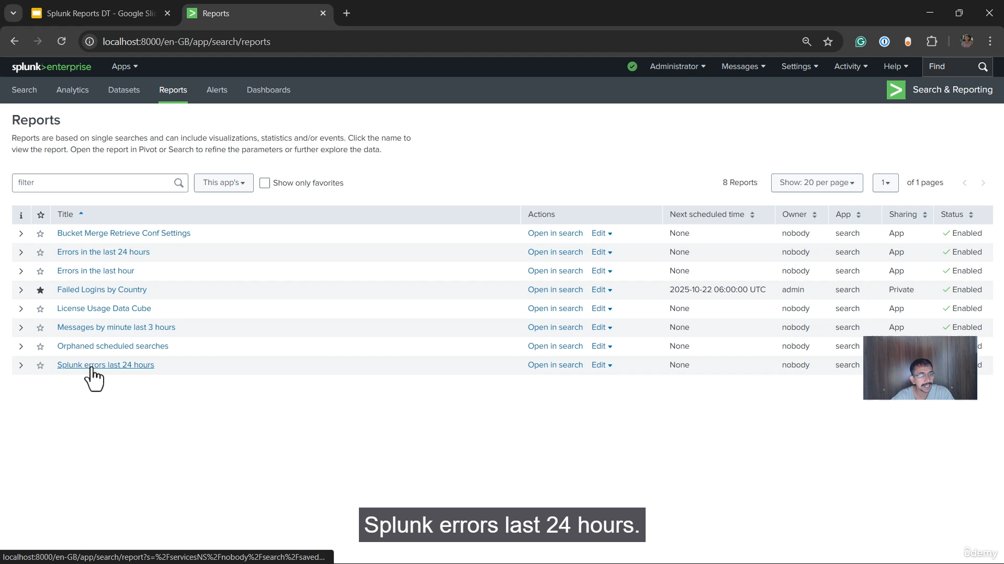

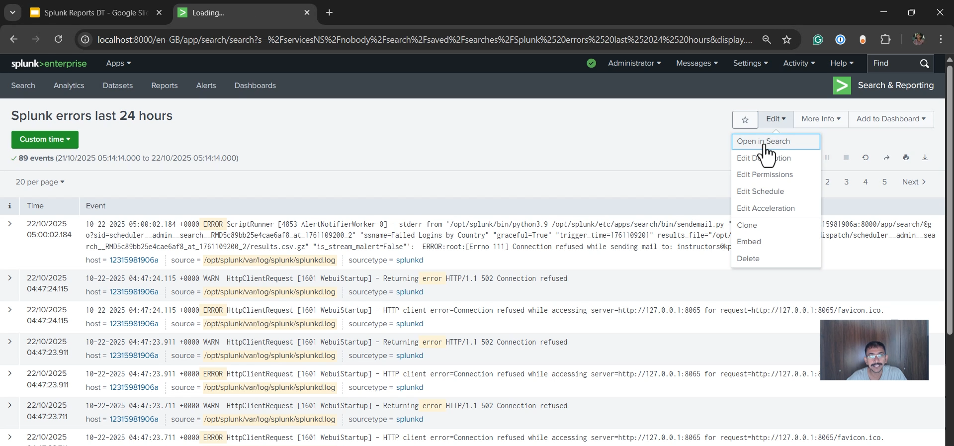

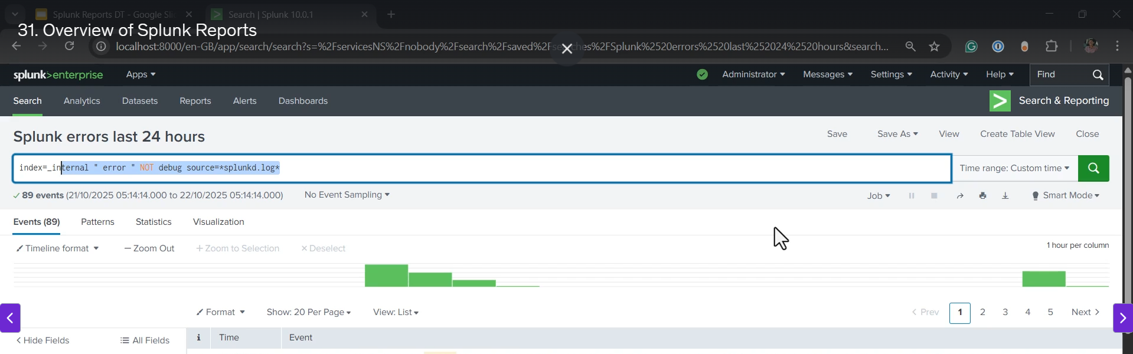

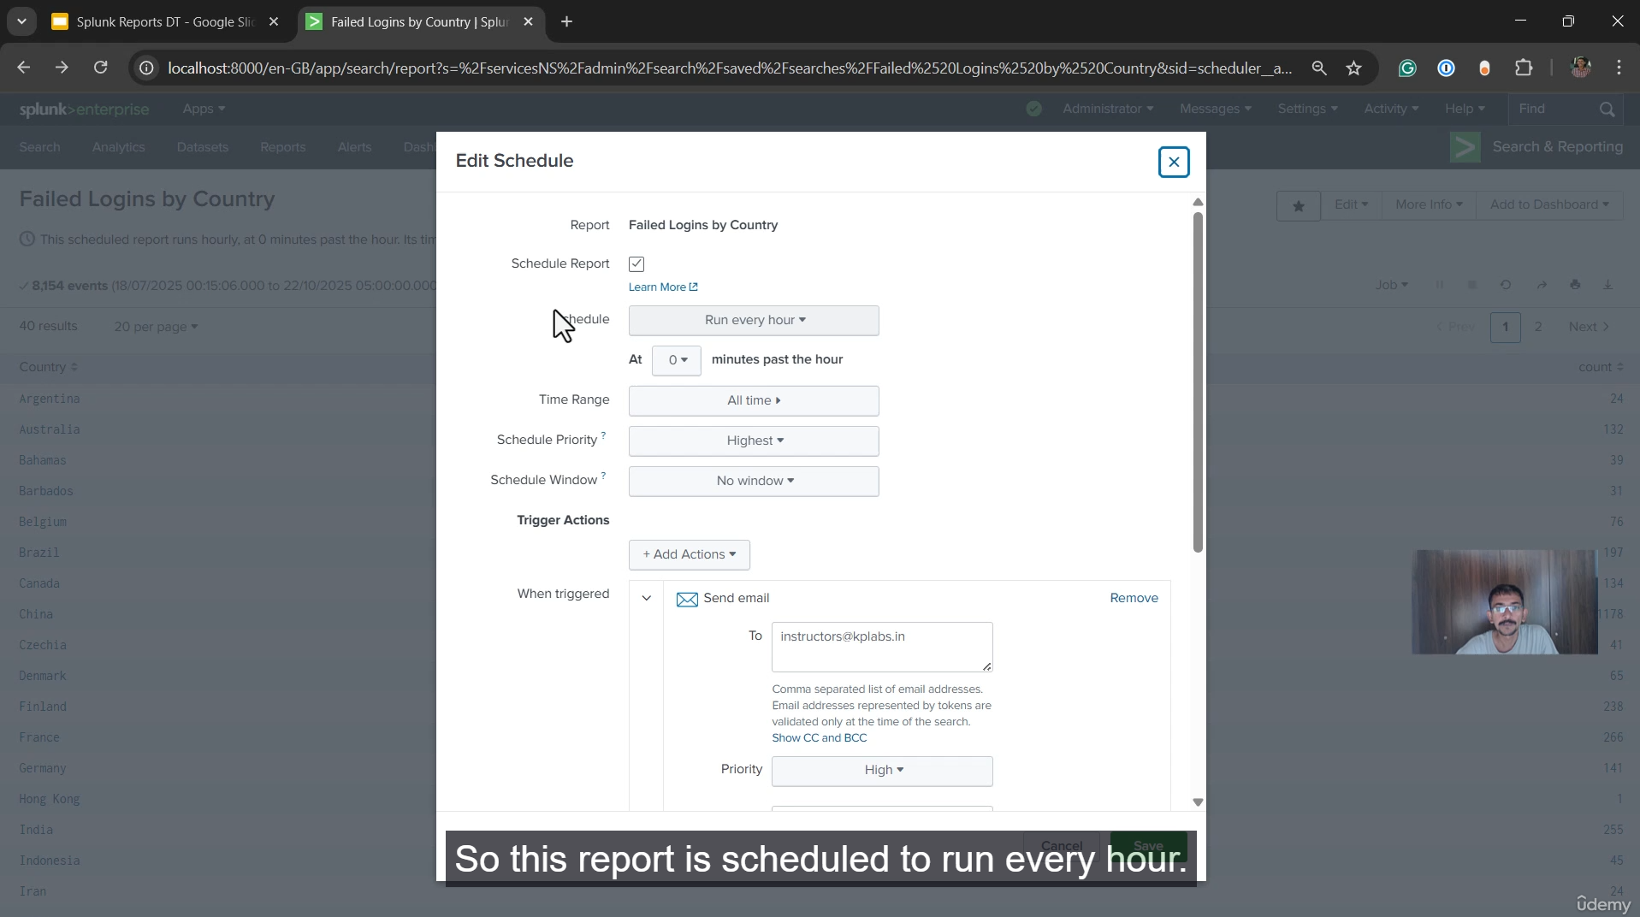

**1. Definition and Overview of Splunk Reports**

* **A Splunk Report is a saved search query** that runs on your indexed data to generate summarized results.
* It is essentially the **Saved Search Query (SPL query)** that you would normally run manually, but it is stored within the report.
* Reports provide the **direct output/results** without the user having to manually re-run the Search Processing Language (SPL) query every time.

**2. Key Benefits and Features**

* **Automation/Scheduling:** One of the most significant benefits is the ability to **schedule** the report to run automatically at regular intervals (e.g., every 24 hours, weekly, monthly, or via a custom cron schedule). This eliminates the need for manual execution.
* **Result Distribution:** The summarized results of the report can be automatically **distributed** to appropriate stakeholders (like a sales manager or a security manager) through various channels, including:
  + Email (e.g., with results attached as PDF, CSV, etc.)
  + Slack (via Webhooks)
  + Webhooks
  + Saved to Dashboards
* **Customization:** There are various customization options available for scheduling, distribution, and prioritizing the report runs (e.g., setting a **Schedule Priority** to Highest for critical, timely reports).

**3. Workflow Example (Daily Sales Number Report)**

1. **Create the SPL Query:** Develop the SPL query that finds the required data (e.g., the daily sales number).
2. **Create the Report:** Save the query as a report (e.g., "Daily Sales Number Report").
3. **Schedule:** Set the report to run at regular intervals (e.g., every 24 hours).
4. **Distribute Results:** Configure the report to automatically send the output (e.g., as a PDF or CSV) via email to the sales manager.
5. **Automation:** The entire process becomes automated, ensuring the manager receives the report every day without manual intervention.

**4. Demonstration in Splunk**

The speaker walks through the **Reports** section in the Splunk Search and Reporting app, showing:

* How to open an existing report (e.g., "Splunk errors last 24 hours" or a custom "failed logins by country" report) to see the immediate output.
* How to find the underlying **SPL Query** for any report by selecting **Open in Search**, confirming that the report is a saved search query.
* How to access the **Edit Schedule** and **Add Actions** options (like "Send email") to configure the report's automation and distribution.

In essence, Splunk reports transform a one-time search query into a **recurring, automated data delivery mechanism** for business and operational intelligence.

===================================================================================

1. **Practical – Splunk Reports:**

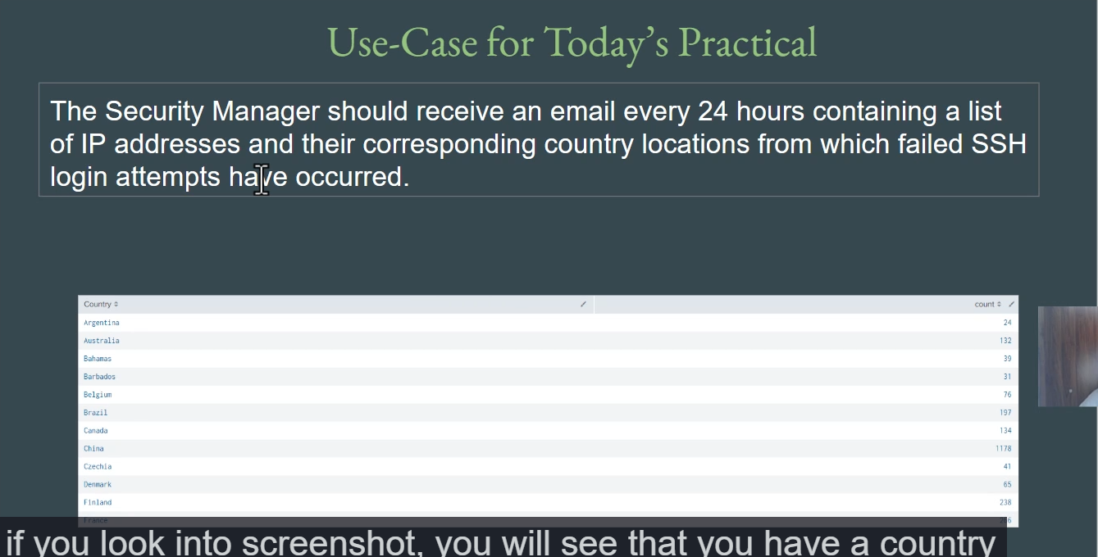

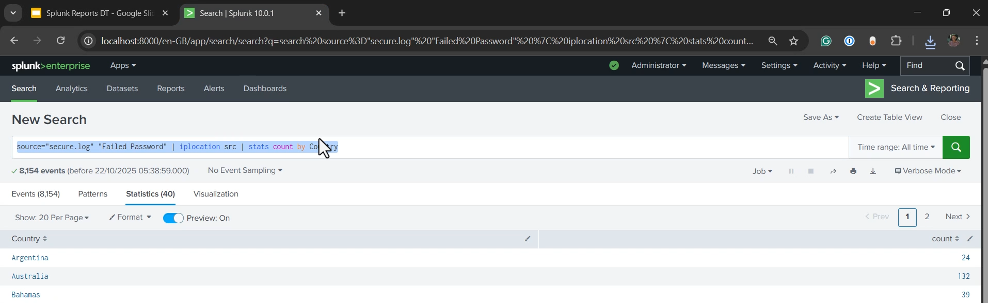

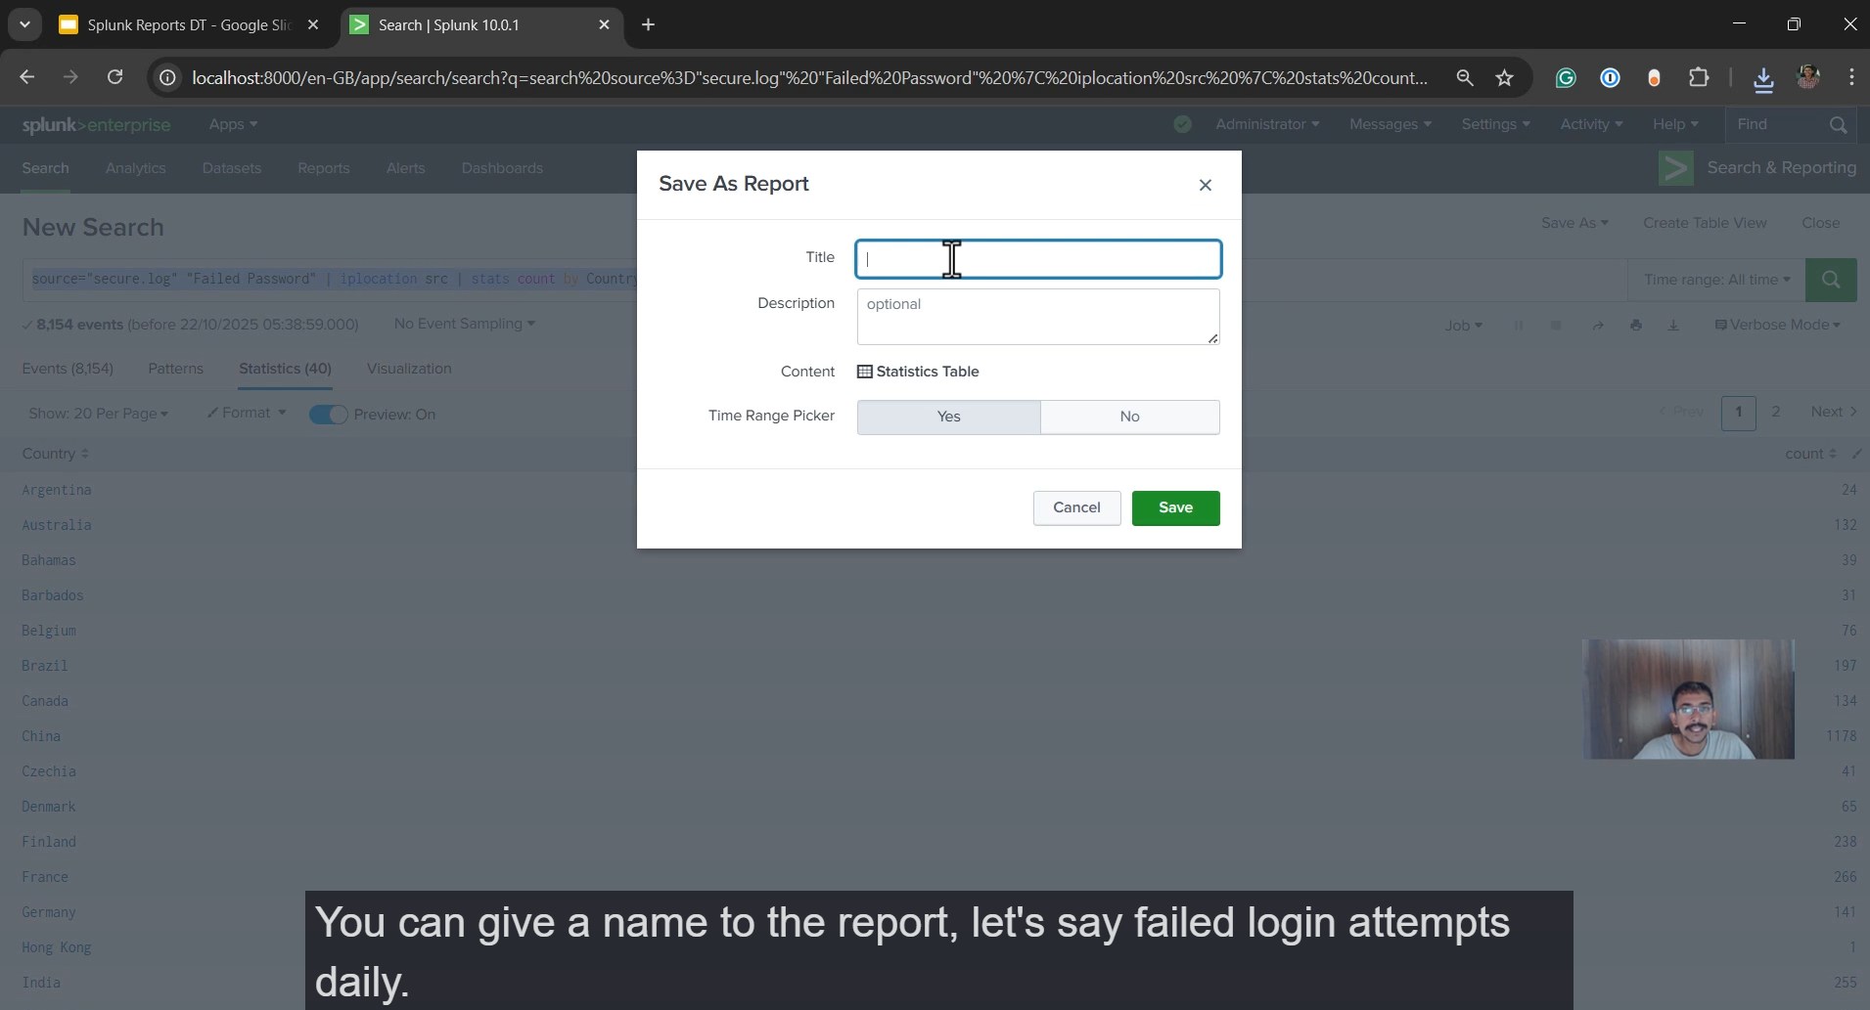

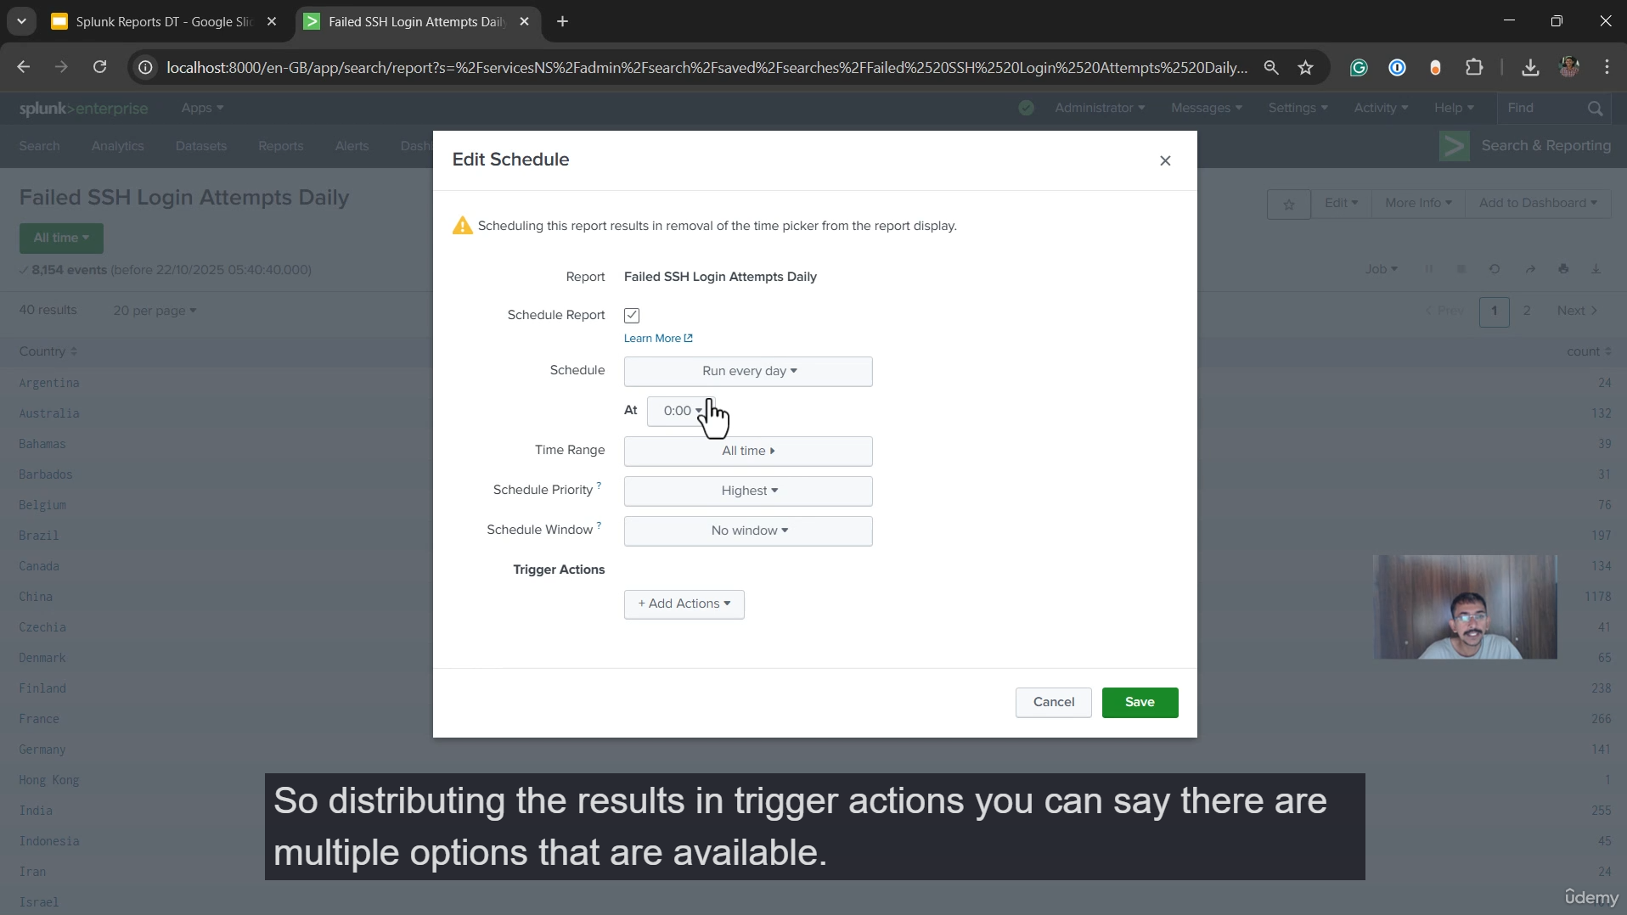

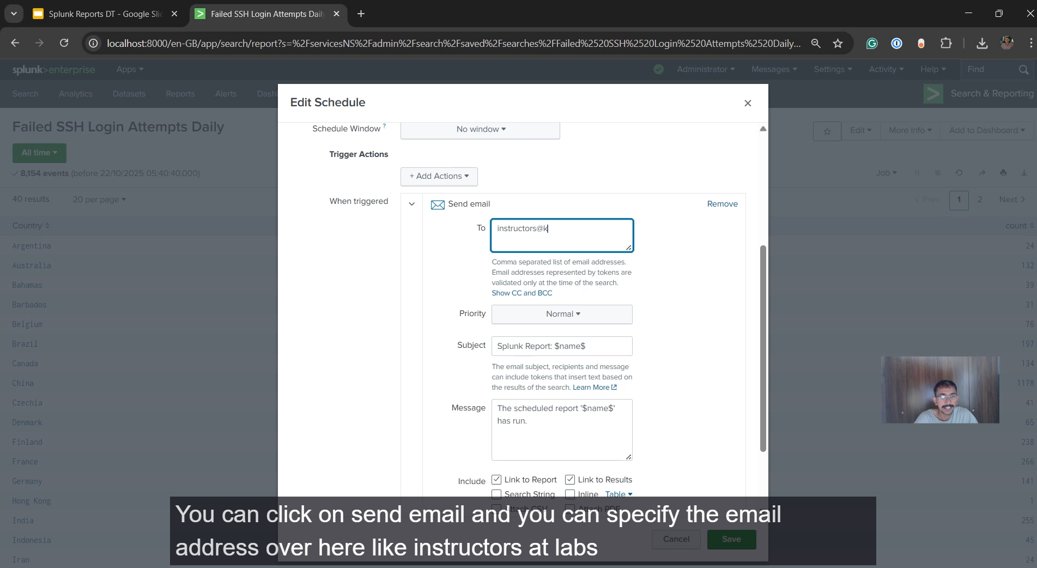

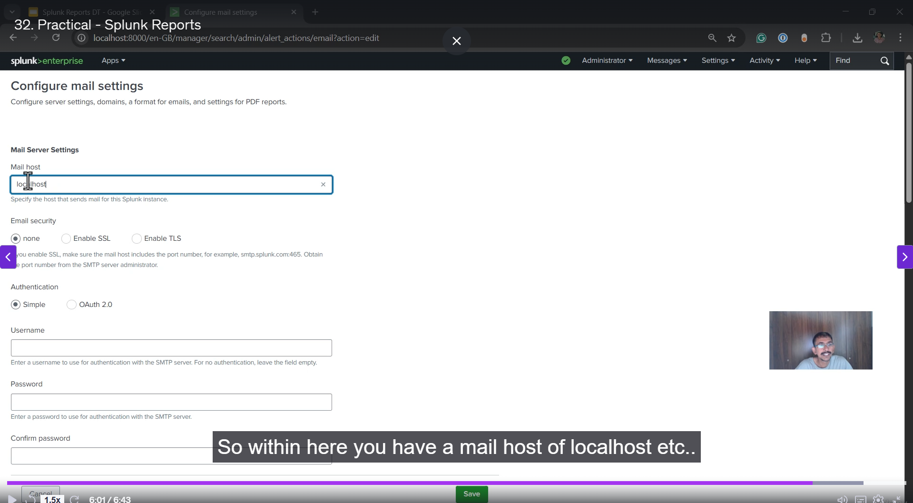

**1. Write the Splunk Search Processing Language (SPL) Query**

The goal is to find all "failed password" events over SSH, extract the IP address to determine its geographic location (country), and then count the number of failed attempts per country.

**The suggested SPL query is:**

sourcetype="secure.log" "failed password" ssh | iplocation <IP_FIELD_NAME> | stats count by Country

**2. Save the Search as a Report**

Once the query is complete and produces the desired results (Country and count of failed login attempts), it must be saved as a report.

1. **Run the SPL Query:** Execute the query in the Splunk Search & Reporting app.
2. **Save as Report:** Click the **Save As** button (usually located above the search bar) and select **Report**.
3. **Name the Report:** Provide a unique and descriptive name, such as **failed login attempts daily**.
4. **Save:** Click **Save** to finalize the report creation.

**3. Configure the Report Schedule and Email Distribution**

To automate the delivery of the report to the security manager, you need to configure a schedule and a distribution action.

**A. Scheduling the Report**

1. **Access Report Settings:** Navigate to the **Reports** section of the Splunk app, or if prompted after saving, click **View** or **Edit** the report.
2. **Edit Schedule:** Click **Edit** next to the report, and then select **Edit Schedule**.
3. **Schedule Report:** Check the **Schedule Report** option.
4. **Set Frequency:** Set the schedule to **Run every day** (or a custom Cron schedule) to meet the "every 24 hours" requirement.
5. **Set Schedule Priority (Optional):** Adjust the **Schedule Priority** if necessary (e.g., to Highest) to ensure the report runs promptly, especially on a busy Splunk instance.

**B. Distributing the Results via Email**

1. **Access Trigger Actions:** Within the **Edit Schedule** dialog, look for the **Trigger Actions** section (or the **Add Actions** button).
2. **Select Send Email:** Click **Add Actions** and choose **Send Email**.
3. **Specify Recipients:** Enter the security manager's email address in the **To** field (e.g., instructors@labs.in).
4. **Attach Results:** Select an attachment format for the report results, such as **Attach CSV** or **Attach PDF**. The CSV format is often preferred for data that may need further manipulation or logging.
5. **Save:** Click **Save** to apply the scheduling and email settings.

**C. Prerequisites (Email Configuration)**

For the email distribution to work, the **Splunk server must be correctly configured to send email**. This is an administrative task:

1. **Access Email Settings:** Go to **Settings** $\rightarrow$ **Server Settings** $\rightarrow$ **Email Settings**.
2. **Configure SMTP:** You must specify the **Mail host** (the SMTP server address), and potentially a username and password if the server requires authentication.
3. **Authentication:** Ensure the necessary authentication and email-sending permissions are correctly set on the Splunk instance and the mail host.

Once the report is scheduled and the SMTP settings are configured, the Splunk instance will automatically run the SPL query every 24 hours and email the generated results (list of countries and failed login counts) to the specified recipient.

===================================================================================

1. **Overview of Splunk Alerts:**

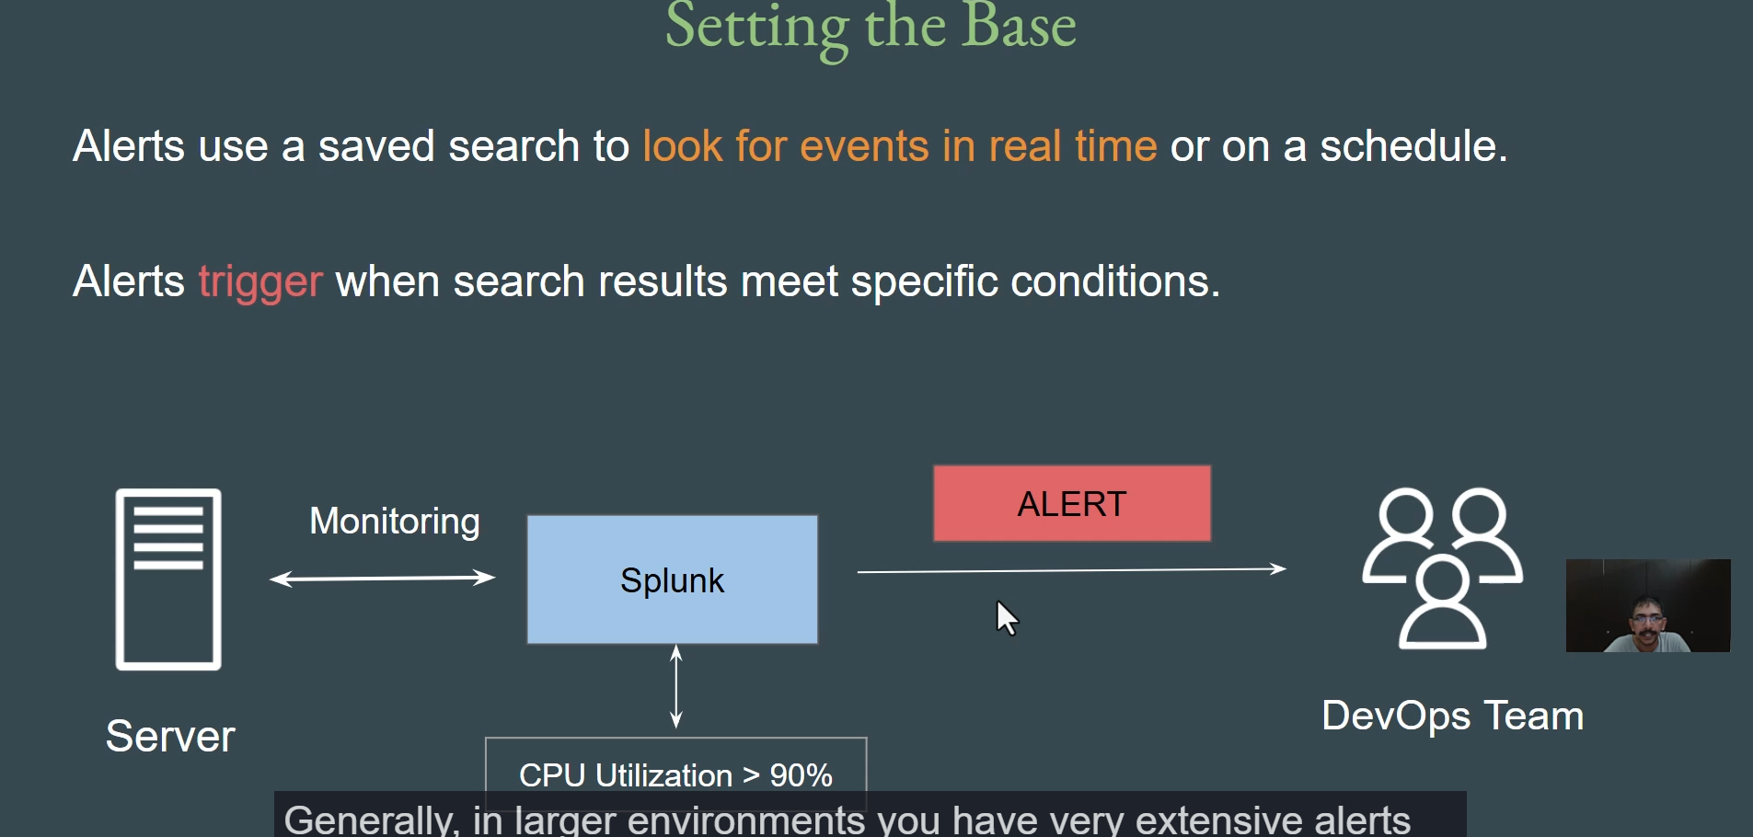

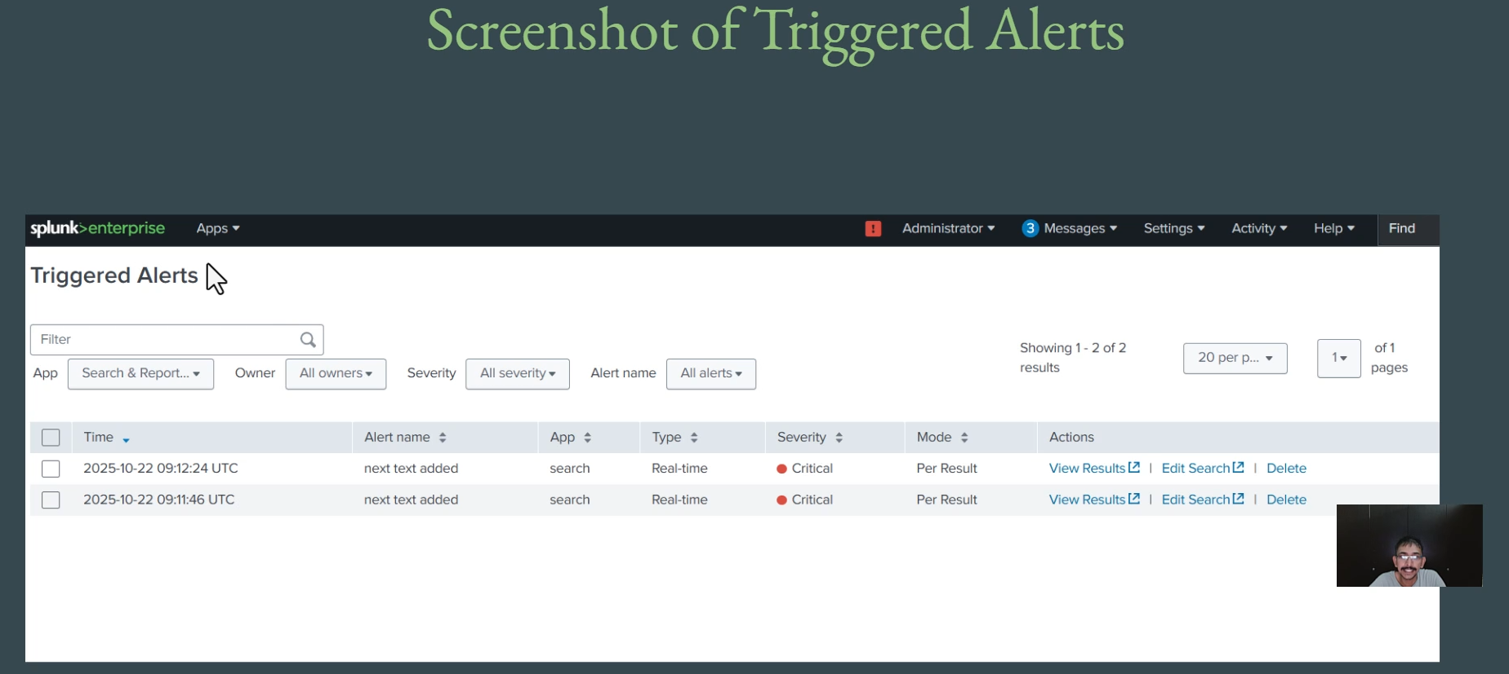

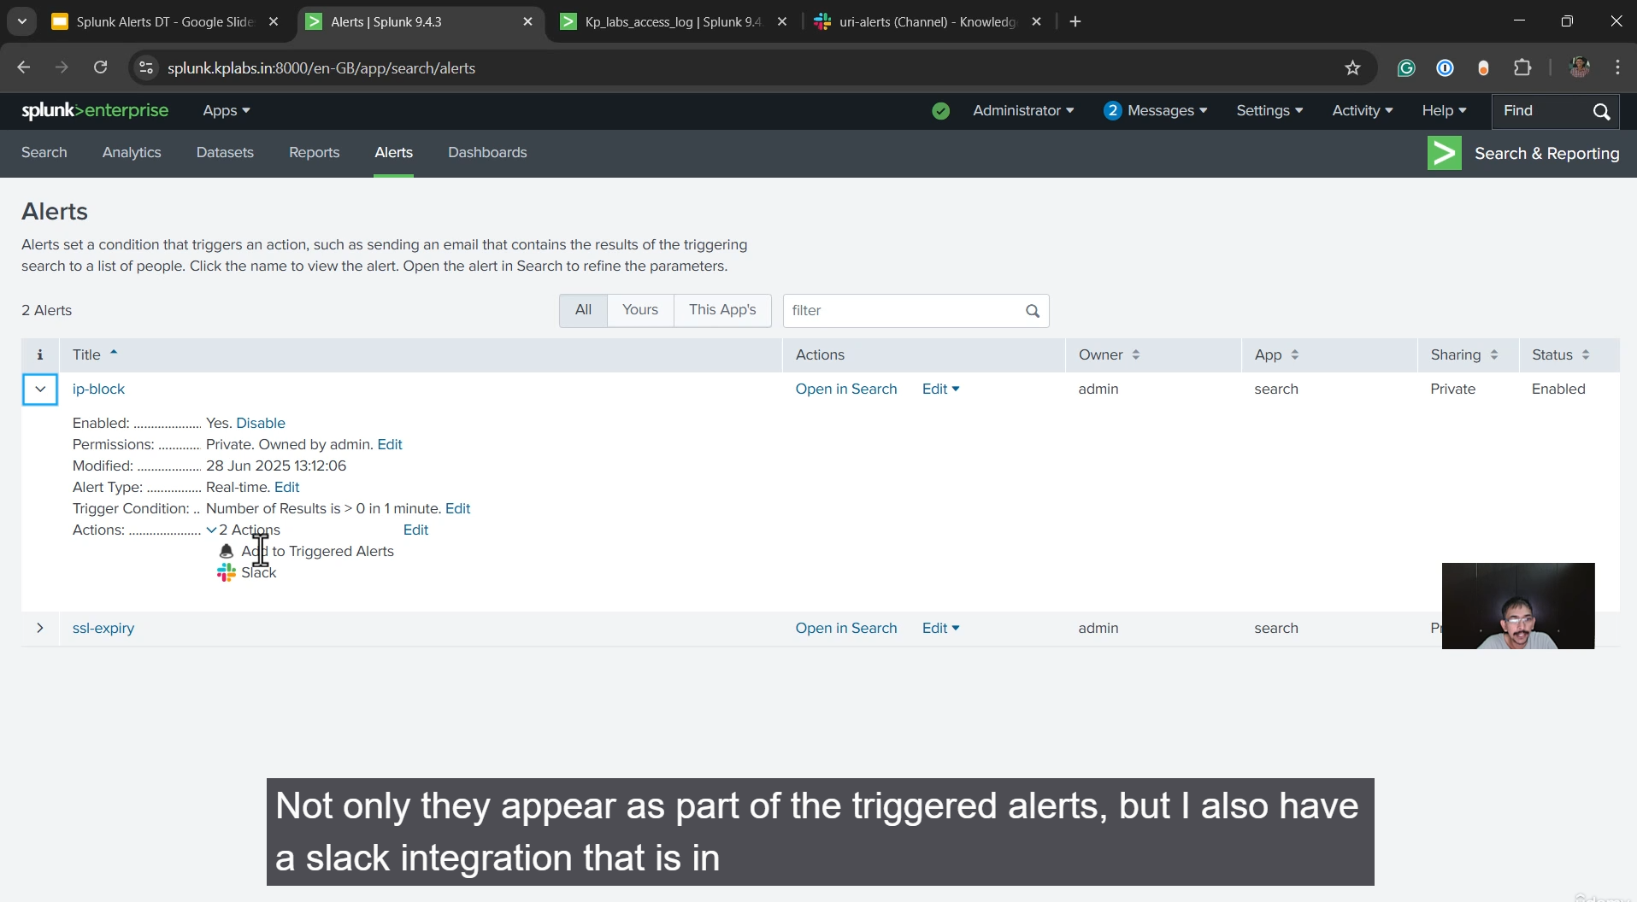

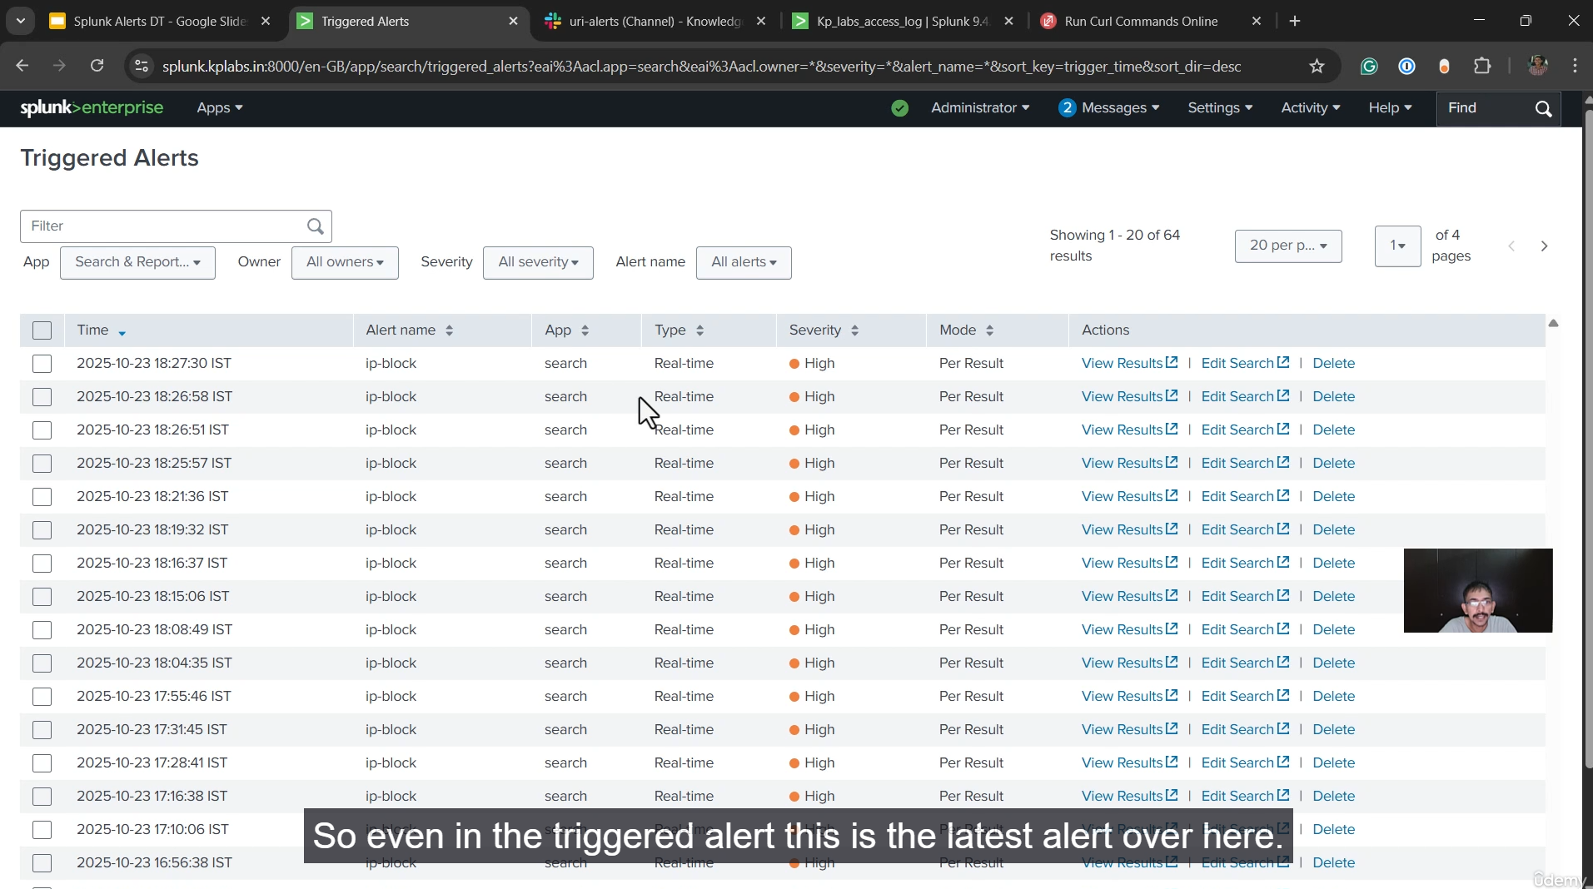

The key takeaways from the discussion on **Splunk Alerts** are their fundamental role in **real-time security monitoring** and operational awareness within production environments.

Alerts are based on **saved searches** that run in real-time or on a schedule, designed to detect specific, critical events.

**Key Concepts of Splunk Alerts**

* **Definition:** A Splunk Alert uses a **saved search** to continuously monitor event data.
* **Purpose:** Alerts are crucial for the timely detection of security attacks (like probing for sensitive files or brute-force attempts) and operational issues (like high CPU utilization) in production environments.
* **Trigger Mechanism:** An alert **triggers** when the search results meet a specific set of **conditions**.
  + *Example:* An alert can be set to trigger when a server's CPU utilization, as logged in Splunk events, is greater than 90%.

**Alert Actions and Notification**

When an alert is triggered, it executes one or more configured **alert actions** to notify the relevant teams or take automated steps.

Common alert actions include:

1. **Adding to Triggered Alerts:** The event is logged in the Splunk **"Triggered Alerts"** dashboard, providing a history and a central point for review.
2. **External Notifications:**
   * **Slack/Teams:** Sending instant messages to a team channel for immediate visibility.
   * **Email:** Sending a detailed notification to a recipient list.
   * **Running Scripts:** Executing a custom script, potentially to automate a response like blocking an attacker's IP address in a firewall.

**Practical Security Examples**

The video demonstrated the importance of alerts using a live test setup monitoring a website's traffic:

* **Probing for Sensitive Paths (IP Block Alert):**
  + **Attack Type:** Attackers attempt to open non-existent or sensitive URI paths (e.g., /admin, /.env, /dot.git/config) to find vulnerabilities or exposed files.
  + **Alert Value:** A configured alert immediately detects these attempts, even though they result in a "404 Not Found" error, and notifies the security team instantly via Slack.
* **Brute Force/DoS Attempts:** High counts of requests from a single IP address can indicate a **brute-force attack** or a form of **Denial of Service (DoS)**, which alerts help to identify quickly.
* **Real-Time Response:** The quick, real-time nature of the alerts (as demonstrated by the instant Slack notification after a manual curl request) allows the security team to identify the source IP and the malicious URI path to take defensive measures, such as blocking the IP address.

===================================================================================

1. **Practical - Splunk Alerts:**

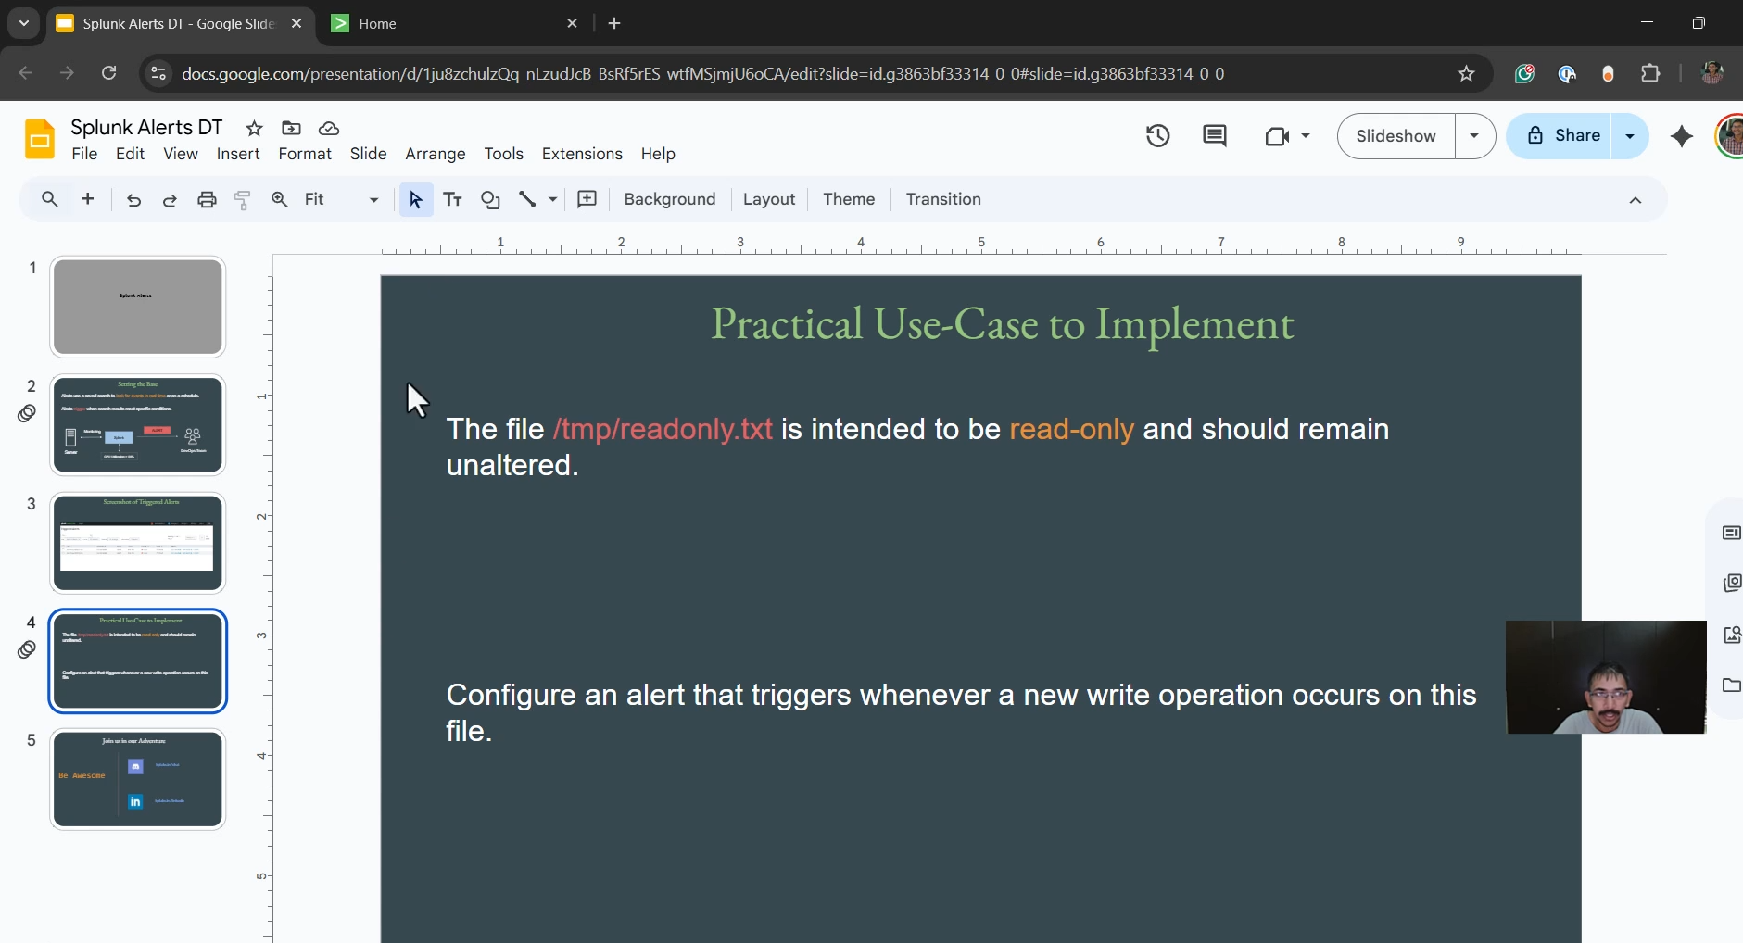

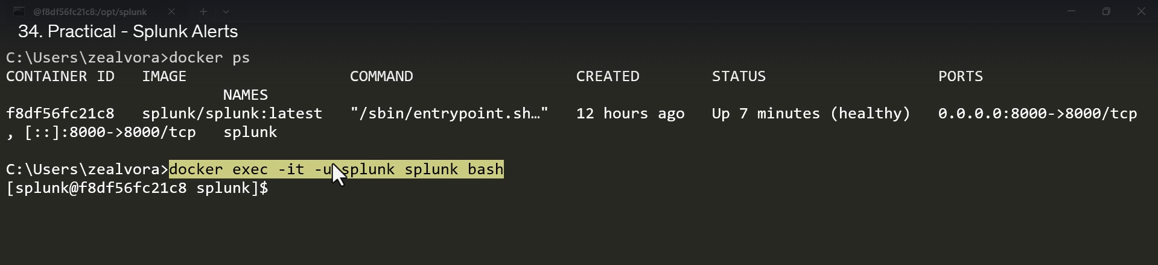

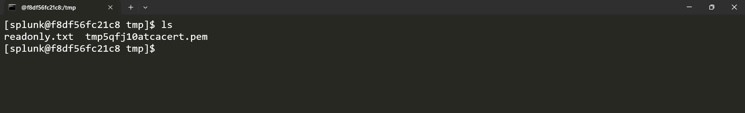

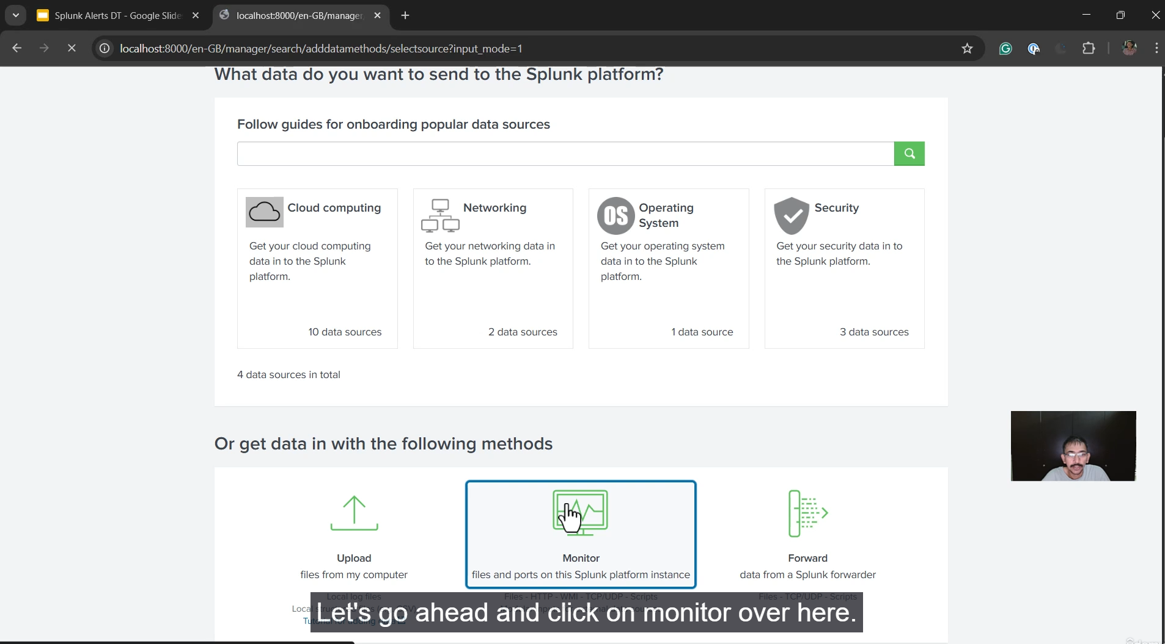

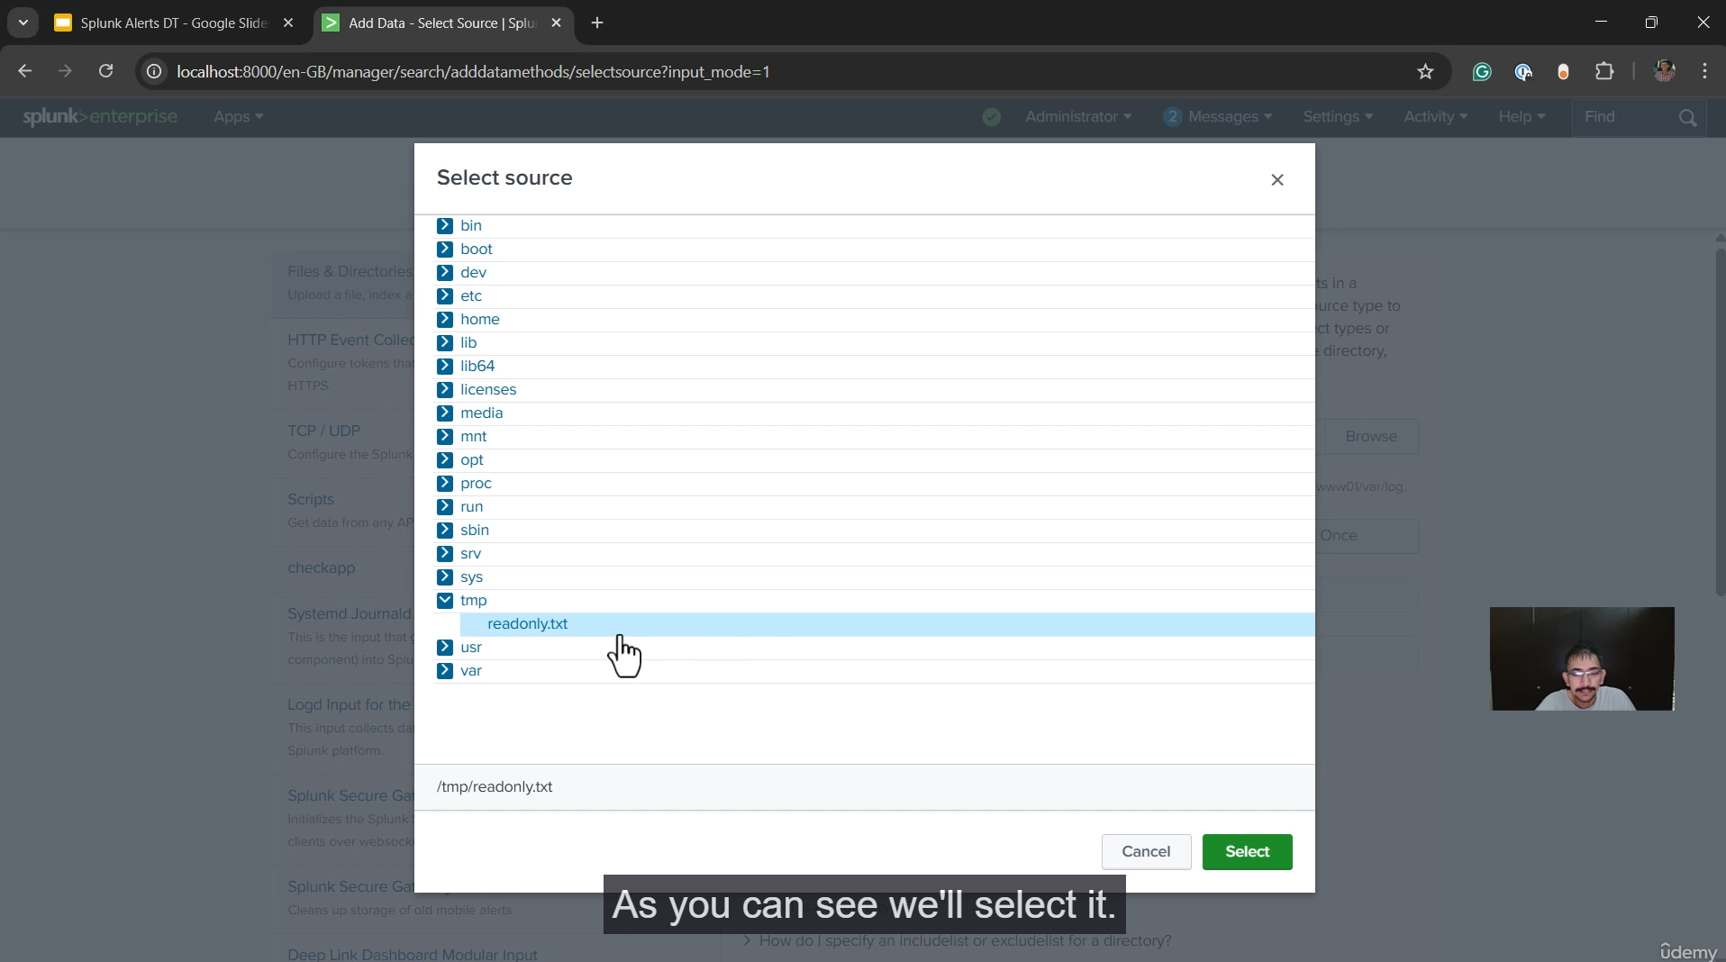

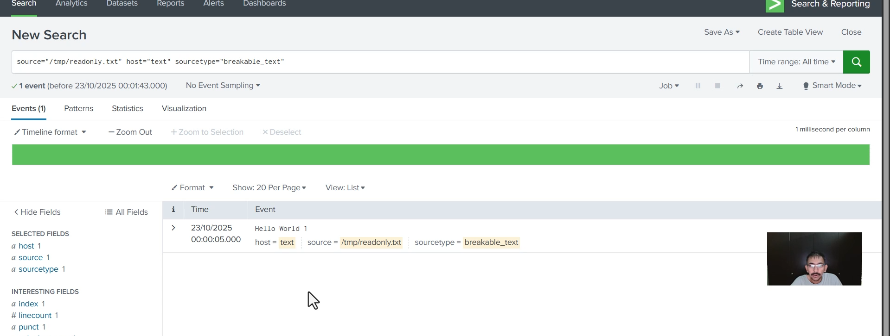

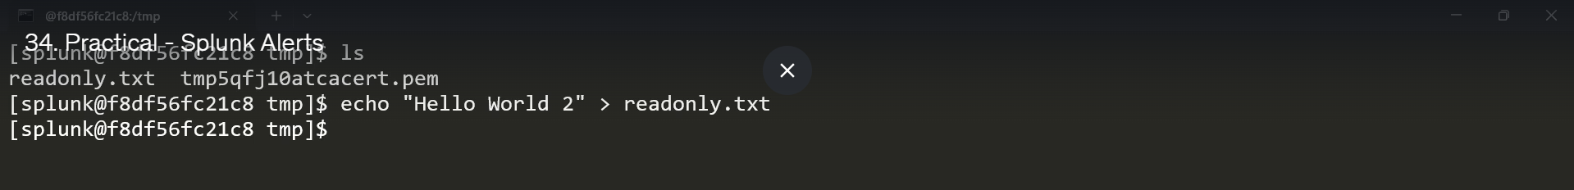

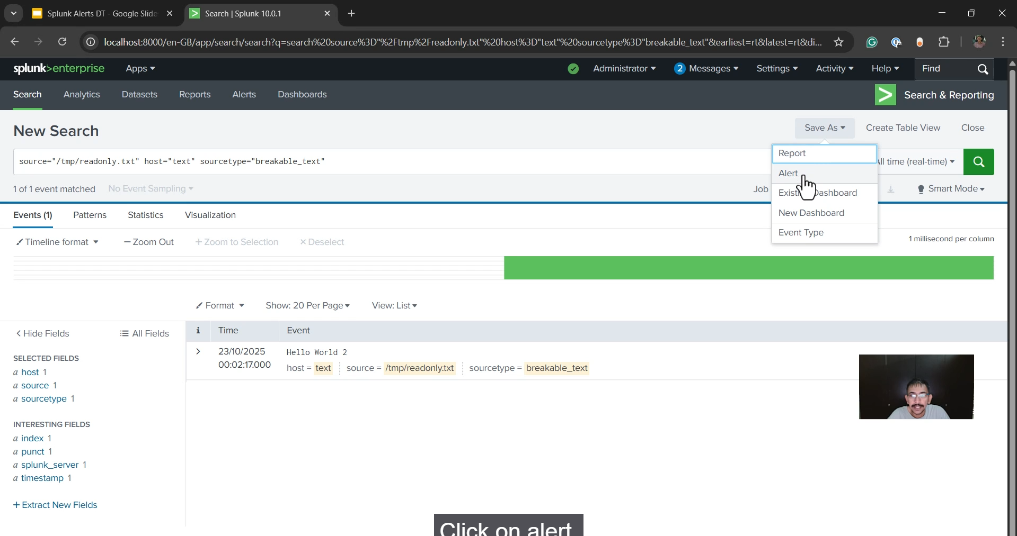

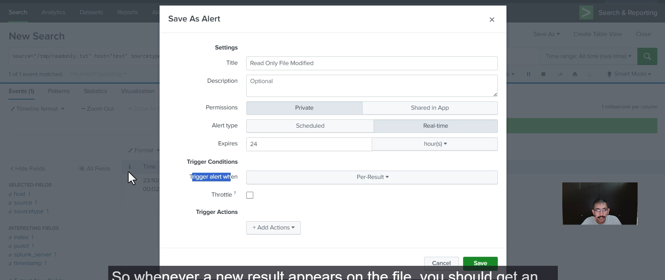

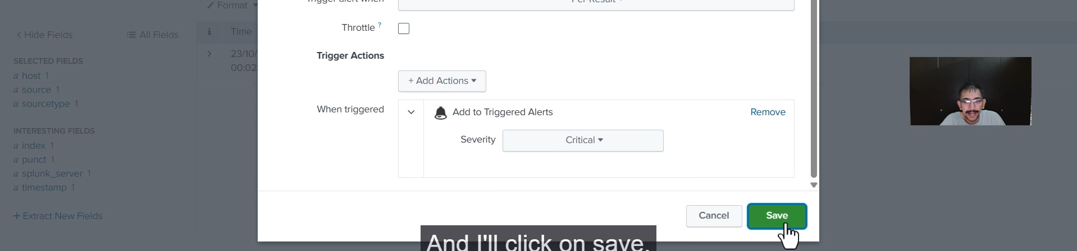

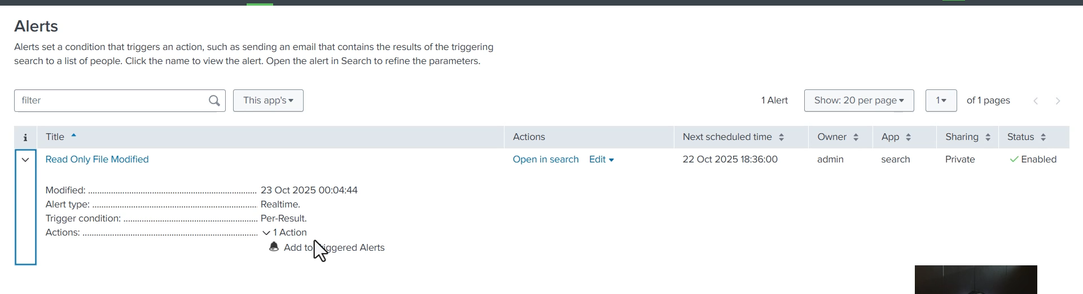

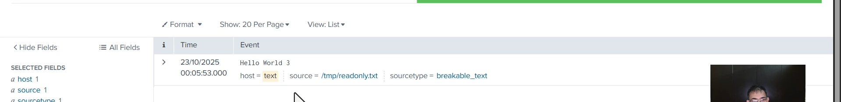

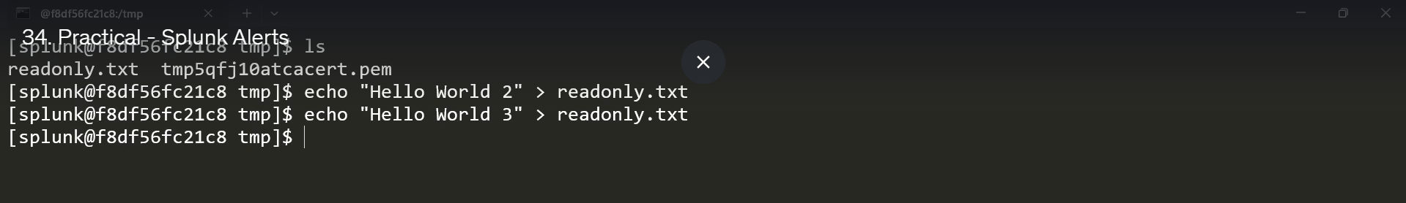

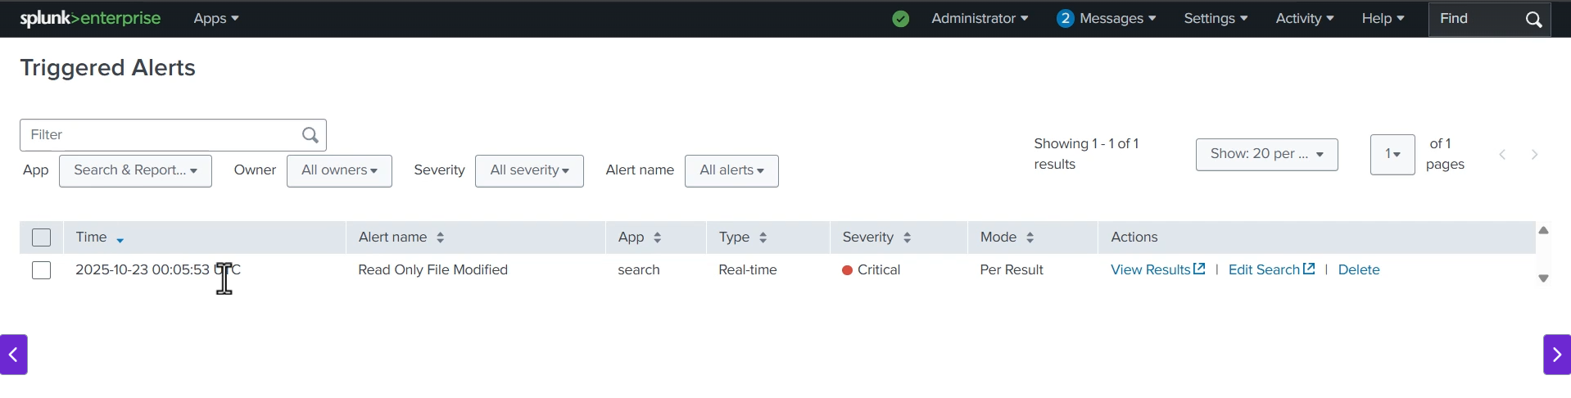

**I. Preparation: Create and Monitor the Target File**

The first step was to ensure Splunk was actively indexing data from the file that needs protection.

**1. File Creation**

* A file named **read_only.txt** was created in a monitored location (the /tmp folder) on the Splunk server (specifically inside the Docker container).
* Initial content (Hello World one) was added.

**2. Splunk Data Input Configuration**

* You navigated to **Settings > Add Data > Monitor**.
* The path to the **read_only.txt** file (/tmp/read_only.txt) was selected.
* The monitor type was set to **Continuous Monitor** so Splunk would continuously watch for new additions (write operations) to the file.
* The data input was configured, including setting a **source type** (e.g., text) and a **host field value** (e.g., text).
* The input was **submitted**, starting the monitoring process.

**3. Verification**

* A search was performed in **Search & Reporting** for events from the monitored file.
* By making a new change (Hello World two) to the file on the server, you confirmed that **new data was immediately indexed** and appeared in the Splunk search results, validating that the data input was working correctly in real-time.

**II. Splunk Alert Creation**

With the data successfully being indexed in real-time, the next phase was to create the alert from the search.

**1. Alert Base Search**

* Starting from the search that shows new events from the file (e.g., index=<your_index> source="/tmp/read_only.txt"), you clicked **Save As > Alert**.

**2. Alert Definition**

* **Title:** read only file modify
* **Alert Type:** **Real-time** was selected, which is essential for immediate notification of a security event.
* **Trigger Alert When:** **Per-Result** was selected.
  + *Significance:* This is the most crucial setting for this use case. It ensures the alert triggers **every time a new event (a new line/write) is indexed** from this specific file, thus alerting on *every* modification.

**3. Trigger Actions**

* **Action:** **Add to Triggered Alerts** was configured.
  + *Significance:* This is a simple, internal Splunk action to log the alert. In a production environment, this is where you would also configure external actions like **Send Email**, **Webhook** (for integration with services like Slack or Microsoft Teams), or **Run a Script** (for automated response).
* **Severity:** **Critical** was set to reflect the importance of the event.
* The alert was **saved**.

**III. Testing and Review**

The final step confirmed that the alert logic was correct.

**1. Triggering the Alert**

* Another new write operation (hello world three) was performed on the read_only.txt file.

**2. Reviewing the Triggered Alert**

* Navigating to **Alerts > Triggered Alerts** showed a new entry for the **read only file modify** alert with a **Critical** severity.
* Clicking **View Result** on the triggered alert displayed the specific event that caused the trigger (hello world three), allowing for immediate investigation of the unauthorized change.

This workflow successfully implemented a **real-time security alert** to detect unauthorized writes on a critical file by leveraging Splunk's file monitoring and **Real-time Per-Result** alerting mechanism.

===================================================================================

1. **Overview of Dashboards and Panels:**

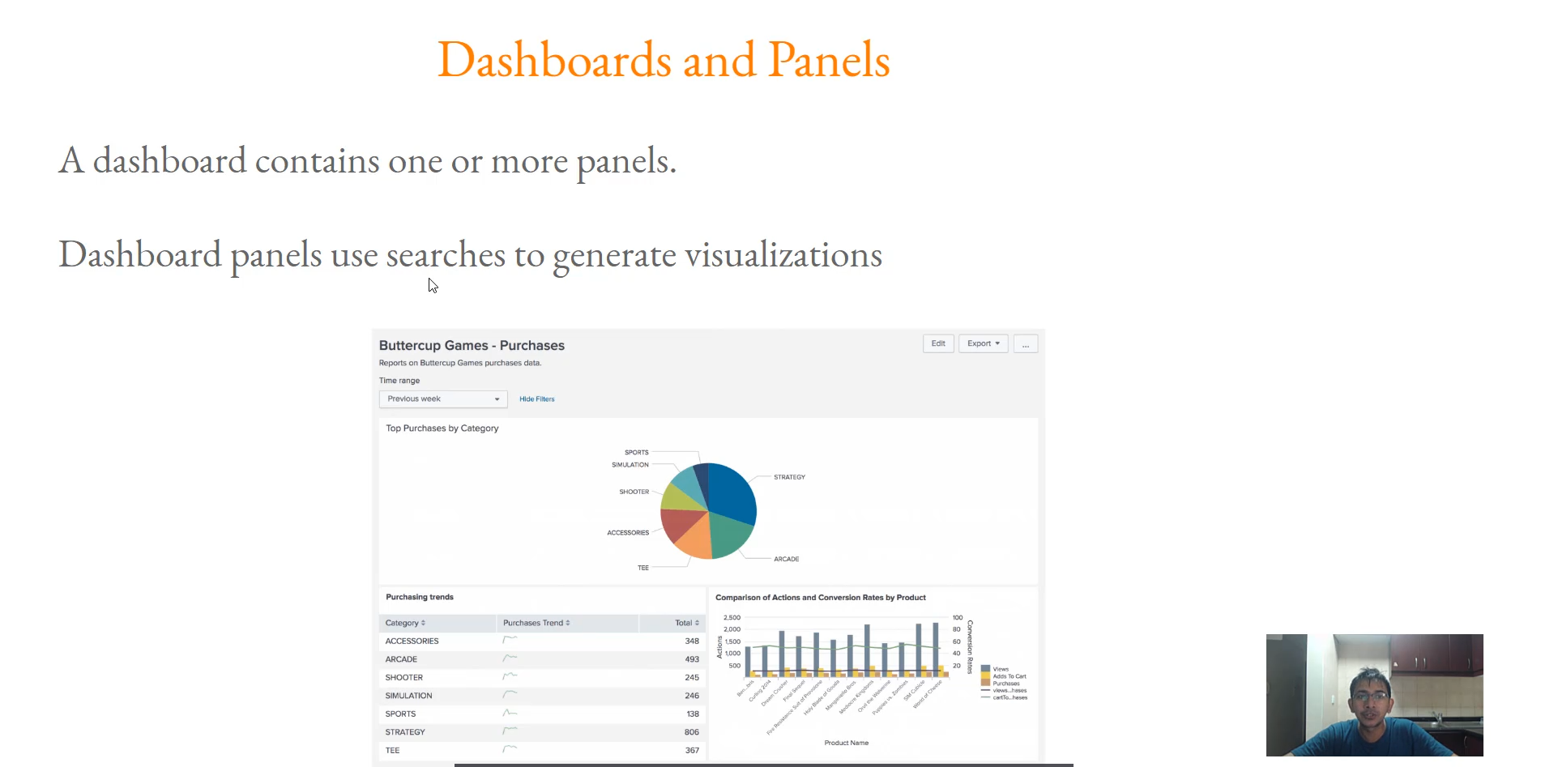

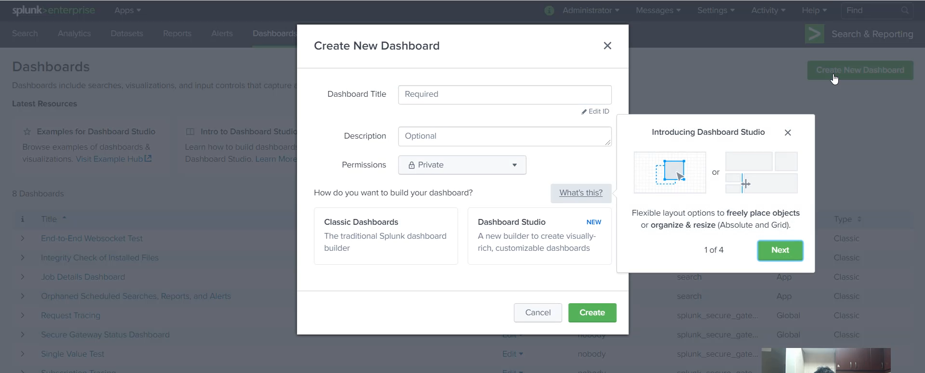

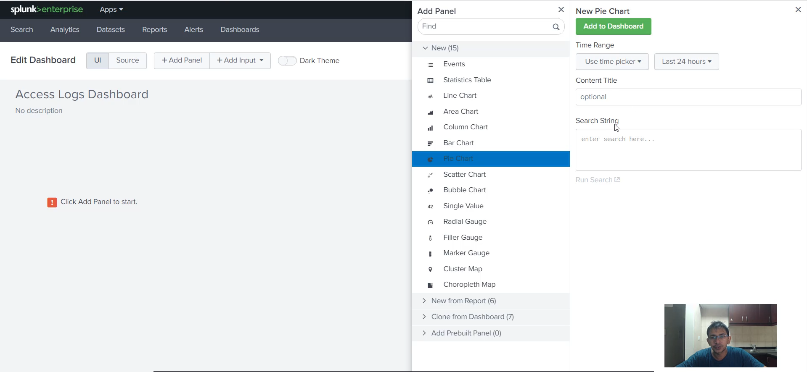

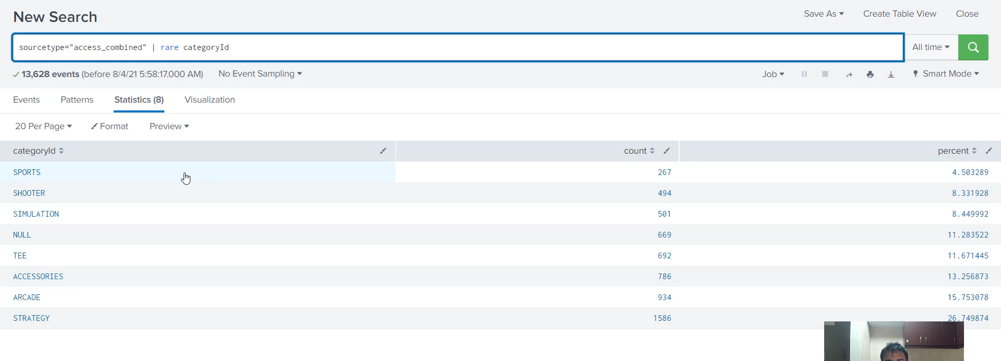

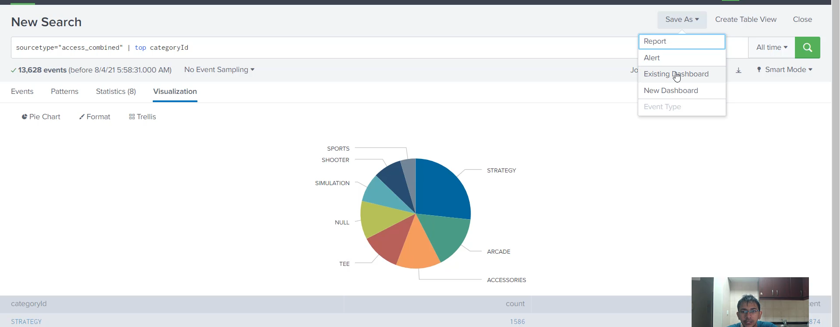

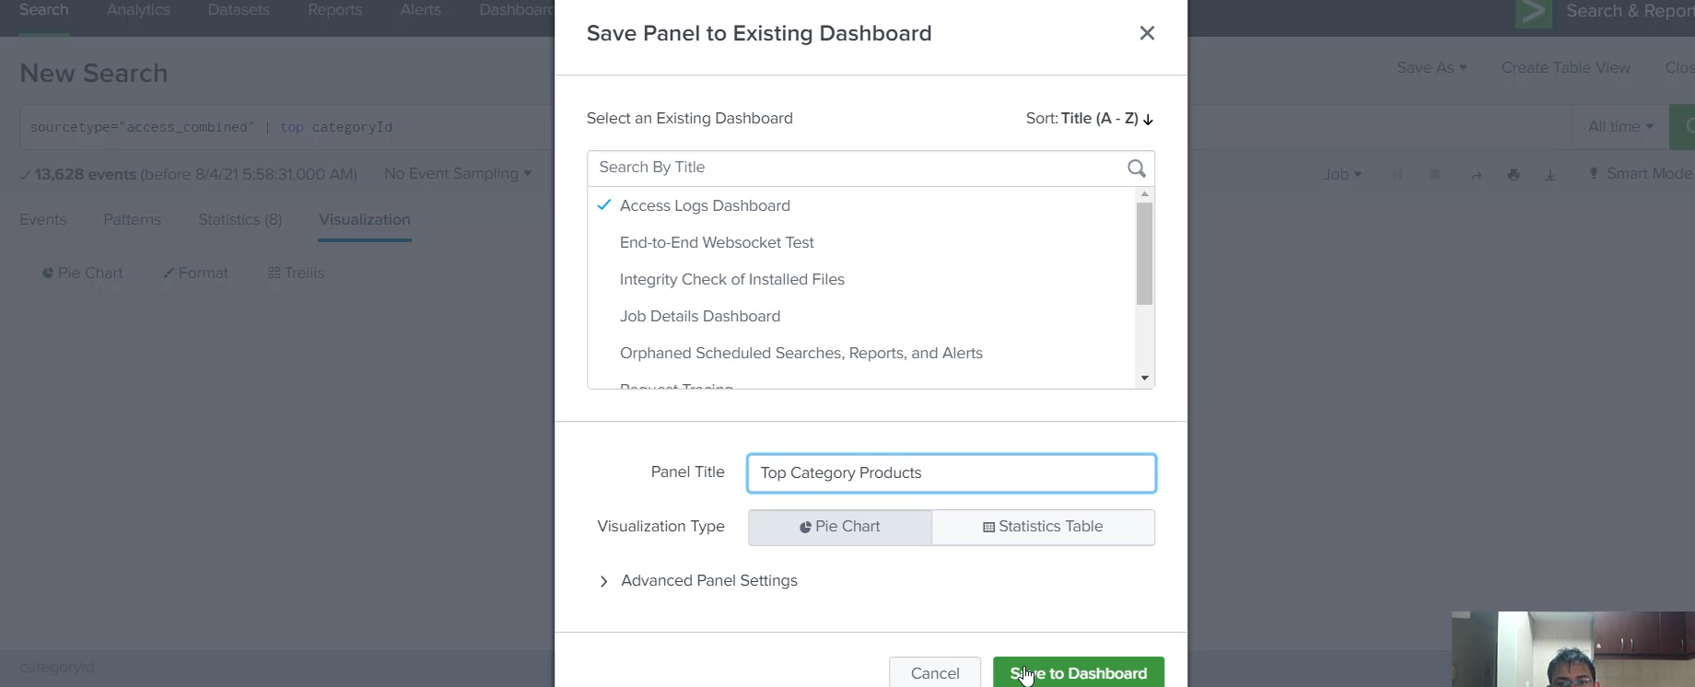

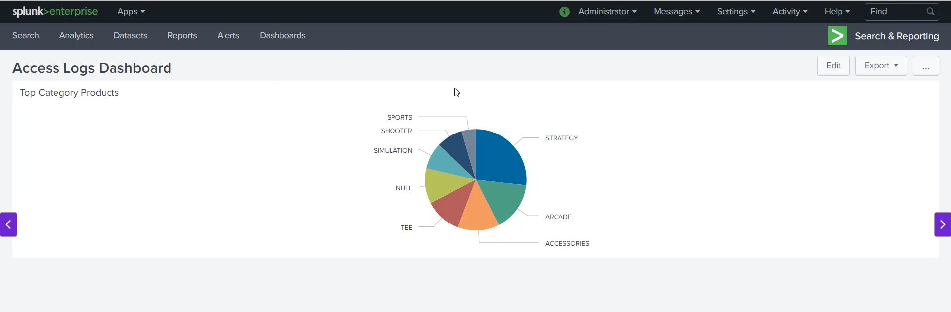

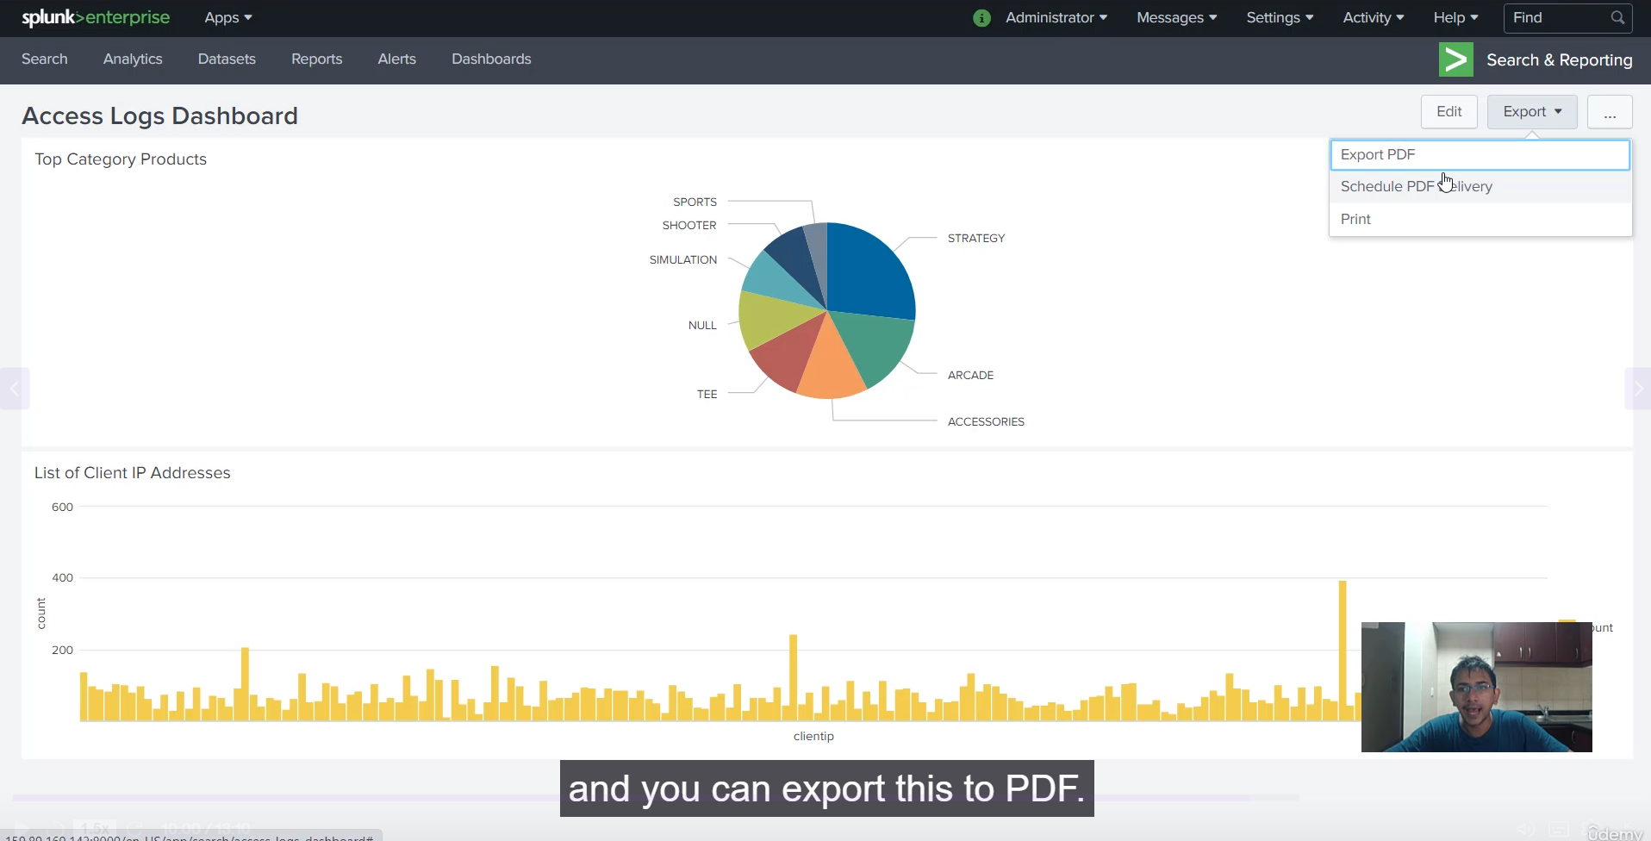

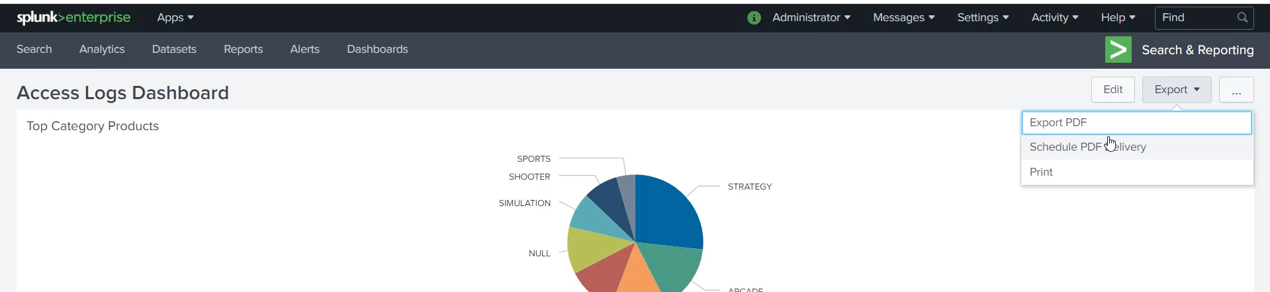

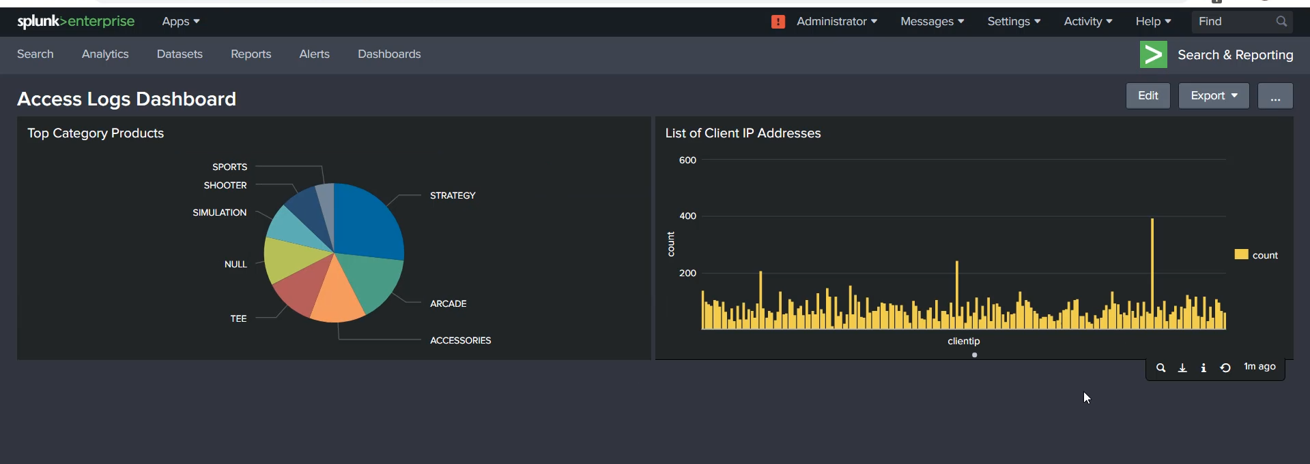

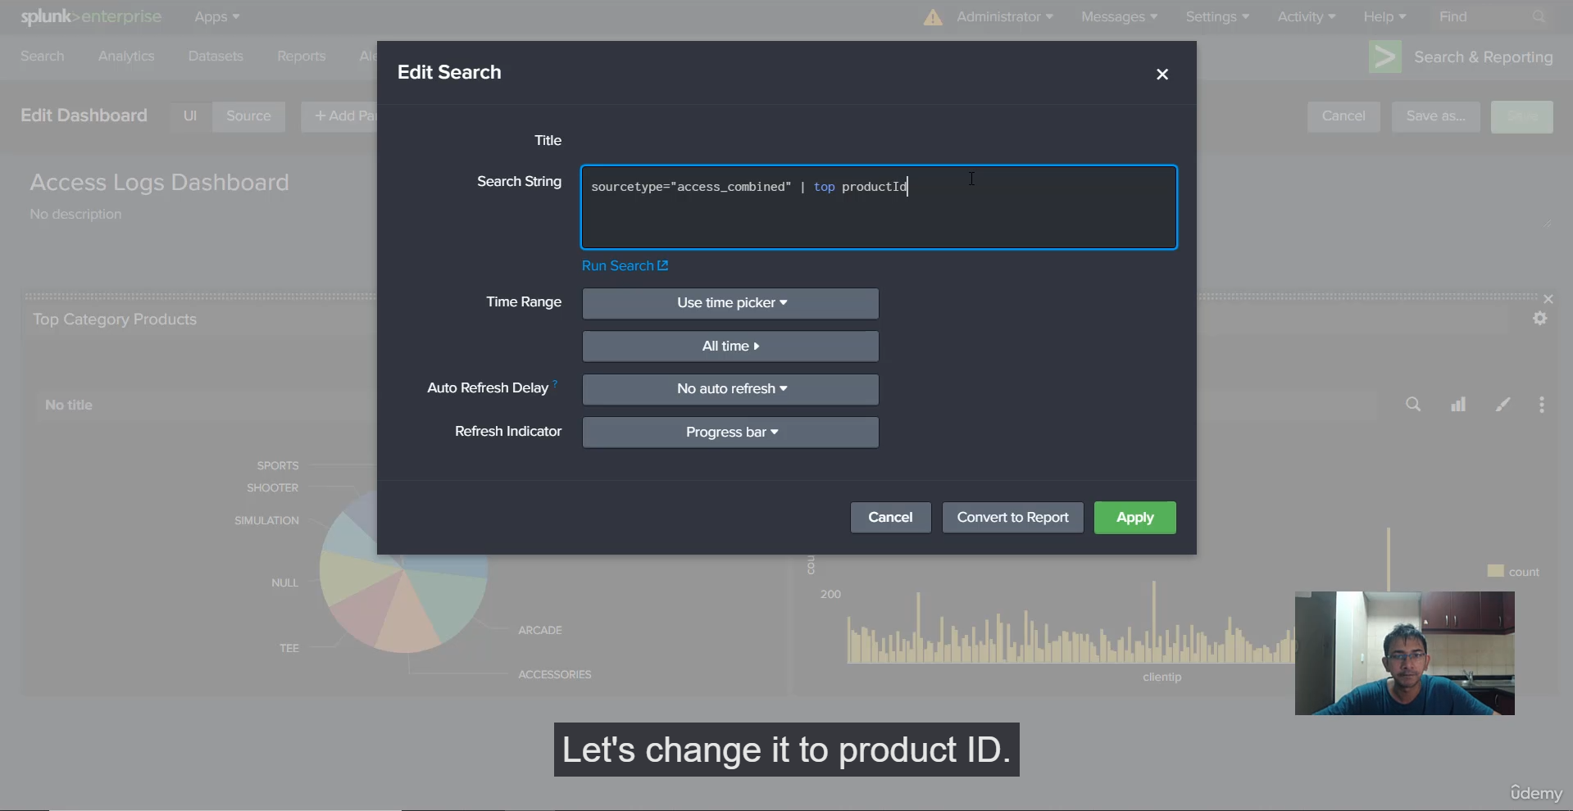

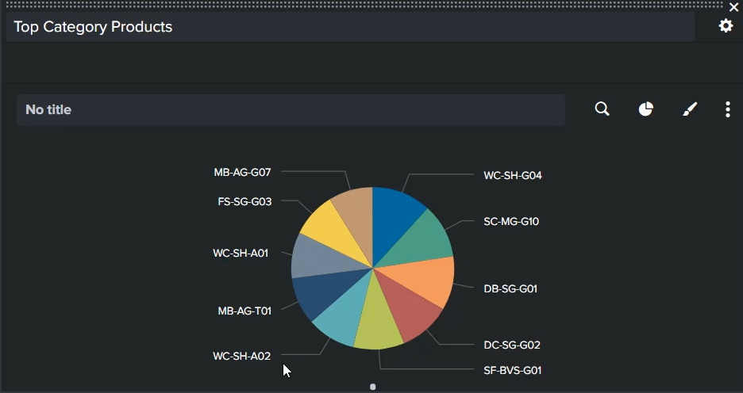

**1. Dashboard and Panel Overview**

* **Dashboard Structure:** A dashboard consists of one or more **panels**.
* **Panel Function:** Each panel uses an **SPL search query** to generate a specific **visualization** (e.g., pie chart, column chart).
* **Classic Dashboards vs. Dashboard Studio:** The demonstration focuses on **Classic Dashboards** (which are more common in older/many organizations), though **Dashboard Studio** is mentioned as the newer, more customizable approach.
* **Editing:** Dashboards can be modified via a **UI** or by directly editing the **source** (Simple XML code for Classic Dashboards).

**2. Creating the Dashboard and First Panel (Pie Chart)**

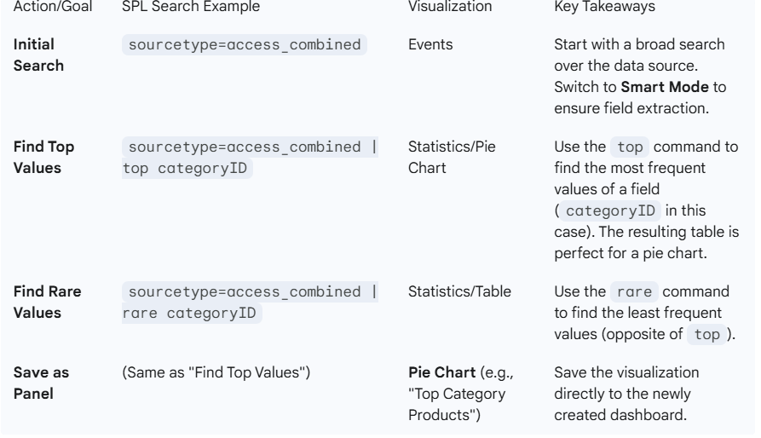

**3. Creating the Second Panel (Column Chart):**

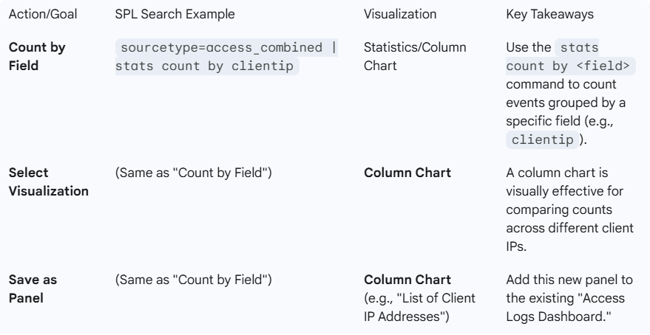

**4. Dashboard Customization and Export**

* **Rearranging Panels (Drag-and-Drop):** In the Edit view, panels can be clicked and dragged to position them next to each other instead of stacked vertically, creating a more efficient layout.
* **Theme:** The dashboard can be switched between **light theme** and **dark theme**.
* **Editing Panel Search:** The search query for an existing panel can be edited either through the UI ("Edit Search") or directly in the **Source** view (Simple XML).
* **Export:** The entire dashboard can be **exported to PDF** using the **Export** button in the dashboard view, making it easy to share a static copy with management.

===================================================================================

1. **Building Dashboards Inputs – Time Range Picker:**

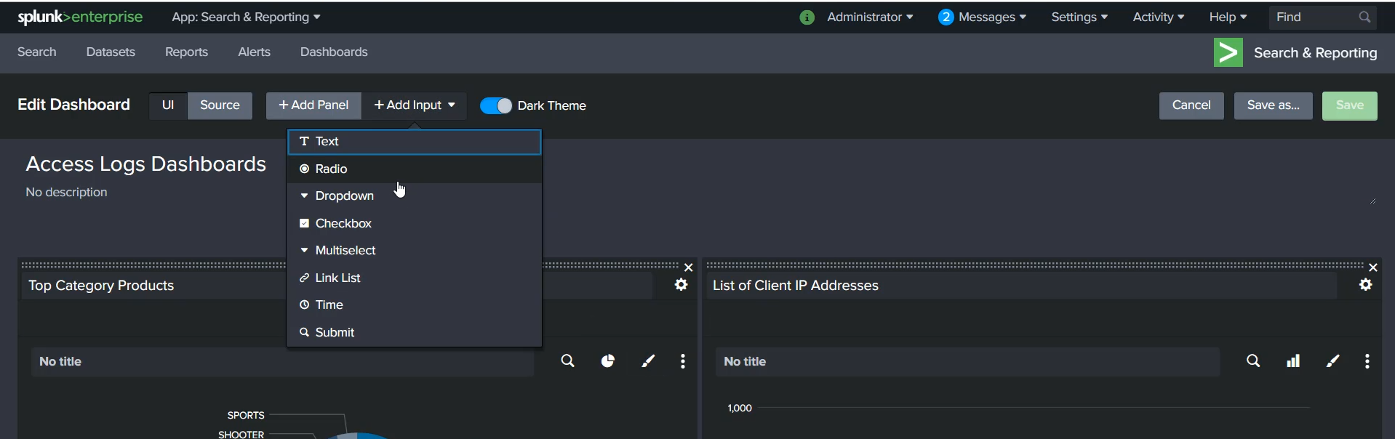

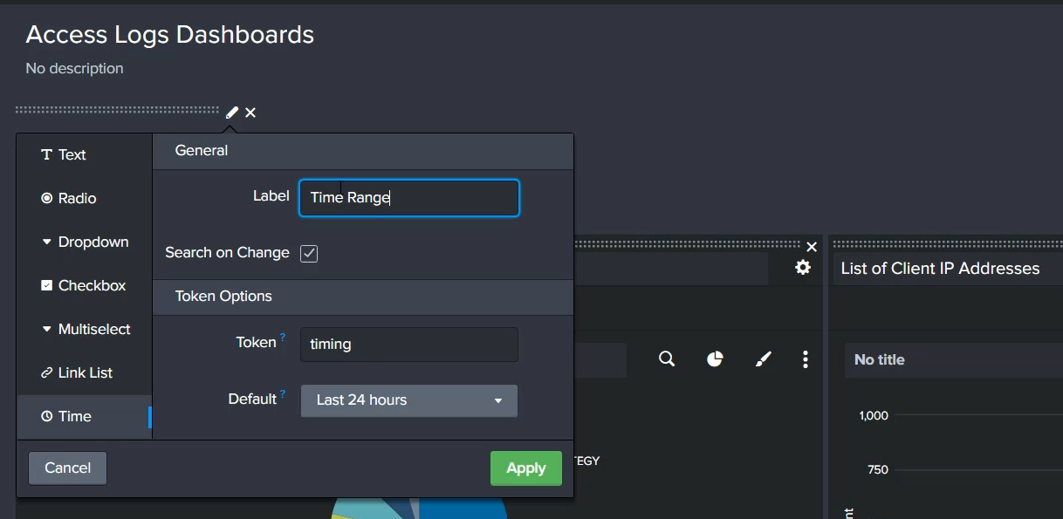

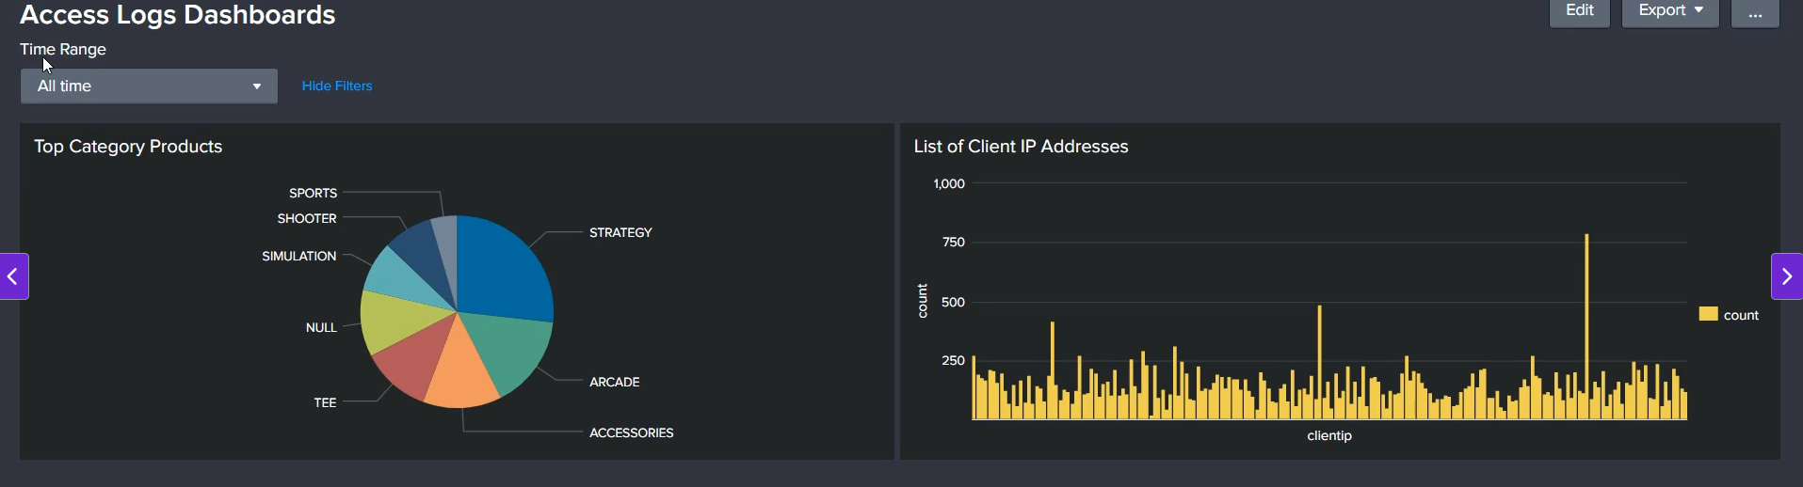

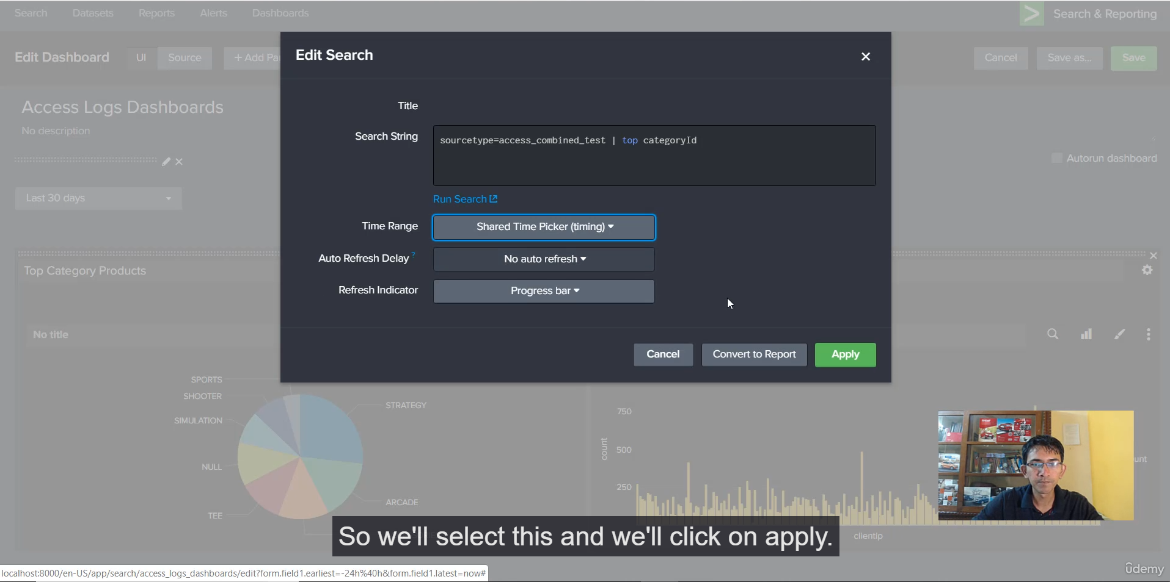

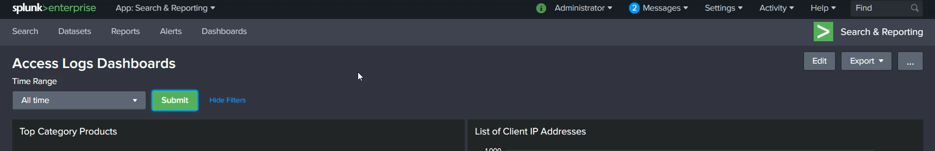

**1. The Need for a Time Range Picker**

* Dashboards become more useful when management can quickly change the time window (e.g., last 24 hours, last 7 days) for all panels.
* This feature is common in professional Splunk apps, such as the Splunk App for AWS.

**2. Steps to Add and Configure the Time Range Picker**

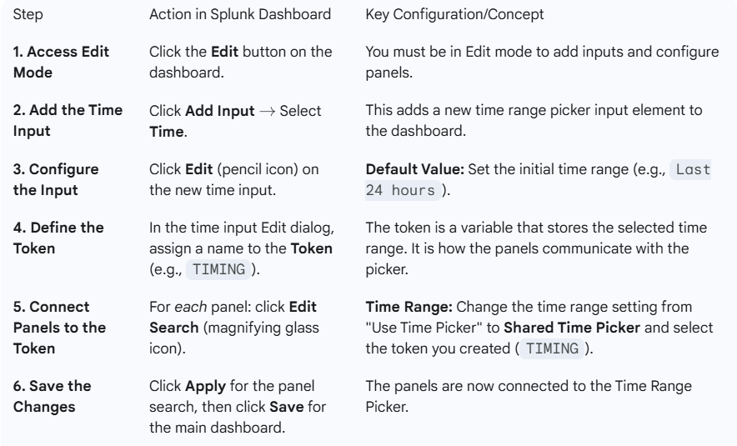

**3. Understanding the "Search on Change" and Submit Button**

The video also discusses two ways to trigger the panel updates:

* **Search on Change (Default):**
  + In the time input's Edit dialog, **"Search on change"** is typically checked.
  + This makes the dashboard immediately refresh the panels as soon as a user selects a new time range.
* **Using a Submit Button:**
  + To use a submit button, you must **deselect "Search on change"** in the time input's Edit dialog.
  + Then, add a **Submit Input** (Input $\rightarrow$ Submit).
  + When a user changes the time range, the panels will **only refresh after the user clicks the "Submit" button**. This is useful for dashboards with long-running searches where you want to gather all inputs before running the queries.

**4. Customizing the Time Picker Label**

* You can add a descriptive label to the Time Range Picker (e.g., "Time Range") by going into the Edit dialog of the input and modifying the **Label** field. This improves the user experience.

===================================================================================

1. **Building Dashboards Inputs – Text Boc:**

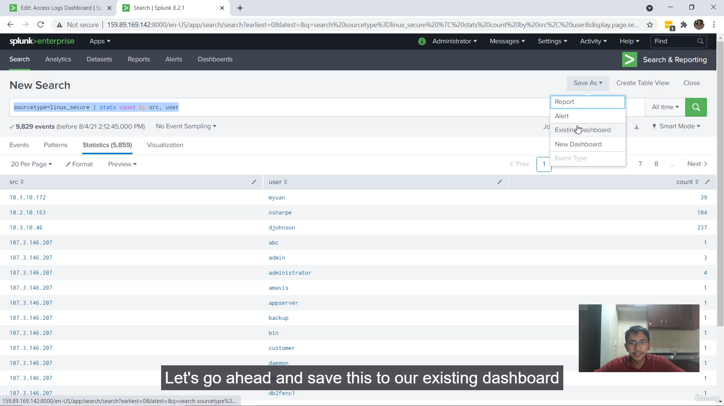

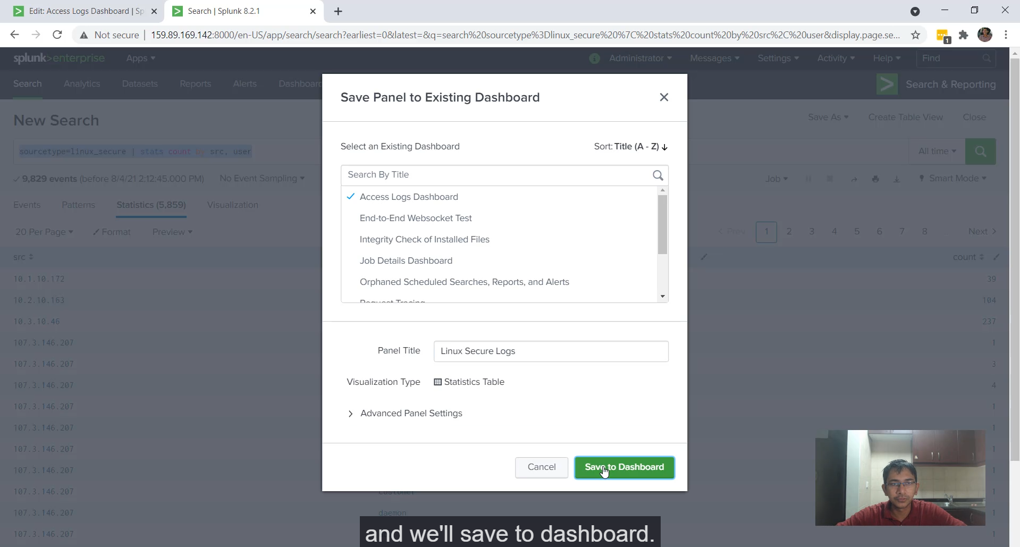

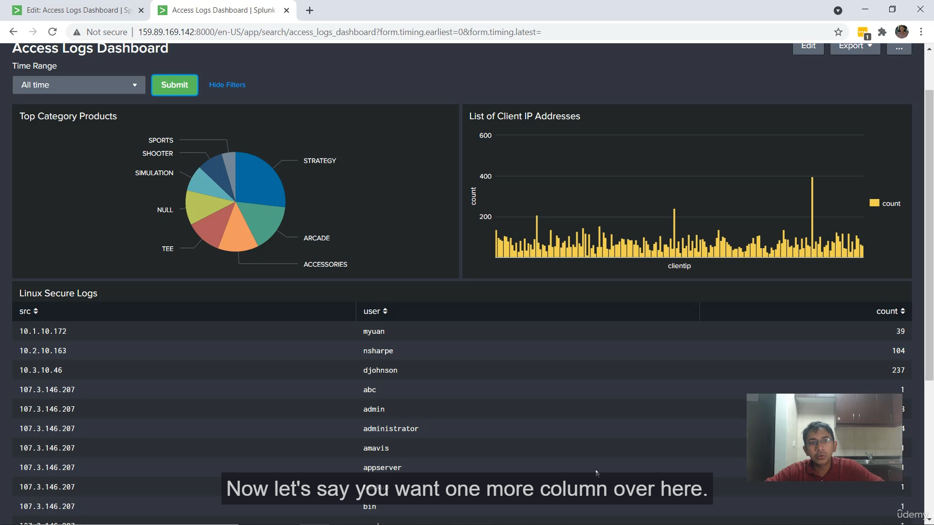

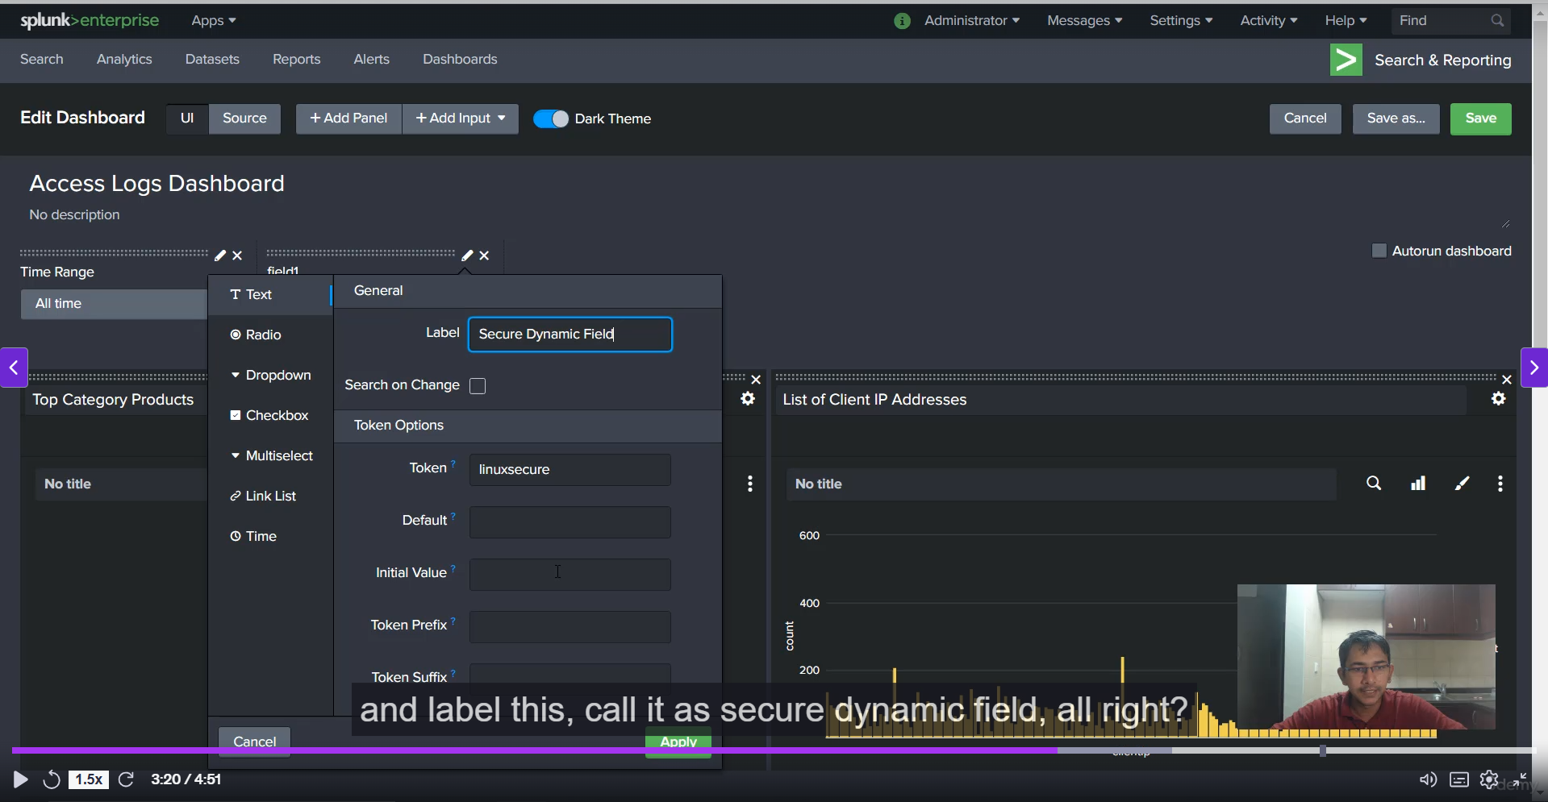

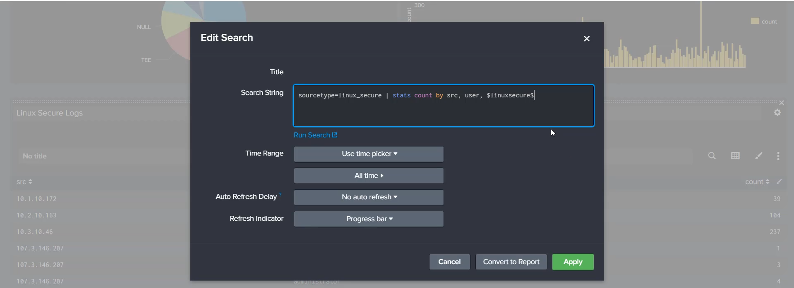

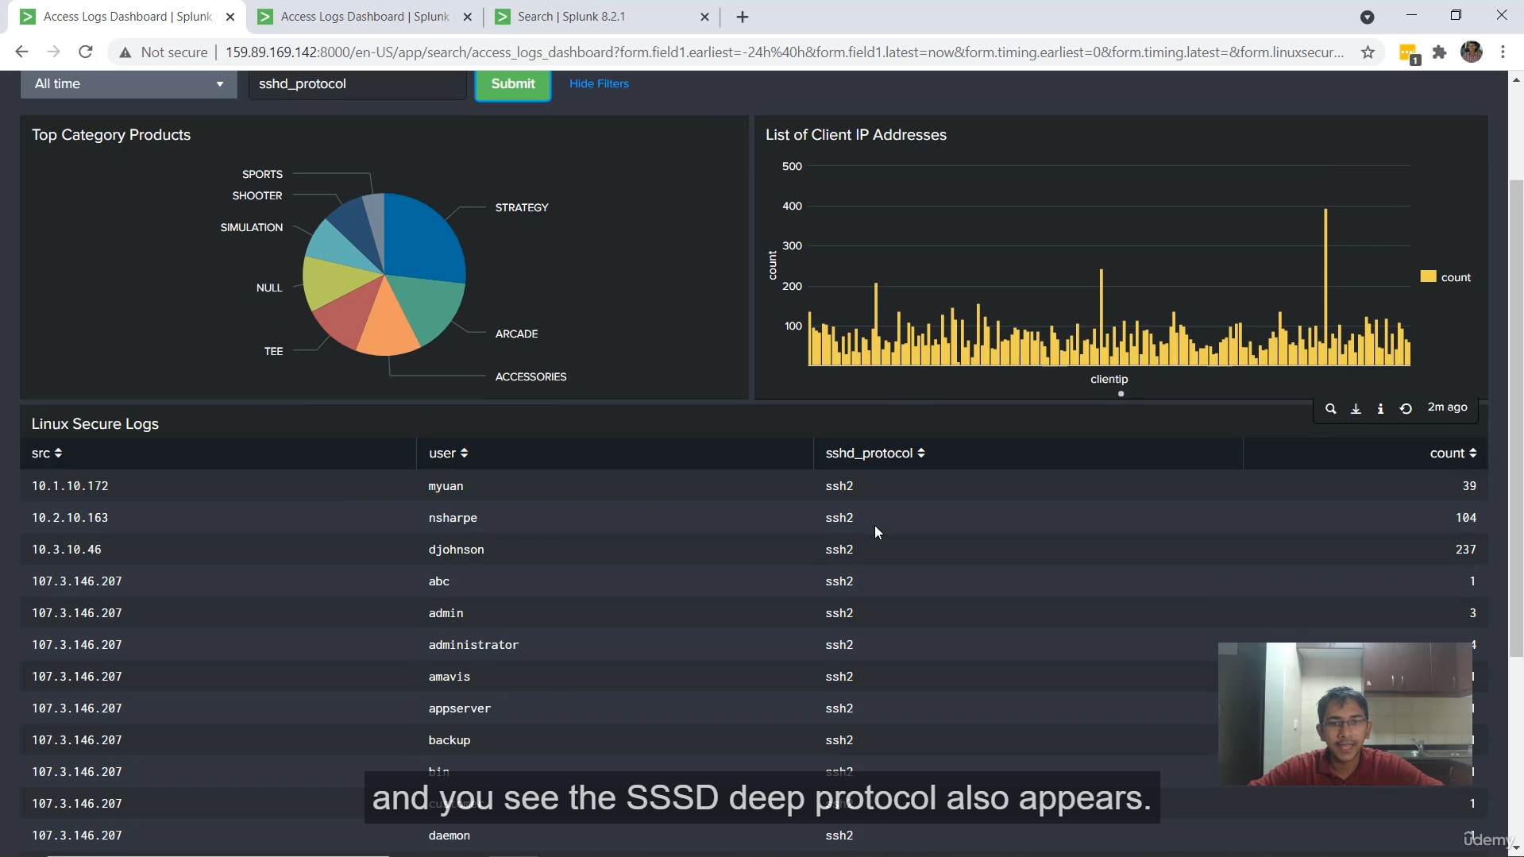

**Splunk Dashboard: Text-Based Input Summary:**

**Core Concepts**

* **Objective:** To introduce and demonstrate the usage of a text-based input in a Splunk dashboard for creating dynamic searches.
* **Dynamic Panel:** The goal is to allow a dashboard user to input an interesting field name (e.g., SRC port) into a text box, and have that field automatically added as a column in a results panel.

**Step-by-Step Implementation**

1. **Create the Base SPL Search:**
   * **Data:** Uses the linux_secure sourcetype logs.
   * **Initial Query:** The base search is created to count events by two fixed fields: | stats count by source user.
   * **Dashboard Integration:** This search is saved to the existing **Access Logs** dashboard under the panel title **"Linux Secure Logs"**.
   * **Initial View:** The resulting panel initially displays **source**, **user**, and **count**.
2. **Add the Text Input Element:**
   * The user adds a new **"Text"** input type to the dashboard.
   * **Token Setup:**
     + **Token Name:** Set to Linux Secure (This is the variable name that will hold the user's input).
     + **Label:** Set to Secure Dynamic Field (The display name for the text box on the dashboard).
3. **Link the Text Input to the Search Panel (Using Tokens):**
   * **Edit Panel Search:** The search for the "Linux Secure Logs" panel is edited.
   * **Token Integration:** The **token name** (Linux Secure) is inserted into the stats command of the SPL query, making the search dynamic: | stats count by source user $Linux Secure$ *(The token is referenced using dollar signs: $TokenName$)*
   * **Applying the Change:** After saving and applying, the dashboard is now linked.
4. **Testing the Dynamic Behavior:**
   * **Successful Test 1:** Typing SRC_port into the new **Secure Dynamic Field** text box and clicking **Submit** causes a new SRC_port column to appear in the table along with source, user, and count.
   * **Successful Test 2:** Typing SSSD protocol and clicking **Submit** causes the SSSD protocol column to appear, replacing the previous dynamic column.
   * **Conclusion:** This confirms that the text input is successfully passing its value (the field name) to the panel's search query, making the dashboard panel **highly interactive** and **field-agnostic**.

**Extra Clarifying Points**

* **Tokens as Variables (Crucial Concept):** A **Token** in Splunk (e.g., $Linux Secure$) acts as a temporary variable. When a user enters a value into an input box, that value is assigned to the token. When the search runs, Splunk replaces the token ($Linux Secure$) in the SPL with the actual user-typed value (e.g., SRC_port).
* **Input Type Use Case:** Text input is ideal for **free-form user entry** like keywords, partial field values, or, as shown here, entirely **dynamic fields** that a dashboard creator might not want to hardcode or list in a dropdown.
* **Submit Button Requirement:** Unlike some inputs that automatically update (searchWhenChanged), a simple text input often requires the user to click a **Submit** button for the token's value to update and the dependent panel search to re-run.

===================================================================================

1. **Building Dashboards Inputs – Drop down:**

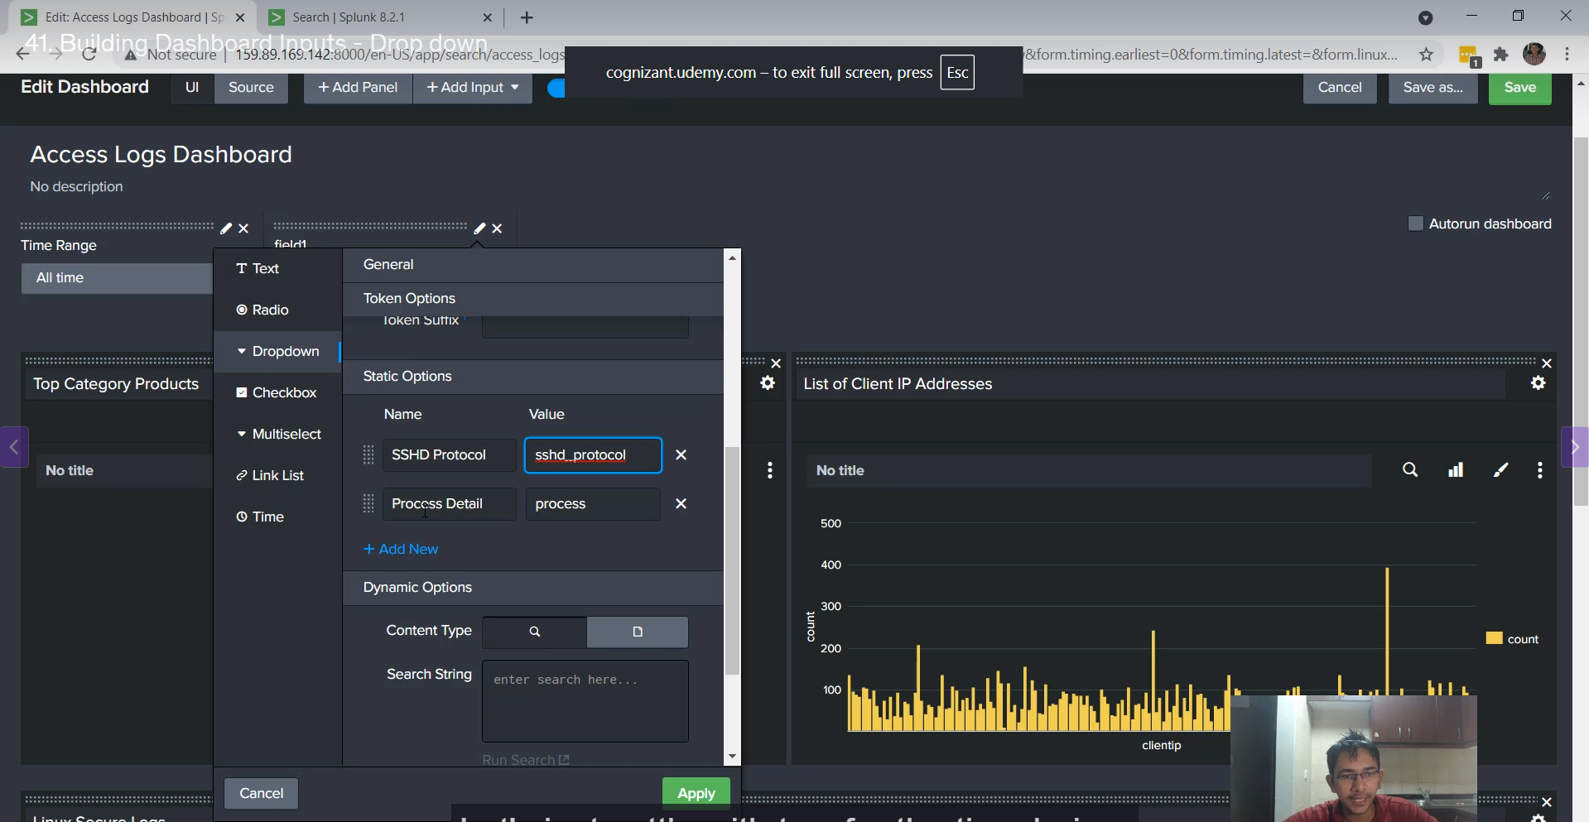

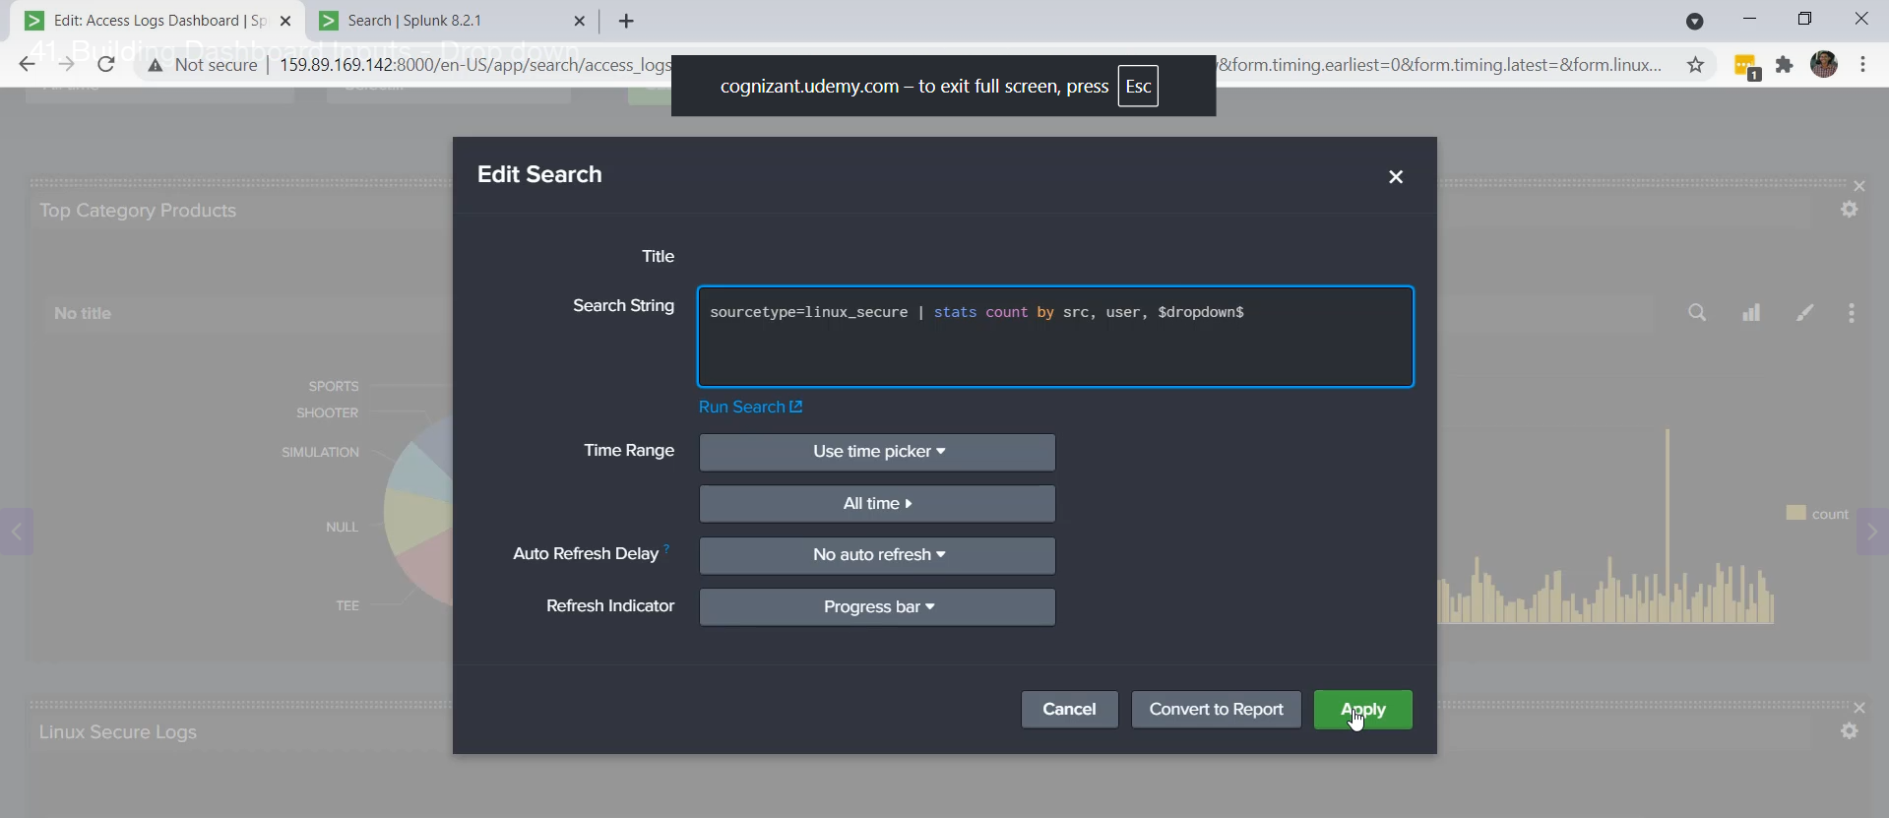

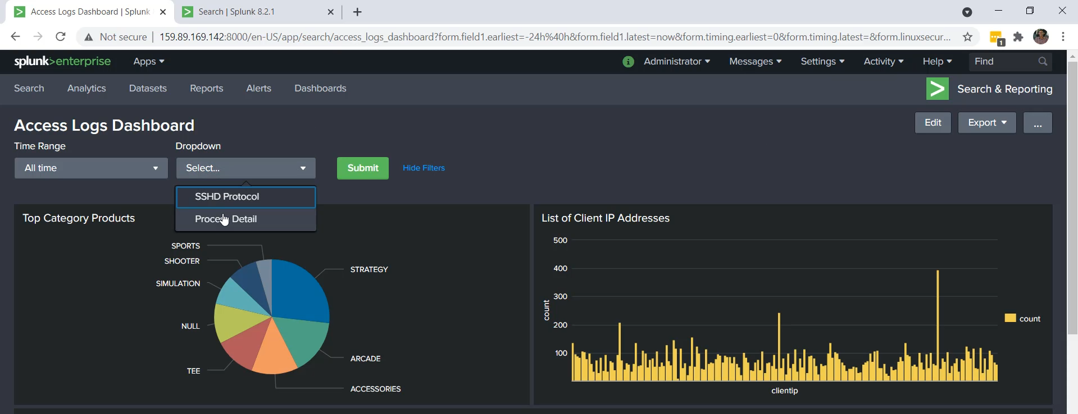  
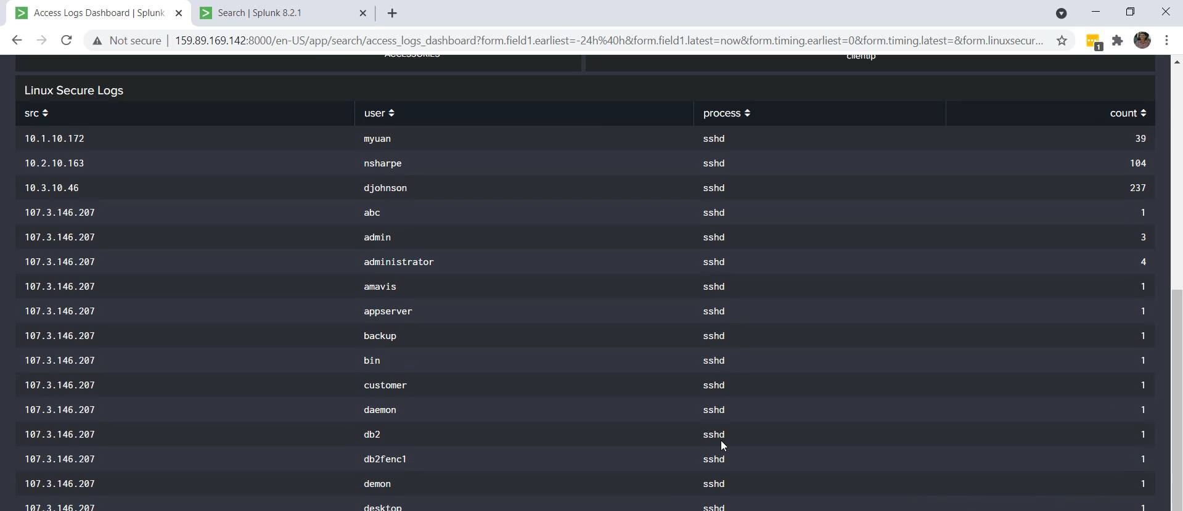

**Splunk Input Summary: Text vs. Dropdown**

**Key Points of the Discussion**

* **Previous Topic Review:** The earlier video discussed the basics and features of **text input** in designing Splunk dashboards and panels.
* **Disadvantage of Text Input:** A key disadvantage of text-based input is the requirement for the user to **know the exact name of the field beforehand** (e.g., SSSD_protocol).
  + This is challenging, especially with larger datasets where the number of field extractions is huge.
* **Solution: The Dropdown Input:** To avoid this challenge, a **dropdown input** is used.
  + The dropdown contains the required **field names pre-populated**, meaning the user doesn't need to memorize or type them.
* **Implementation Steps:**
  1. **Removal of Text Input:** The previously created text-based input was removed.
  2. **Creation of Dropdown Input:** A new input of type **dropdown** was created.
     + The token was set to **dropdown** (used to reference the input's selected value in the search).
  3. **Defining Static Options:** Static options were configured for the dropdown:
     + **Display Name:** SSSD protocol | **Value:** SSSD_protocol
     + **Display Name:** Process Detail | **Value:** process (This is the underlying field name).
  4. **Editing the Search:** The underlying search query was updated to use the dropdown's token (dropdown) instead of the previous static field name (e.g., changing Linux secure to dropdown).
     + This allows the search to dynamically filter based on the user's selection from the dropdown.
* **Demonstrated Benefit:** When using the dropdown, the user can easily select the desired field (Process Detail or SSSD protocol), click **Submit**, and the panel dynamically updates to show the data corresponding to that selected field.

**Core Takeaway**

The **dropdown input is superior to the text input** for selecting fields because it **presents valid options upfront**, eliminating the user's need to memorize or correctly type the field name, thus providing a much **better user experience** and making the dashboard more accessible.

******************************************************************************************************************************************************************************************************************************************************************************************